
Cairo University
Faculty Of Computer Science And Artificial Intelligence
Information Systems Department

Graduation Project Report
Udjat Track
By
20220269 Maya Ahmed Rady
20220374 Hana Hany Ibrahim
20230609 Duaa Abd-Elati Abd-Elazeem
20220355 Nadra Mahmoud Saad

20220334 Mariam Matrawy Ahmed

20220089 Tasmin Gomaa Anter

Under the Supervisors of:
Dr. Dina Ezzat
TA. Nehal Akram

Department of Information Systems, Faculty of Computers and Artificial Intelligence, Cairo University, Egypt
February - 2026
Table of Contents
Chapter 1 Introduction 6
1.1 Background and Motivation 6
1.2 Problem Statement 7
1.3 Objectives 7
1.4 Project Scope and Limitations 8
1.4.1 Project Scope 8
1.4.2 Project Limitations 8
1.4.3 Initial Project Plan 9
1.4.4 Team Members and Responsibilities 10
1.5 Project Methodology 10
1.5.1 Selected Methodology 10
1.5.2 Waterfall Phases Applied to the Project 11
1.6 Project Outline 11
Chapter 2 Market and Literature Survey 12
2.1 Justification for Focusing on Heavy Transport Vehicles 12
2.1.1 Technology Gap in Existing Heavy Truck Fleets 13
2.1.2 Comparison Between Udjat Track and OEM-Integrated ADAS 15
2.2 Literature Survey: Causes of Heavy-Truck Accidents and Risk Factors 16
2.2.1 Driver Fatigue and Driving Duration 16
2.2.2 Aggressive and Risky Driving Behaviors 17
2.3 Driver Survey Results: Safety Needs and Technology Acceptance 18
2.4 Existing Solutions and Market Landscape 21
2.4.1 Techurity: Driver Monitoring System (DMS) 21
2.4.2 FMS Tech: Fleet Management Solutions 21
2.4.3 Softec: Altari Fleet Management System 22
2.4.4 Udjat Track (Proposed System) 22
2.4.5 Functionality Comparison: 23
Chapter 3 Udjat Track Analysis 25
3.1 Main Problem 25
3.2 Stakeholders and Responsibilities 26
3.2.1 Primary System Users 26
3.2.2 Business and Commercial Stakeholders 27
3.3 Functional requirements 28
3.3.1 Authentication and User Management 28
3.3.2 Trip Operations 28
3.3.3 Driver Monitoring and Fatigue Detection 29
3.3.4 Safety Alerts 29
3.3.5 Incident Reporting and Emergency Handling 29
3.3.6 Proximity and Collision Warning 30
3.3.7 Navigation and Location-Based Services 30
3.3.8 Fleet Management 30
3.3.9 System and Edge Operations 31
3.4 Non-Functional Requirements 31
3.4.1 Performance 31
3.4.2 Reliability and Availability 31
3.4.3 Security 31
3.4.4 Scalability 31
3.4.5 Usability 32
3.4.6 Accuracy and Robustness 32
3.4.7 Maintainability 32
3.4.8 Compliance 32
3.5 System Scenarios 33
3.6 System Modeling 39
3.6.1 Use Case Diagram 39
3.6.2 Use Case Tables 40
3.6.3 Class Diagram 51
3.6.4 ERD Diagram 54
3.6.5 IoT Sequence Diagram 55
3.6.6 Mobile Sequence Diagram 58
3.6.7 Backend Sequence Diagram 61
Chapter 6 Conclusions and Future Work 63
6.1 Conclusions 63
6.2 Future Work 64
References 68

List of Tables

Table 1: Percentage Distribution of Accident-Involved Truck Drivers According to Sleep Duration, Continuous Driving Time, and Total Driving Hours 16
Table 2: Frequency Distribution of Aggressive Driving Behaviors among Accident-Involved Truck Drivers 17
Table 3: Competitors Functionalities Comparison Table 23
Table 4: Report Internal Maintenance Issues Use Case Table 40
Table 5: View Alert Use Case Table 42
Table 6: Add Trip Use Case Table 44
Table 7: Send SOS Alert Use Case Table 46
Table 8: Generate Blind Spots Alert Case Table 48
Table 9: Detect Crash Event Use Case Table 49
Table 10: Detect Driver State Use Case Table 50

List of Figures
Figure 1: Percentage of crashes by vehicle type in Egypt 13
Figure 2: Driver Preferences for Accident Response and Support Mechanisms (n = 10) 19
Figure 3: Frequency of Driver Fatigue While Driving (n = 10) 19
Figure 4: Driver Acceptance of In-Cabin Fatigue and Attention Alerts (n = 10) 20
Figure 5: Preferred Alert Modalities During Risky Driving Situations (n = 10) 20
Figure 6: AI-Based Driver Fatigue Detection and Accident Prevention Using Raspberry Pi Camera 33
Figure 7: Manual SOS–Based Vehicle Breakdown and Maintenance Assistance Workflow 34
Figure 8: Blind-Spot Monitoring System for Heavy Trucks in Urban Traffic 35
Figure 9: Map-Based Medical and Safety Assistance Navigation for Long-Haul Drivers 36
Figure 10: Trip-Based Emergency Escalation and Fleet Manager Notification 37
Figure 11: Baseline Fleet Trip Monitoring and Safety Awareness 38
Figure 12 Udjat Track Use Case Diagram. 39
Figure 13: Udjat Track Backend Class Diagram. 51
Figure 14: Udjat Track IoT Class Diagram. 52
Figure 15: Udjat Track Mobile Class Diagram. 53
Figure 16: Udjat Track Entity Relationship Diagram. 54
Figure 17: The Crash Detection Sequence Diagram. 55
Figure 18: Periodic Sensor Sampling Sequence Diagram 56
Figure 19: Proximity Event Detection Sequence Diagram 57
Figure 20: Driver Alert Generation and Notification Sequence Diagram 58
Figure 21: Nearby Facilities Retrieval Sequence Diagram 59
Figure 22: Offline-to-Online Data Synchronization Sequence Diagram 60
Figure 23: Delete Vehicle Sequence Diagram 61
Figure 24: Track Driver Status Sequence Diagram 62

Introduction

1.1 Background and Motivation
Road traffic accidents constitute one of the most critical public safety challenges in Egypt. National injury surveillance data reported by the Egyptian Ministry of Health in collaboration with the World Health Organization show that road traffic injuries increased from 11.52% of total injuries in 2001 to 12.87% in 2009, reflecting a persistent deterioration in road safety conditions. Heavy transport trucks play a dominant role in this context, as more than 96% of goods in Egypt are transported by trucks, making their safety impact particularly significant. Due to their large size, excessive weight, and extended operating hours, truck-related accidents are often more severe than those involving passenger vehicles, and quantitative analysis on the Cairo–Suez Highway confirms that trucks have a statistically significant correlation with total road traffic accidents, with their contribution estimated at 0.92 times that of passenger cars.

Human factors have been identified as the primary contributors to truck-related crashes in Egypt. A large-scale study involving 615 Egyptian truck drivers found that fatigue, lack of sleep, prolonged continuous driving, obesity, and drug use are the most influential factors affecting crash involvement. The same study reports that drivers who slept less than 6 hours accounted for 59% of accident-involved drivers, while 41% of drivers involved in accidents drove more than 15 hours per day.

Furthermore, truck accidents are associated with high-severity outcomes. Survey-based accident data revealed that 13% of truck accidents resulted in deaths, while 19% resulted in injuries, and 49% caused property damage. In fatal truck accidents, 51% involved the death of at least one person, and 36% involved the death of two or more individuals, emphasizing the catastrophic nature of these incidents.

Despite these alarming figures, most heavy transport vehicles operating on Egyptian roads still lack intelligent driver monitoring, fatigue detection, and real-time accident response systems. Existing safety solutions are largely limited to basic GPS tracking, while advanced driver assistance technologies remain financially inaccessible for most local fleet operators. This gap between the high risk of truck-related accidents and the limited availability of effective safety technologies motivates the development of an intelligent, affordable, and locally adaptable safety system for heavy transport trucks.

1.2 Problem Statement
Heavy transport truck accidents in Egypt continue to occur at high rates due to a combination of human, technical, and systemic factors. Empirical studies confirm that driver fatigue, excessive continuous driving, distraction, and aggressive driving behavior are statistically significant predictors of accident occurrence among truck drivers.

Current safety practices rely heavily on post-accident reporting rather than real-time prevention. Most trucks lack integrated systems capable of detecting driver drowsiness, monitoring unsafe driving durations, or automatically reporting crashes when drivers are unconscious or unable to call for help. Research indicates that more than 30% of fatal truck crashes are fatigue-related, according to findings referenced by the National Transportation Safety Board.

Fleet operators also face limited visibility into driver behavior and vehicle safety conditions during long-haul trips. As a result, dangerous conditions such as micro-sleep, distraction, or prolonged driving often go unnoticed until a severe accident occurs. This absence of proactive monitoring creates a critical gap between existing road safety challenges and effective accident prevention mechanisms, leading to unnecessary loss of life, cargo damage, and economic disruption.

1.3 Objectives
In response to the challenges mentioned, the objectives of this project focus on improving safety and operational efficiency in heavy transport truck operations. The system aims to reduce accidents caused by driver fatigue, sickness, and unsafe driving behavior by continuously monitoring drivers during active trips and issuing timely alerts when abnormal conditions are detected. To address the lack of structured trip oversight and excessive continuous driving, the system supports comprehensive trip management by enabling drivers to create, track, and end trips while automatically logging into driving duration, break periods, and trip history.

In addition, to overcome limited fleet visibility and delayed intervention, the system provides fleet managers with centralized tools to manage driver accounts, monitor trip progress, and review safety alerts in real time.The integration of map-based services also addresses navigation challenges faced by drivers by displaying essential nearby facilities such as roads, hospitals, gas stations, and maintenance centers. Through these objectives, the project seeks to bridge the gap between current road safety challenges and proactive accident prevention by improving coordination between drivers, fleet managers, emergency services, and maintenance centers, ultimately contributing to safer and more efficient heavy transport operations.

1.4 Project Scope and Limitations

1.4.1 Project Scope
Udjat Track is a comprehensive, AI-powered safety and assistance platform designed specifically for the heavy transport sector in Egypt. The project scope encompasses the following core areas:
- AI-Powered Driver Monitoring: Utilising on-device computer vision to detect signs of drowsiness, head nodding, and prolonged eye closure, triggering immediate in-app alarms.
- IoT Assistance: Integrating ultrasonic sensors for blind-spot and forward-collision warnings, which are features often absent in older Egyptian truck models.
- Emergency Response Automation: Implementing accident detection via internal smartphone IMU sensors and an automatic SOS system that notifies emergency services and fleet managers if a driver is unresponsive.
- Fleet Oversight Platform: Developing a companion web app for remote real-time monitoring of vehicle locations, safety status, and incident logs.
- Compliance and Analytical Reporting: Generating automated trip and safety log reports in PDF format for insurance, compliance, and post-incident review.

1.4.2 Project Limitations
During the ongoing development of the system, several anticipated technical and environmental limitations are being considered and gradually addressed:
Hardware and Processing Constraints: Real-time video processing requires substantial computational resources, including RAM and CPU capacity. To ensure feasibility on embedded hardware, the design approach includes techniques such as resizing input frames, adopting adaptive frame rates.
Connectivity and Network Dependency: Heavy transport routes frequently traverse areas with unreliable cellular coverage. Since the system depends on the mobile network for cloud synchronization, mechanisms such as local data buffering and network failover strategies are being incorporated to minimize data loss during connectivity interruptions.
Environmental Factors: The in-vehicle hardware is expected to operate under challenging conditions, including strong vibrations, high temperatures, and humidity. Accordingly, the system design includes plans for protective and durable casings for sensors and electronic components to enhance reliability in real-world deployment.
External Data Dependency: The “Nearby Help Map” functionality relies on third-party mapping services such as Google Maps or OpenStreetMap. As a result, its performance and availability remain dependent on the uptime and accessibility of these external APIs.

1.4.3 Initial Project Plan
The project followed a Waterfall methodology, chosen for its structured, linear approach which suits safety-critical systems requiring hardware integration and stable requirements. The plan consisted of five sequential phases:
- Requirements Analysis: Eliciting functional and non-functional requirements through system analysis.
- System Design: Designing the architecture, UI/UX, and UML diagrams (e.g., Use Case, Class).
- Implementation: Developing the mobile app, web dashboard, and integrating IoT hardware.
- Testing: Validating functionality, usability, and safety protocols.
- Deployment and Evaluation: Final system deployment and performance assessment.

1.4.4 Team Members and Responsibilities
The project was developed by a multidisciplinary team within the Information Systems Department at FCAI-CU.
Team Member | Main Responsibilities
Maya Ahmed | AI & ML, Mobile Application Development.
Nadra Mahmoud | AI & ML, Mobile Application Development.
Duaa Abd-Elati | Back-End Development
Hana Hany | Front-End Development
Tasneem Gomaa | UI/UX Design, Front-End Development.
Mariam Matrawy | Back-End Development

1.5 Project Methodology

1.5.1 Selected Methodology
The Waterfall methodology follows a linear and sequential approach, where each phase must be completed before moving to the next. This methodology was chosen for the following reasons:
- The project requirements are clearly defined and stable, which makes a sequential development approach suitable.
- Udjat Track has a fixed scope and deadline, making Waterfall easier to manage and document.
- Each phase (analysis, design, implementation, testing, and deployment) can be reviewed and approved before proceeding, reducing the risk of major changes later.
- The system involves hardware integration and safety-critical features, which benefit from careful upfront planning and structured execution as offered by the waterfall.

1.5.2 Waterfall Phases Applied to the Project
- Requirements Analysis:
Gathering functional and non-functional requirements through user research and system analysis.
- System Design:
Creating system architecture, information architecture, wireframes, and UI/UX designs.
- Implementation:
Developing the mobile application, web dashboard, and integrating hardware components.
- Testing:
Conducting functional testing, usability testing, and safety validation.
- Deployment and Evaluation:
Deploying the final system and evaluating its performance and usability.

1.6 Project Outline
• Chapter 1: presents the background and motivation for the project, the problem statement regarding heavy transport safety in Egypt, the project objectives, scope, limitations, and the Waterfall methodology adopted for development.
• Chapter 2: presents the literature review of heavy transport safety challenges, the technological gap in existing truck fleets, a comparison between Udjat Track and OEM-integrated ADAS, and an analysis of existing commercial solutions and driver risk factors.
• Chapter 3: presents the analysis of the Udjat Track system, including its core problem, stakeholder roles, functional and non-functional requirements, detailed system scenarios, and system modeling through various UML diagrams.
• Chapter 6: presents the conclusions regarding the potential of the Udjat Track system as a safety intervention and outlines future work such as advanced AI adaptation, insurance integration, and intelligent break management.

Market and Literature Survey

2.1 Justification for Focusing on Heavy Transport Vehicles
Heavy transport vehicles, particularly trucks, represent a critical focus area in road safety research due to their disproportionate involvement in severe traffic accidents. A study conducted in 2020 on Egyptian road traffic conditions indicates that heavy vehicles contribute significantly to serious crashes as a result of their large mass, heavy payloads, and longer stopping distances compared to light vehicles. Expert analyses estimate that trucks are involved in approximately 20–40% of road collisions in Egypt, many of which result in severe injuries or fatalities.

Evidence focusing specifically on truck-related accidents further highlights the severity of this vehicle category. Data derived from a detailed study of Egyptian truck drivers shows that while 49% of truck crashes result in vehicle damage only, a combined 38% lead to injuries or deaths, and 13% result in fatalities alone. Compared to general road accident statistics, these figures indicate that truck accidents tend to produce more severe outcomes, reinforcing the need for targeted safety interventions rather than generalized traffic safety measures.

Statistical analysis of accident patterns on major freight corridors further supports this focus. A study conducted on the Cairo–Suez Highway reveals a strong positive correlation between truck-involved accidents and the total number of road traffic accidents (Pearson correlation = 0.891, significant at the 0.01 level). This finding indicates that increases in truck-related accidents substantially influence overall accident occurrence, identifying trucks as a key predictive factor in traffic safety outcomes on this critical highway.

Taken together, the high level of truck involvement in severe accidents, their statistically significant contribution to overall accident occurrence, and their essential role in freight transportation provide a clear and data-driven justification for selecting heavy transport vehicles as the primary focus of this project. Interventions targeting truck safety, therefore, have the potential to produce meaningful improvements in overall road safety conditions in Egypt.

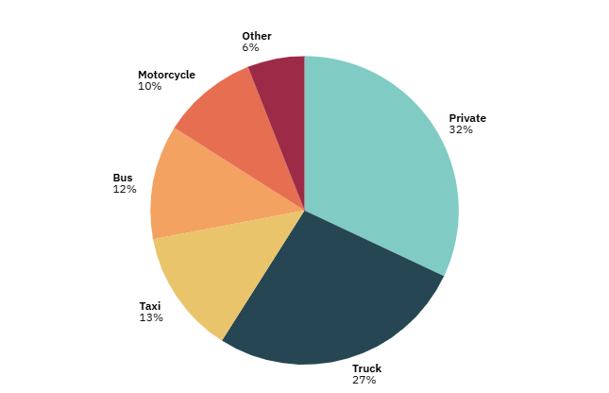
Figure 1: Percentage of crashes by vehicle type in Egypt

2.1.1 Technology Gap in Existing Heavy Truck Fleets
Industry evidence suggests that, despite the rapid expansion of the Egyptian commercial vehicle market, the majority of heavy trucks currently in operation are not equipped with modern active safety technologies such as Advanced Driver Assistance Systems (ADAS). The Egypt Trucks Market Report emphasizes strong growth in market value from USD 0.53 billion in 2024 to an estimated USD 1.51 billion by 2030, driven by infrastructure development and rising logistics demand. In parallel, the Egypt Fleet Management Industry is valued at approximately USD 210 million, reflecting the increasing digitalization of fleets driven by e-commerce growth, urbanization, and demand for cost-effective logistics operations, particularly in Cairo and Alexandria, the country’s primary transport hubs. However, the report does not indicate that ADAS or other advanced safety systems are widely integrated into standard heavy-truck configurations, implying that fleet modernization has prioritized capacity and transport efficiency rather than embedded vehicle safety intelligence.

This inference is reinforced by analyses of the Egyptian fleet management sector, which show that technological adoption has primarily focused on basic telematics and operational monitoring rather than proactive safety automation. The Egypt Fleet Management Industry Report highlights increasing use of GPS tracking and real-time monitoring, further strengthened by 2023 regulations mandating certified tracking devices for commercial vehicles, as well as a market structure in which the services segment (fleet tracking, maintenance, and fuel management) dominates, demonstrating a primary focus on operational efficiency rather than driver safety automation. Similarly, the Truck Auxiliary Braking Device Market Report indicates that even fundamental safety enhancements remain unevenly adopted and are largely limited to braking performance rather than comprehensive electronic safety or driver-support systems.

Collectively, these findings indicate that while digital monitoring technologies are becoming more common in Egyptian fleets, with an estimated 30% of fleets expected to adopt IoT and telematics solutions, these systems primarily support route optimization, fuel efficiency, and compliance rather than real-time driver safety assistance. Most heavy trucks, particularly in logistics, construction, and industrial sectors, therefore continue to operate without built-in ADAS or comparable advanced safety functionalities. This persistent technological gap underscores the necessity of affordable retrofit solutions such as the Udjat Track system that can provide real-time driver support, hazard detection, and proactive collision prevention for vehicles that lack integrated modern safety technology.

2.1.2 Comparison Between Udjat Track and OEM-Integrated ADAS
Advanced Driver Assistance Systems (ADAS) are widely recognized for improving road safety through technologies such as automatic emergency braking, adaptive cruise control, lane departure warnings, and blind-spot detection. The commercial vehicle ADAS market is projected to grow at approximately 13.6% CAGR between 2024 and 2029, reflecting increasing interest in automation and safety technologies for heavy vehicles.
However, despite this projected growth, several barriers limit the widespread adoption of ADAS in existing heavy truck fleets. A major constraint is the high cost of ADAS hardware, installation, and calibration, with full systems costing around USD 3,000 per vehicle. This makes adoption particularly difficult in price-sensitive and emerging markets, where fleet operators tend to prioritize basic operational needs over advanced safety technologies.
Beyond cost, technical and acceptance barriers further slow ADAS penetration. Many heavy trucks especially older models lack the necessary electronic architecture to support factory-level ADAS, making retrofitting complex and expensive. Additionally, some drivers and small fleet operators express concerns about system reliability, maintenance costs, and unclear direct benefits, which further discourages adoption. As a result, ADAS installation rates in commercial heavy vehicles remain relatively low (often reported below 20%), leaving a large proportion of fleets without advanced safety support.
These limitations are particularly relevant in contexts such as Egypt, where many heavy trucks are older models and fleet modernization has focused mainly on GPS tracking and basic telematics rather than advanced safety automation.
In contrast, Udjat Track is designed as a low-cost, retrofit-friendly alternative for heavy trucks that lack OEM ADAS. Using modular edge-based sensors such as IMU for crash detection, ultrasonic sensors for blind-spot and proximity warnings, and AI-based driver fatigue monitoring the system provides practical, real-time safety support without requiring deep vehicle integration or expensive proprietary hardware.
Unlike traditional ADAS, which primarily focuses on external vehicle environment monitoring and automated control, Udjat Track emphasizes driver state awareness, proximity hazard detection, and automated emergency response, directly targeting fatigue- and distraction-related risks that are highly relevant to long-haul truck operations. This makes it a feasible and effective safety solution for fleets where full ADAS adoption remains impractical.

2.2 Literature Survey: Causes of Heavy-Truck Accidents and Risk Factors

2.2.1 Driver Fatigue and Driving Duration
In the Egyptian context, the study “Factors Affecting Accident Risks among Truck Drivers in Egypt” (ICTTE) demonstrates a strong relationship between accident involvement and fatigue-related factors, particularly insufficient sleeping hours, extended continuous driving, and excessive total driving hours. The findings indicate that drivers who sleep less than six hours exhibit substantially higher accident involvement rates compared to those who obtain adequate rest. Similarly, accident occurrence increases progressively as continuous driving duration exceeds four hours and as total daily driving time extends beyond ten hours. These results confirm that fatigue accumulation, rather than isolated driving events, plays a decisive role in elevating crash risk among truck drivers.
Further evidence from the ICTTE study demonstrates that accident occurrence among drivers sleeping less than six hours increases significantly with longer driving durations. For drivers with insufficient sleep, accident involvement rises from 13% when continuous driving is less than four hours to 34% when it exceeds eight hours. A similar pattern is observed for total driving hours, where accident occurrence increases from 9% for drivers operating less than five hours to 41% for those driving more than fifteen hours. These findings indicate that fatigue risk is cumulative and strongly influenced by the interaction between sleep deprivation and prolonged driving exposure.

Table 1: Percentage Distribution of Accident-Involved Truck Drivers According to Sleep Duration, Continuous Driving Time, and Total Driving Hours
Sleeping Hours | Less than 6 hours | 7 - 8 hours. | More than 8 hours
Sleeping Hours | 59% | 36% | 5%
Continuous Driving | Less than 4 hours | From 4 to 6 hours | From 7 to 8 hours | More than 8 hours
Continuous Driving | 13% | 24% | 29% | 34%
Total Driving Hours | From 1 to 5 hours | From 6 to 10 hours | From 11 to 15 hours | More than 15 hours
Total Driving Hours | 9% | 21% | 28% | 41%

2.2.2 Aggressive and Risky Driving Behaviors
Aggressive and risky driving behaviors constitute another significant category of factors associated with accident involvement among truck drivers. The ICTTE study assessed such behaviors using frequency-based categories, not at all, sometimes, and often, to capture how frequently drivers engage in specific actions.

The results show that a considerable proportion of drivers reported sometimes or often engaging in aggressive behaviors. For example, 44.6% of drivers reported sometimes engaging in racing behavior, and 11.2% reported doing so often, while 44.2% reported not racing at all. Speeding behavior was reported sometimes by 42.9% of drivers and often by 16.4%, compared to 40.5% who indicated they did not speed.

Additional aggressive tendencies were also observed. Self-overconfidence was reported sometimes by 36.4% of drivers and often by 9.1%, while traffic violations were reported sometimes by 34.1% and often by 9.6%. Collectively, these findings indicate that aggressive driving behaviors are not isolated incidents but recurrent practices among a substantial subset of truck drivers, particularly when combined with fatigue and extended driving hours.

Table 2: Frequency Distribution of Aggressive Driving Behaviors among Accident-Involved Truck Drivers
Aggressive Driving | Variable | Not at all | Sometimes | Often
Aggressive Driving | Racing | 44.2% | 44.6% | 11.2%
Aggressive Driving | Speeding | 40.5% | 42.9% | 16.4%
Aggressive Driving | Self-Overconfidence | 54.5% | 36.4% | 9.1%
Aggressive Driving | Drug use traffic offense | 56.3% | 34.1% | 9.6%

2.3 Driver Survey Results: Safety Needs and Technology Acceptance
To complement the market analysis and literature survey, a small-scale driver survey was conducted involving 10 heavy-truck drivers operating in Egypt. The survey aimed to capture practical insights related to fatigue, safety risks, and acceptance of in-vehicle assistance technologies.

The results indicate that driver fatigue is common, with most participants reporting feeling fatigued while driving either sometimes or often. In addition, the majority of drivers expressed acceptance of in-cabin alerts for fatigue or loss of attention, indicating openness toward supportive safety systems. Audible alerts, either alone or combined with visual warnings, were preferred over visual-only alerts, suggesting the need for immediate and attention-grabbing feedback.

Drivers also reported frequent exposure to proximity and blind-spot risks, and most believed that proximity alerts would help reduce collision likelihood. In the event of an accident, respondents favored automated response mechanisms, such as automatic emergency notification and location sharing, over manual phone calls.

Overall, the survey findings support the inclusion of fatigue monitoring, proximity hazard detection, audible alert mechanisms, and automatic accident notification as core functionalities of the proposed system to match drivers' needs.

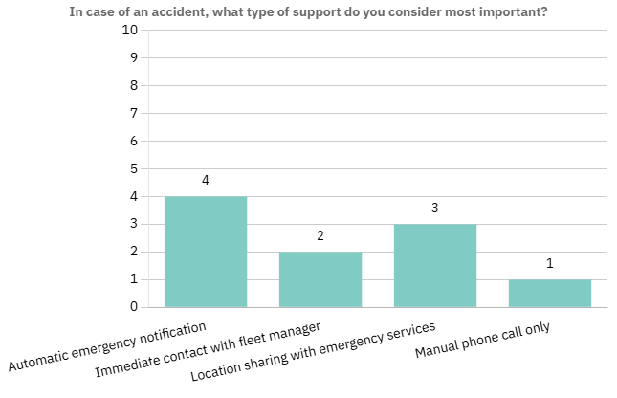
Figure 2: Driver Preferences for Accident Response and Support Mechanisms (n = 10)
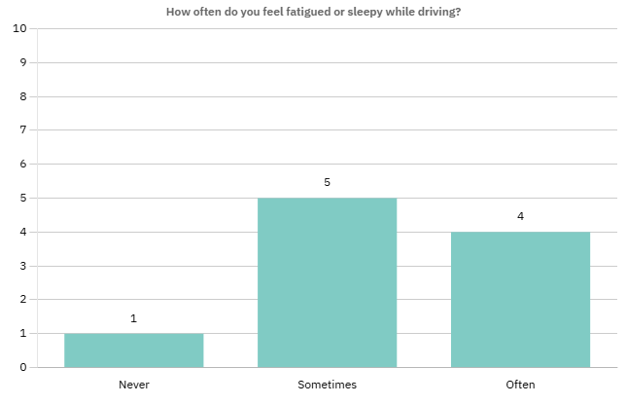
Figure 3: Frequency of Driver Fatigue While Driving (n = 10)

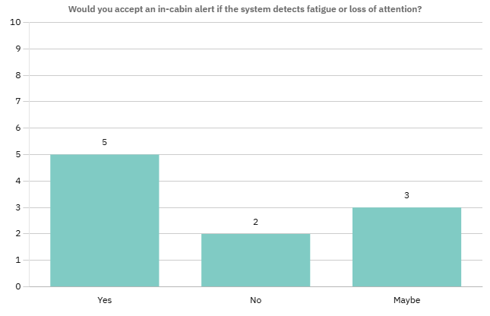

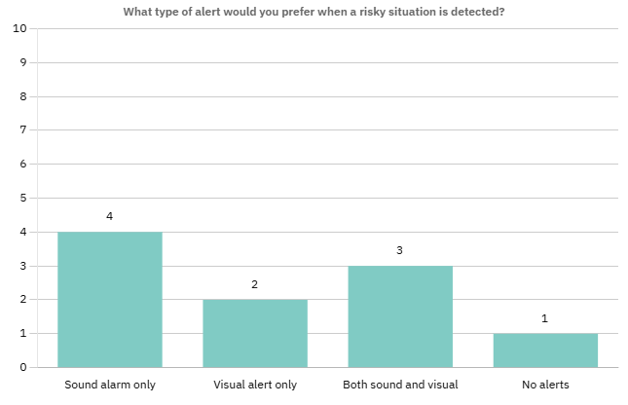
Figure 4: Driver Acceptance of In-Cabin Fatigue and Attention Alerts (n = 10)

Figure 5: Preferred Alert Modalities During Risky Driving Situations (n = 10)

2.4 Existing Solutions and Market Landscape
The increasing focus on road safety and fleet efficiency has led to the development of several commercial driver monitoring and fleet management solutions. These systems primarily aim to reduce accident risk, improve regulatory compliance, and enhance operational efficiency. A review of existing solutions highlights their core capabilities, underlying design approaches, and limitations, particularly with respect to cost, deployment flexibility, and suitability for older heavy transport vehicles.

2.4.1 Techurity: Driver Monitoring System (DMS)
Techurity provides an artificial intelligence–based driver monitoring system that utilizes in-cabin cameras to detect driver fatigue, distraction, and inattentive behavior. The system generates real-time alerts and uploads video streams and behavioral analytics to cloud-based dashboards accessible by fleet managers. While the solution demonstrates strong capabilities in driver state monitoring and regulatory compliance, it relies on proprietary hardware and continuous cloud connectivity, which may increase deployment cost and limit scalability for small or medium-sized fleets.

2.4.2 FMS Tech: Fleet Management Solutions
FMS Tech offers a comprehensive fleet management platform that integrates GPS tracking, driver behavior analysis, fuel management, and vehicle diagnostics. The system emphasizes operational efficiency through route optimization, performance reporting, and centralized cloud dashboards. Although the platform provides extensive fleet-level insights, it is primarily designed for logistics and operational monitoring rather than real-time safety intervention, and it depends on specialized onboard devices and subscription-based services.

2.4.3 Softec: Altari Fleet Management System
Softec’s Altari FMS is an enterprise-level fleet management solution targeting large-scale logistics and corporate fleets. The platform combines telematics data, predictive maintenance, and driver performance analytics to support compliance and operational decision-making. While Altari FMS is well-suited for high-volume commercial operations, its reliance on proprietary hardware, complex software modules, and enterprise-scale deployment models may limit its accessibility for smaller fleets or retrofitting older vehicles.

2.4.4 Udjat Track (Proposed System)
Udjat Track is proposed as a low-cost, sensor-based smart safety and monitoring system designed specifically for heavy transport vehicles. Unlike existing commercial solutions that rely heavily on proprietary hardware and cloud-centric processing, Udjat Track adopts an edge-processing approach using a Raspberry Pi and onboard sensors. The system detects risky conditions such as proximity hazards, driver fatigue indicators, and crash events locally, enabling faster response and reduced dependency on continuous network connectivity. Alerts and summarized data are transmitted to a backend system through a mobile application, allowing real-time awareness while maintaining affordability.

The system is intentionally designed to be retrofit-friendly, making it suitable for older trucks that lack built-in advanced driver assistance systems. By prioritizing safety-focused detection, local decision-making, and cost efficiency, Udjat Track addresses a gap in the current market between high-end enterprise fleet platforms and the practical needs of small to medium heavy-transport operators.

2.4.5 Functionality Comparison:
Table 3: Competitors' Functionalities Comparison Table
Feature / System Capability | Udjat Track (Proposed System) | Techurity DMS | FMS Tech | Softec Altari FMS
GPS Tracking | Yes (via mobile) | Yes | Yes | Yes
Trip Creation & Logs | Yes | Limited | Yes | Yes
Driver Drowsiness Detection | Via IMU behavior patterns | AI Camera-Based | No | No
Blind Spot / Proximity Detection | Ultrasonic Sensor | No | No | No
Crash Detection | IMU-based | Video-based | No | No
Driver Status Monitoring | Yes | Yes | Limited | Limited
Vehicle Motion Monitoring | Yes (IMU) | Camera Only | No | Basic
Real-Time Alerts to Mobile | Yes | Yes | Dashboard Only | Dashboard Only
Edge Processing (on-device) | Yes | Partial | No | No
Works on Old Trucks (Retrofit) | Designed for old vehicles | Needs installation | Needs CAN bus | Needs vehicle interface
Proprietary Hardware Required | No | Yes | Yes | Yes
Uses Open Components | Raspberry Pi & Sensors | Closed system | Closed system | Closed system
Installation Complexity | Simple | Medium | Complex | Complex
Maintenance Cost | Very Low | High | High | High
Cloud Dependency | Only for storage & dashboards | Heavy | Heavy | Heavy
Focus on Safety Events | Core Feature | Camera Events | Limited | Limited
FleetManagement Tools | Basic | Limited | Advanced | Advanced

Udjat Track Analysis

3.1 Main Problem
Heavy transport vehicles pose a critical road safety challenge due to their disproportionate involvement in severe traffic accidents and the structural risks associated with their operation. The large mass and dimensions of trucks increase stopping distances and collision energy, leading to higher crash severity and greater harm to both truck drivers and other road users.

Statistical analyses indicate that truck traffic contributes significantly to overall accident occurrence and represents a strong predictor of accident frequency, with a greater impact than passenger vehicles. In addition, truck operations are commonly characterized by extended driving hours, limited rest opportunities, and high occupational pressure, which increase exposure to fatigue, distraction, and risky driving behaviors.

Despite these elevated risks, many heavy transport vehicles, particularly older fleets, lack integrated safety systems capable of monitoring driver condition, detecting proximity hazards, or providing automatic accident response. Existing solutions are often costly or oriented toward fleet management rather than real-time safety intervention.

Accordingly, the main problem addressed in this project is the lack of an affordable, real-time safety monitoring and intervention system tailored to heavy transport vehicles, capable of reducing accident risk through early detection, timely alerts, and automated response mechanisms.

3.2 Stakeholders and Responsibilities

3.2.1 Primary System Users
3.2.1.1 Driver
Stakeholder | Driver
Role | Primary end-user of the mobile application and in-vehicle IoT system
Responsibilities | - Start and end trips  - View trip logs and trip progress  - View maps and nearby facilities (hospitals, gas stations, maintenance centers)  - Respond to real-time fatigue, drowsiness, and blind-spot alerts  - View blind-spot warnings generated by the IoT sensor system  - Report internal maintenance issues  - Initiate SOS requests when required

3.2.1.2 Fleet Manager
Stakeholder | Fleet Manager
Role | Primary user of the web-based dashboard
Responsibilities | - Register, update, and delete driver accounts  - Add, update, and delete vehicles  - Assign drivers and vehicles to trips  - Create and monitor trips  - Track real-time driver and vehicle status  - View system alerts and safety notifications  - Monitor trip progress and driver behavior

3.2.2 Business and Commercial Stakeholders
3.2.2.1 Heavy Transport Companies
Stakeholder | Heavy Transport Companies
Role | System owners and operational beneficiaries
Objectives | - Reduce accident rates and vehicle downtime  - Improve driver safety and compliance  - Protect cargo and fleet assets  - Enhance operational efficiency

3.2.2.2 Insurance Companies
Stakeholder | Insurance Companies
Role | Risk assessment and financial coverage entities
Objectives | - Analyze trip and safety logs  - Assess fleet risk levels  - Offer reduced premiums to compliant fleets

3.3 Functional requirements

3.3.1 Authentication and User Management
FR-01: Super Manager Authentication
The system shall allow the Super Manager to log in and manage the startup account.
FR-02: Fleet Manager Signup and Validation
The system shall allow fleet managers to sign up, select a subscription plan, and submit required validation criteria (e.g., business license, fleet size). Super Manager approval shall be required before login.
FR-03: Fleet Manager Login
The system shall allow validated fleet managers to securely log in with role-based access.
FR-04: Driver Account Creation and Assignment
Fleet Managers shall be able to register drivers, assign them to specific vehicles and trips, and manage their access.
FR-05: Driver Authentication
Drivers shall log in to the mobile application using credentials created by their fleet manager. The system shall enforce role-based access control

3.3.2 Trip Operations
FR-06: Trip Creation
Fleet managers shall be responsible for adding trips by specifying essential details such as the scheduled start and end time, starting location and destination, and by adding the assigned vehicle and a qualified driver to each trip.
FR-07: Trip Lifecycle Management
Drivers shall start, and end trips. Trips shall log start/end times, routes, duration, and break periods.
FR-08: Local Trip History Access
Drivers shall view trip history and logs locally.
FR-09: Trip Event Logging
The system shall record all operational and behavioral events during trips for real-time monitoring and future analysis.

3.3.3 Driver Monitoring and Fatigue Detection

FR-10: Facial Video Acquisition
Continuous capture of driver facial video via in-vehicle camera.
FR-11: Face Detection and Tracking
Real-time detection and tracking of driver faces.
FR-12: Driver State Classification
Classify drivers as Alert, Drowsy, High-Risk, or Unconscious based on combined biometric and temporal data.

3.3.4 Safety Alerts
FR-13: Real-Time Safety Alerts
Audio and visual alerts for unsafe driving conditions.
FR-14: Break Recommendation
Notifications when fatigue thresholds are exceeded.

3.3.5 Incident Reporting and Emergency Handling
FR-15: Manual Internal Issues Reporting
Drivers report internal vehicle issues. Reports forwarded to fleet managers in real-time.
FR-16: Manual SOS Alert
Drivers can send SOS manually if conscious. SOS includes real-time location and driver state sent to fleet managers.
FR-17: Automatic SOS Alert
Automatic SOS is sent in case the driver is unconscious, which includes real-time location and driver state sent to fleet managers, and fleet manager calls SOS.
FR-18: Crash Detection
Detect crash-level impacts.
FR-19: Driver Responsiveness Verification
The countdown timer verifies responsiveness after unconsciousness or crash detection.
FR-20: Emergency Stakeholder Notification
The fleet manager is notified in real time.

3.3.6 Proximity and Collision Warning

FR-21: Blind-Spot Detection
Side ultrasonic sensors detect nearby obstacles.
FR-22: Forward Distance Measurement
Detect obstacles in front using forward sensors.
FR-23: Collision Warning Delivery
Generate warnings in mobile apps when risk is detected.

3.3.7 Navigation and Location-Based Services
FR-24: Interactive Map Visualization
Drivers and fleet managers can view live maps, vehicle location, nearby hospitals, gas stations, and maintenance centers
FR-25: External Map API Integration
The system shall retrieve live map data, and location info from external APIs (e.g., Google Maps).

3.3.8 Fleet Management
FR-26: Real-Time Fleet Monitoring
Fleet managers view real-time vehicle location and driver state.
FR-27: Live Event Feed
Fleet managers receive alerts for accidents, fatigue, and SOS.
FR-28: Remote Trip Termination
Fleet managers can terminate trips remotely during emergencies.
FR-29: Predictive Maintenance
Monitor vehicle usage and notify managers when thresholds are reached.
FR-30: Report Generation
Generate safety, compliance, and trip reports.

3.3.9 System and Edge Operations
FR-31: Edge-Based AI Inference
Real-time processing on vehicle edge units.
FR-32: Sensor Data Acquisition and Transmission
Collect GPS, IMU, and ultrasonic sensor data at specified frequencies.
FR-33: Network Failover and Offline Data Storage
Maintain local data integrity during network outages; synchronize with cloud when connectivity is restored.

3.4 Non-Functional Requirements

3.4.1 Performance
NFR-01: Low-Latency Monitoring: Notifications delivered <500 ms.

3.4.2 Reliability and Availability
NFR-02: Mobile App Reliability: Run continuously as a foreground service.
NFR-03: Fault Tolerance: Local storage during outages

3.4.3 Security
NFR-04: Role-Based Access Control: Super Manager, Fleet Manager, Driver.

3.4.4 Scalability
NFR-06: Dynamic Cloud Resource Scaling: The system shall dynamically allocate cloud resources to ensure that the average API response time remains below 1 second, and does not exceed 3 seconds under peak load conditions.

3.4.5 Usability
NFR-07: Mobile UI: Distraction-free, high-contrast/night mode.
NFR-08: Dashboard UI: Intuitive fleet monitoring and alerts.
NFR-09: Alert Comprehensibility: Immediate understanding and actionability.

3.4.6 Accuracy and Robustness
NFR-10: Sensor/Edge Robustness: Vibration, temperature, humidity tolerance.

3.4.7 Maintainability
NFR-11: Modular Architecture: Independent upgrade/replacement of subsystems.
NFR-12: Logging and Diagnostics: Error and event logs accessible for troubleshooting.

3.4.8 Compliance
NFR-13: Regulatory Compliance: Automotive safety and transport regulations.
NFR-14: Communication Standards: Wi-Fi (IEEE 802.11) and cellular standards.

3.5 System Scenarios
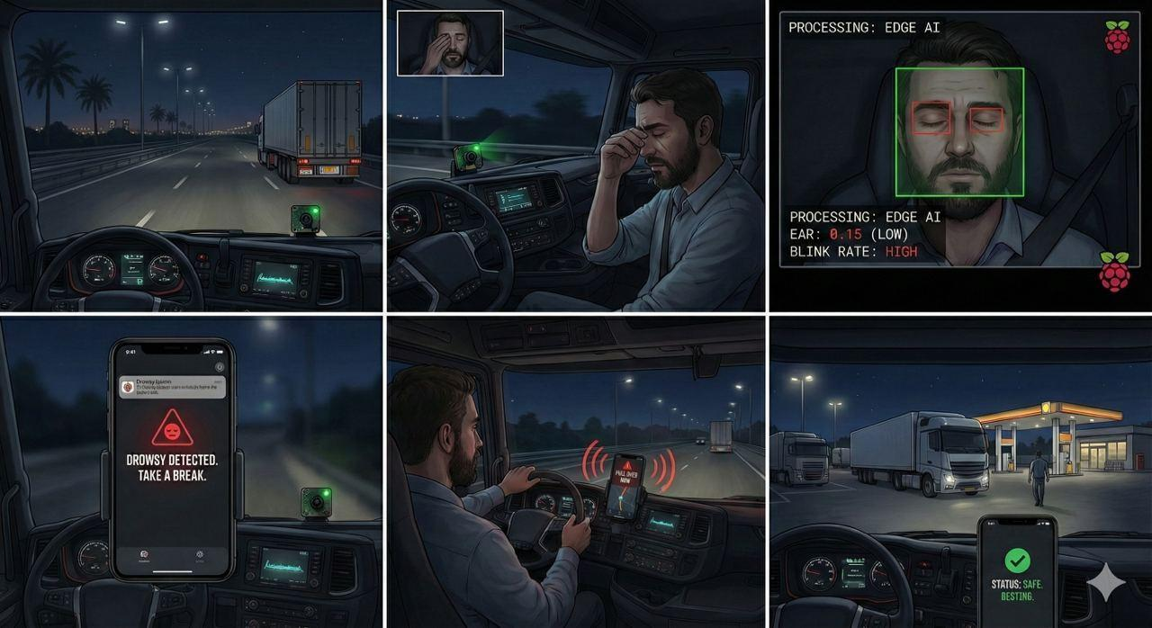
Figure 6: AI-Based Driver Fatigue Detection and Accident Prevention Using Raspberry Pi Camera
Description:
This figure presents an AI-based driver fatigue detection system operating inside a long-haul cargo truck during night driving. A Raspberry Pi camera mounted on the dashboard continuously captures the driver’s face and processes eye-closure and blink metrics locally using edge AI techniques. When fatigue indicators exceed safe thresholds, the system classifies the driver as drowsy and sends the status to a smartphone fixed on the dashboard. The mobile application displays “Drowsy Detected” and triggers an audio alert to warn the driver without requiring manual interaction. The driver then pulls over to rest, after which normal eye behavior is detected and the system status returns to “Safe,” demonstrating effective early intervention and accident prevention.

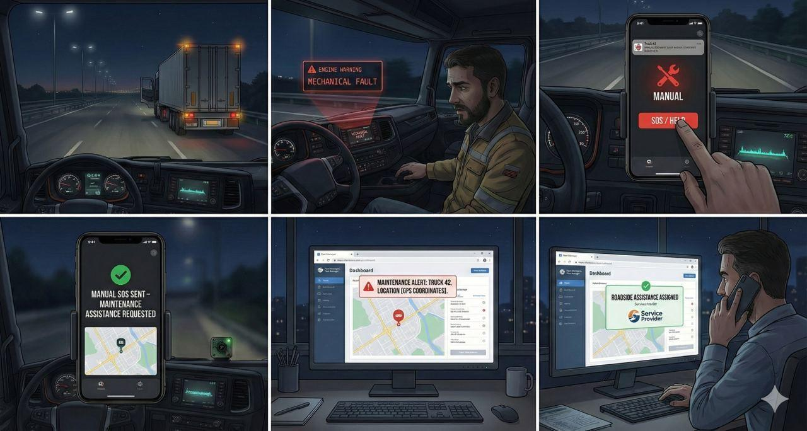
Figure 7: Manual SOS–Based Vehicle Breakdown and Maintenance Assistance Workflow
Description:
This figure illustrates the operation of the manual SOS feature for handling non-medical vehicle breakdowns during highway transport. When a heavy truck experiences a mechanical or maintenance issue, such as an engine warning or tire problem, the driver safely pulls over to the roadside and activates hazard lights. Using a smartphone securely mounted inside the cabin, the driver manually triggers the “SOS / Help” function within the mobile application. The system confirms that a maintenance assistance request has been sent. The alert is received on the fleet manager’s web dashboard, where the truck’s real-time GPS location is clearly displayed on a map interface. The fleet manager then assigns appropriate roadside assistance or maintenance support, enabling fast coordination and minimizing trip disruption through direct, non-emergency communication.

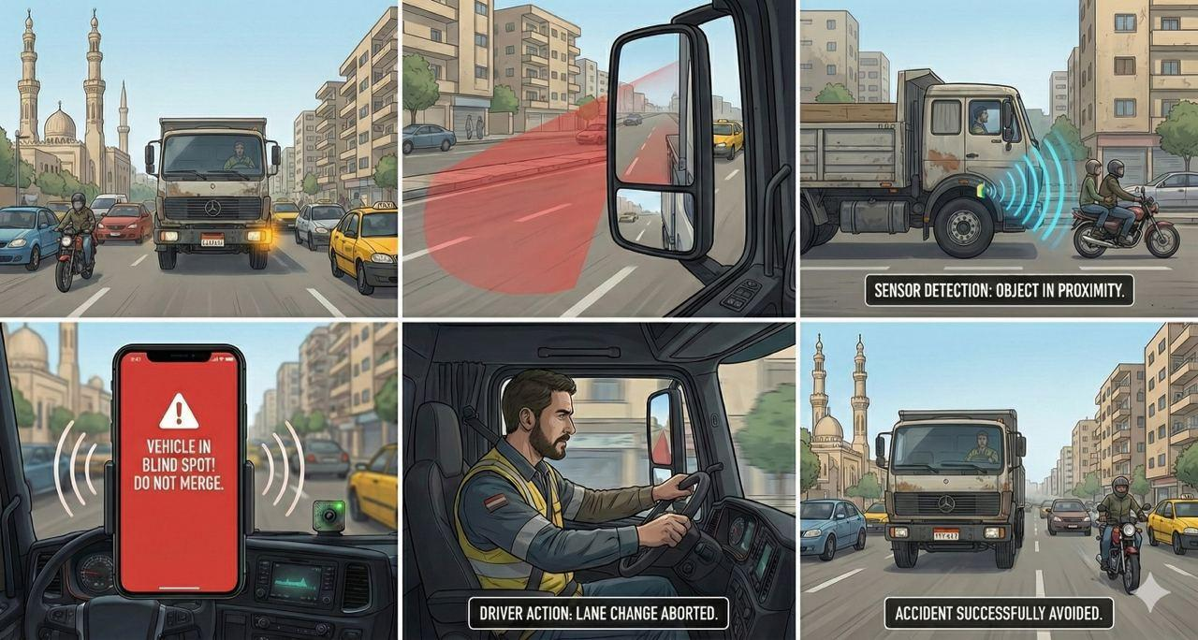
Figure 8: Blind-Spot Monitoring System for Heavy Trucks in Urban Traffic
Description:
This figure illustrates the operation of a blind-spot monitoring system for a heavy transport truck navigating busy urban streets in Cairo. As the truck prepares to change lanes, surrounding traffic includes nearby cars and motorcycles, one of which is positioned within the truck’s blind spot and not visible through mirrors. Ultrasonic sensors mounted on the vehicle continuously measure the distance to nearby objects and detect the presence of the hidden motorcycle. The processed proximity data is sent to a smartphone securely mounted on the dashboard, where the mobile application displays a warning message, “Vehicle in blind spot,” accompanied by an audible alert. The driver responds by stopping the lane change maneuver, allowing the motorcycle to pass safely. The system successfully prevents a potential collision, demonstrating how blind-spot detection enhances urban driving safety and reduces the risk of serious injuries and fatalities.
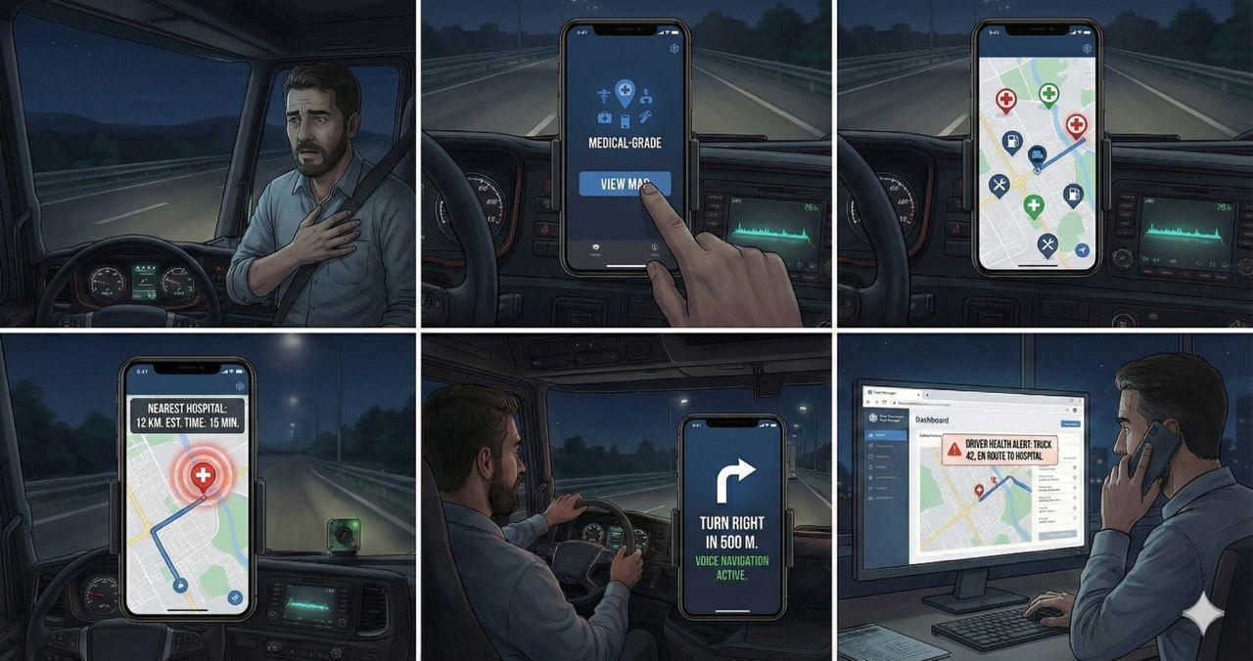
Figure 9: Map-Based Medical and Safety Assistance Navigation for Long-Haul Drivers
Description:
This figure presents a map-based assistance feature designed to support truck drivers in locating nearby medical and safety services during remote highway travel in Egypt. When the driver experiences discomfort while driving, a smartphone securely mounted on the dashboard is used to access the “View Map” function within the mobile application. The system displays a live GPS map showing the truck’s real-time location along with clearly marked nearby hospitals, emergency medical centers, gas stations, and vehicle maintenance facilities. The nearest suitable medical facility is automatically highlighted, with distance, estimated travel time, and a recommended safe route provided. Turn-by-turn voice navigation guides the driver without requiring visual interaction. Simultaneously, the fleet manager monitors the same live map and driver status through the web dashboard. The workflow concludes with the truck arriving safely at the selected facility and the system confirming arrival and safety status, demonstrating effective location-based assistance and coordinated response.

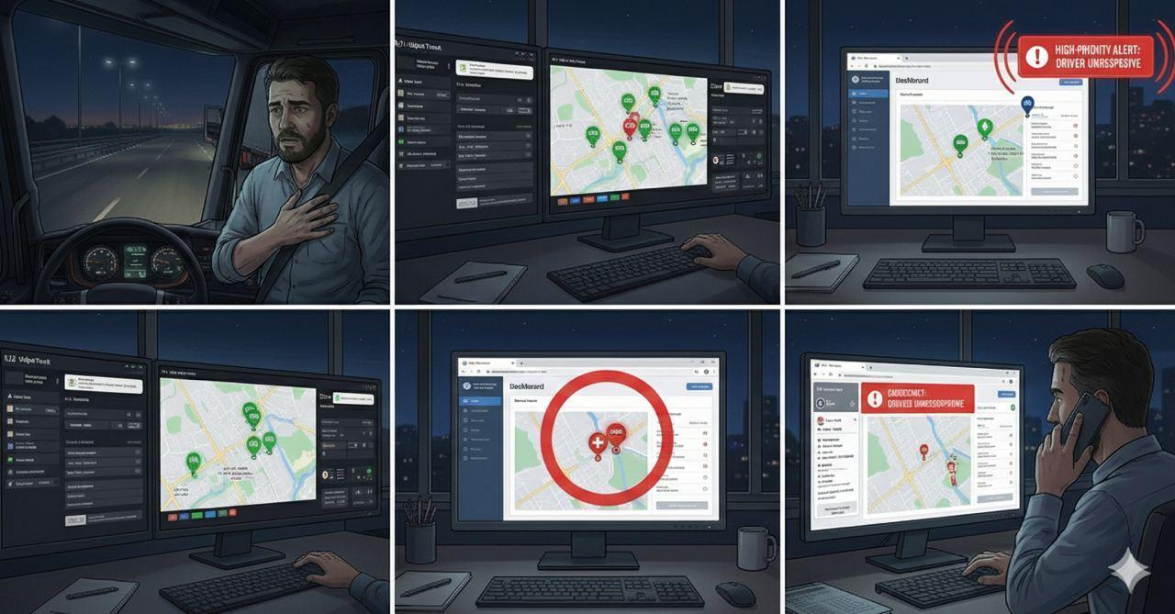
Figure 10: Trip-Based Emergency Escalation and Fleet Manager Notification
Description:
This figure illustrates an automated emergency escalation mechanism based on real-time trip monitoring from the fleet manager’s perspective. During an active transport operation, the Udjat Track web dashboard displays multiple trucks moving along their planned routes on a live map. When abnormal behavior is detected for one vehicle, such as prolonged inactivity or sudden loss of driver response, the corresponding truck indicator changes to a high-priority alert state. The fleet manager is immediately notified through the dashboard interface and can access detailed trip information by selecting the alert. The system presents critical data, including the last recorded movement time, an abrupt speed drop to zero, and the exact GPS location of the truck. A clear status message indicates that the driver is unresponsive and requires action, enabling rapid situational awareness and timely decision-making without direct driver input.
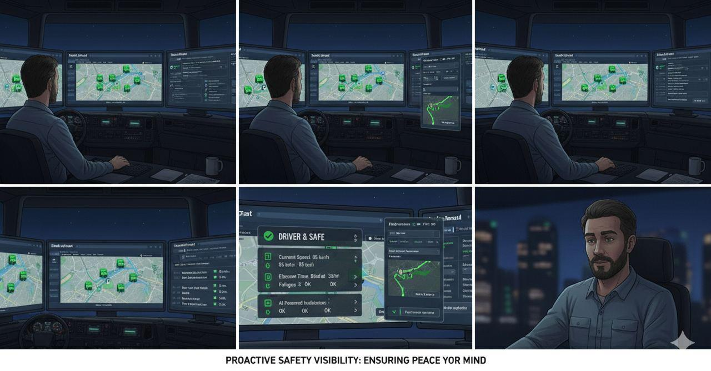
Figure 11: Baseline Fleet Trip Monitoring and Safety Awareness
Description:
This figure illustrates normal fleet operations under continuous AI-powered trip monitoring from the fleet manager’s perspective. The web-based Udjat Track dashboard presents an overview of multiple active trucks traveling across Egyptian highways, each displayed with a safe operational status. Selecting a vehicle reveals real-time trip information, including route progress, speed, and destination, which updates smoothly without interruption. Driver condition and system indicators remain within normal ranges, with no warnings or escalations triggered. The interface emphasizes clarity and stability, demonstrating how continuous monitoring provides transparency, operational awareness, and confidence during routine transport activities

3.6 System Modeling

3.6.1 Use Case Diagram
The Use Case Diagram (Figure 12) illustrates the relationships between the actors and the primary system functionalities
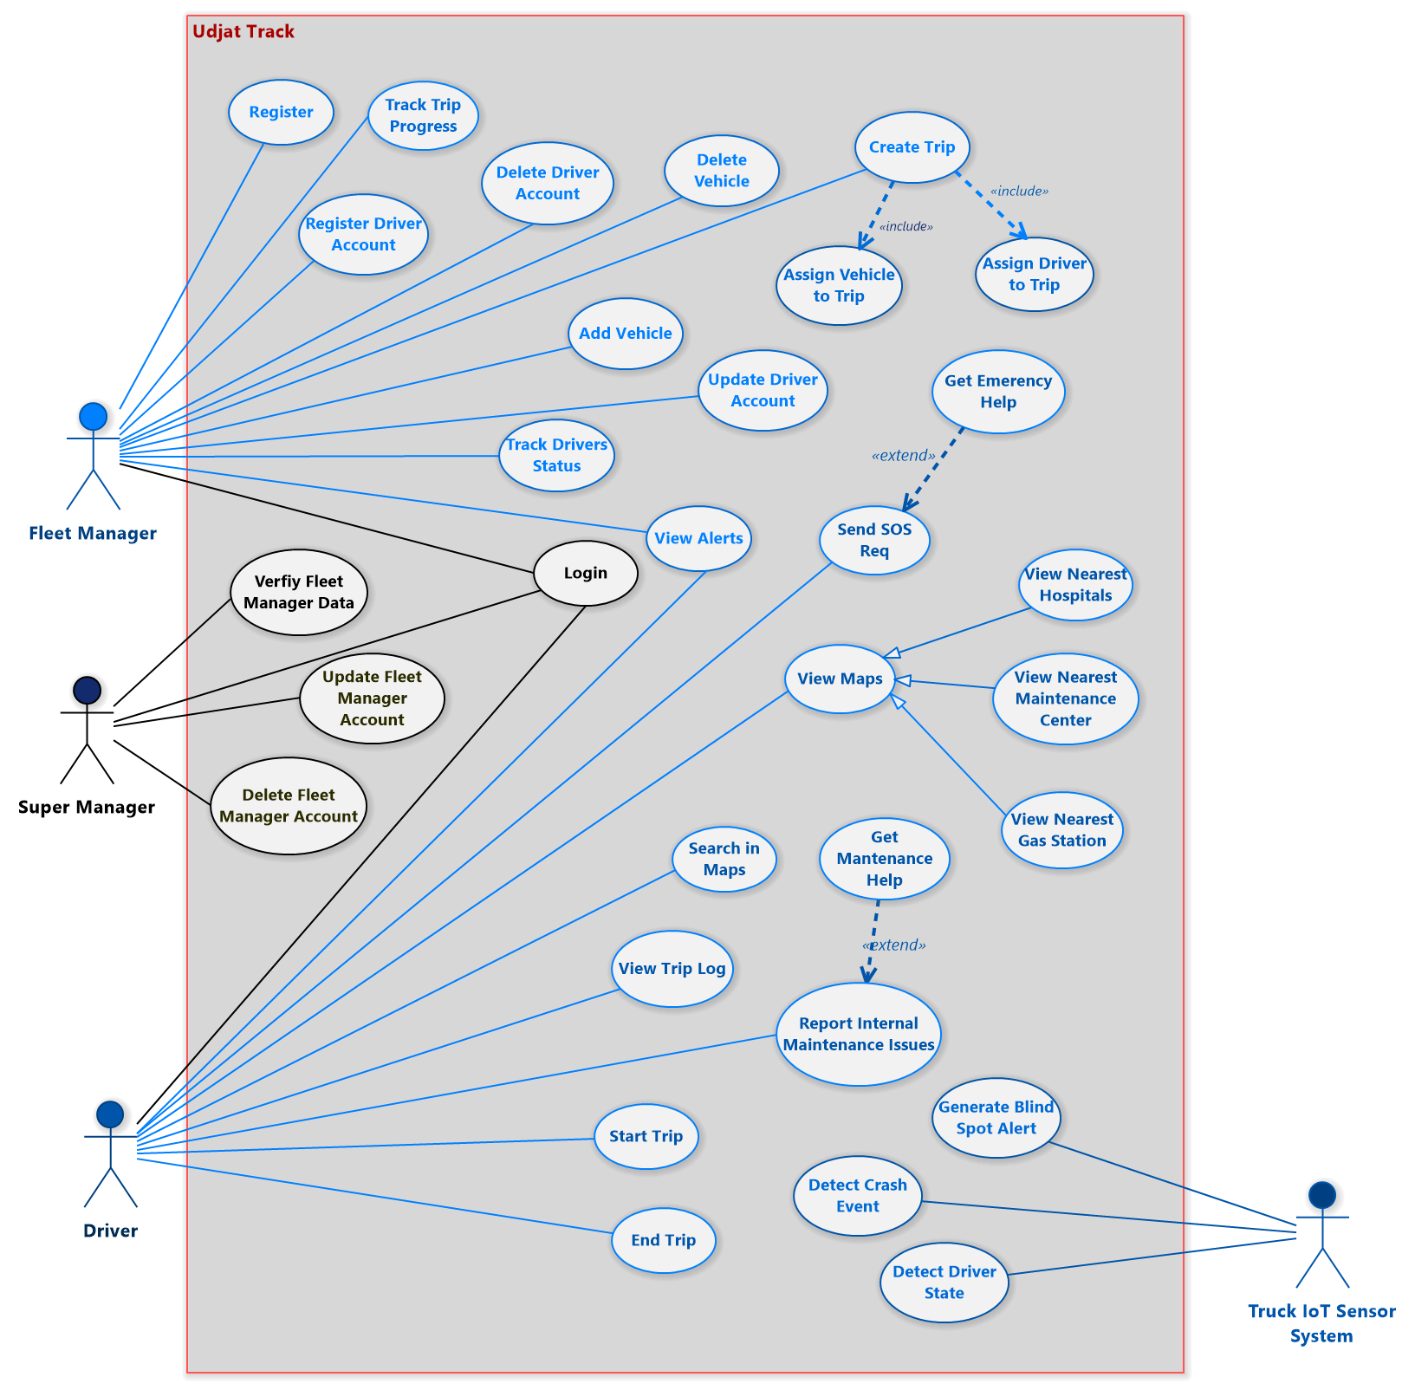
Figure 12: Udjat Track Use Case Diagram

3.6.2 Use Case Tables
Table 4: Report Internal Maintenance Issues Use Case Table
Use Case ID | UC-01
Use Case Name | Report Internal Maintenance Issues
Primary Actor | Driver
Secondary Actor | Maintenance Center
Included Use Cases | Send Help
Description | It describes how an internal maintenance issue, such as engine warning, brake issue, abnormal vibration, or system malfunction, is reported by the driver and handled by the system to be delivered to the Maintenance Center, including logging, notification, and follow-up actions by fleet management.
PreConditions | The driver is authenticated in the mobile application.  The vehicle is assigned to the driver.
Trigger | The driver notices a warning indicating a maintenance issue.
Main Flow | User Action | System Action
Main Flow | 1- The driver opens the Mobile Application and selects “Report Maintenance Issue.”
Main Flow |  | 2- The system displays a maintenance reporting form including issue category, severity level, and optional description.
Main Flow | 3- The driver fills in the form’s fields and submits it.
Main Flow |  | 4- The system packages the maintenance report payload and transmits it securely to the maintenance center.
Alternative Flows | If the network signal is not stable, the Mobile Application stores the maintenance report locally and will be transmitted automatically once connectivity is restored.
PostConditions | The maintenance center is notified of the issue and the driver’s current location.  The fleet manager is notified.  The trip status is updated to Paused or Cancelled, depending on the severity of the maintenance issue.
Non-Functional Notes | Reliability: Maintenance issue reports shall not be lost due to application crashes or temporary network failures.  Availability: The maintenance reporting functionality shall be available 24/7, independent of trip status.

Table 5: View Alerts Use Case Table
Use Case ID: | UC-02
Use Case Name: | View Alerts
Actors: | Driver
Pre-conditions: | - Driver is authorized and assigned  - A trip is active  - Mobile application is connected to the Truck IoT Sensor System
Post-conditions: | - Alert is displayed to the driver.  - Alert is logged with timestamp and type.  - Driver acknowledgement is recorded.
Flow of events: | User Action | System Action
Flow of events: | - Driver is driving during an active trip.
Flow of events: |  | - System continuously monitors safety signals
Flow of events: |  | - System detects a condition that requires warning and generates an alert event.
Flow of events: |  | - System presents the alert (Visual & Sound).
Flow of events: | - Driver sees/hears the alert notification.
Flow of events: | - Driver acknowledges the alert.
Flow of events: |  | - System records acknowledgement and keeps the alert in the trip log for reporting.
Exception: | User Action | System Action
Exception: | 1.a.1 Driver continues driving.
Exception: |  | 1.a.2 System detects a general failure in the alert generation module on the Raspberry Pi
Exception: |  | 1.a.3 System disables real-time alerting functionality and displays: “Alert system temporarily unavailable.”
Exception: |  | 1.a.4 System logs the failure event with timestamp and error type for maintenance review.
Exception: |  | 1.a.5 System attempts periodic recovery in the background while the driver continues the trip.

Table 6: Add Trip Use Case Table
Use Case ID: | UC-03
Use Case Name: | Add Trip
Actors: | - Fleet Manager
Pre-conditions: | 1. Fleet Manager is authenticated and logged into the system.  2. Drivers are already registered.  3. Vehicles already added in the system
Post-conditions: | - A new Trip and corresponding assignments are created and stored, and the trip becomes visible to the assigned driver.
Flow of events: | User Action | System Action
Flow of events: | - Selects the Create Trip function on the Web Dashboard
Flow of events: |  | - Displays the trip creation form and requests a list of available (idle) drivers and vehicles from the Backend
Flow of events: | - Enters trip details, including source, destination, and expected start/end times
Flow of events: |  | - Validates the input format and maintains the list of active, verified drivers and vehicles
Flow of events: | - Selects a specific Vehicle and a qualified Driver to be assigned to the trip
Flow of events: |  | - Checks the AssignmentStatus of the selected entities in the Database to ensure no concurrent active trips exist
Flow of events: | 7. Submits the completed trip creation request
Flow of events: |  | 8. The system validates driver-vehicle compatibility and availability, and a unique ID is created for the trip.
Alternative Flows | Incomplete Data: If the Fleet Manager leaves required fields (like destination) blank, the System prevents submission and highlights the missing fields on the Web Dashboard  Network Failure: If the connection between the dashboard and the cloud is lost during submission, the Web Dashboard notifies the User that the trip could not be saved and suggests retrying when connectivity is restored.
Postconditions | A new Trip and corresponding assignments are created and stored, and the trip becomes visible to the assigned driver.
Non-Functional Notes | Scalability: The backend must be capable of managing at least 1,000 active vehicles and 100 fleet managers simultaneously without performance degradation during the trip creation process.

Table 7: Send SOS Alert Use Case Table

Use Case ID | UC-04
Use Case Name | Send SOS Alert
Primary Actor | Driver
Secondary Actor | Fleet Manager, Emergency Services
Extended Use Cases | Send Emergency Help
Description | This case describes how the system allows a driver to send an emergency SOS alert either manually or automatically. The alert shares the driver’s real-time location, vehicle details, and current driver status with the Fleet Manager and Emergency Services to ensure rapid response during critical situations
PreConditions | 1- Driver is logged into the mobile application  2- Active trip is in progress  3- GPS and network connectivity are available  4-Emergency contact information is configured in the system
Trigger | 1- Driver manually presses the SOS button  2- System detects unconscious driver state  3- IMU sensors detect crash-level impact
Main Flow | User Action | System Action
Main Flow | 1- Detects an emergency requiring assistance
Main Flow | 2- Presses the SOS button in the mobile application
Main Flow |  | 3- Captures current GPS coordinates and driver status
Main Flow | 4- Displays a confirmation dialog to prevent accidental triggers
Main Flow | 5- Confirms the SOS request
Main Flow |  | 6- Compiles alert package including:  • Driver identification  • Vehicle identification  • Real-time GPS location  • Current driver state (Alert/Drowsy/High-Risk)  • Timestamp  • Trip details
 |  | 7- Transmits alert to Fleet Manager's dashboard
 |  | 8- Transmits alert to Emergency Services
 |  | 9- Displays confirmation message to driver
 |  | 10- Continues to share live location updates until help arrives
Alternative Flows | 1- IMU sensors detect crash-level impact  2- System initiates countdown timer for driver responsiveness  3- System displays visual alert and plays audio warning  4a-. If driver responds: Cancel automatic SOS, log crash event 4b- If driver does not respond:  • System automatically triggers SOS alert  • Mark alert as "Crash-related".
PostConditions | 1-SOS alert is successfully transmitted to the Fleet Manager and Emergency Services  2- The driver's real-time location and status are shared  3- Alert is logged in the system for audit purposes  4- Fleet Manager receives notification on the Web Dashboard
Non-Functional Notes | This use case implements FR-18 (Manual SOS) and FR-19 (Automatic SOS) SOS alerts must be transmitted with minimal latency Location and alert data must be securely transmitted and logged.

Table 8: Generate Blind-Spot Alert Use Case Table
Use Case ID: | UC-05
Use Case Name: | Generate Blind-Spot Alert
Actors: | Truck IoT Sensor System
Pre-conditions: | - Ultrasonic sensors are powered and initialized.  - Communication link to the Raspberry Pi/mobile app is available
Post-conditions: | - A blind-spot alert event is generated and sent to the local application.  - The alert event is logged locally.
Flow of events: | Actor Action | System Action
Flow of events: | - Samples ultrasonic distance readings at a fixed interval.
Flow of events: | - Provides distance measurement (cm) for each blind-spot sensor.
Flow of events: |  | - Compares distance values to the blind-spot threshold.
Flow of events: |  | - If the distance is below the threshold, it creates a Blind-Spot Alert event.
Flow of events: |  | - Displays an alert to the driver (sound/visual)
Exception: | Actor Action | System Action
Exception: | 1.a.1 Sensor fails self-test or stops responding.
Exception: |  | 1.a.2 System marks blind-spot monitoring as unavailable and shows: “Blind-spot monitoring unavailable.”
Exception: |  | 1.a.3 Logs failure and continues monitoring other available sensors

Table 9: Detect Crash Event Use Case Table
Use Case ID: | UC-06
Use Case Name: | Detect Crash Event
Actors: | Truck IoT Sensor System
Pre-conditions: | - IMU is powered, calibrated, and sampling.  - Local system clock is available for event timestamping.
Post-conditions: | - Crash event is generated.  - Crash event is delivered to the local alert module and stored for backend sync.
Flow of events: | Actor Action | System Action
Flow of events: | - Continuously samples IMU acceleration and gyroscope values.
Flow of events: | - Provides an updated IMU reading stream.
Flow of events: |  | - gyroscope values. Receives IMU readings and computes magnitude features.
Flow of events: |  | - Compares computed magnitudes against crash thresholds.
Flow of events: |  | - If thresholds are exceeded, it confirms the crash condition and creates a Crash Event.
Flow of events: |  | - Triggers emergency workflow and logs the event.
Exception: | Actor Action | System Action
Exception: | 1.a.1 IMU stops responding or fails self-test.
Exception: |  | 1.a.2 System disables crash detection and displays: “Crash detection unavailable.”
Exception: |  | 1.a.3 Logs failure and attempts background reinitialization.

Table 10: Detect Driver State Use Case Table
Use Case ID: | UC-7
Use Case Name: | Detect Driver State
Actors: | Truck IoT Sensor System
Pre-conditions: | - The in-cabin camera feed is available and functioning properly.
Post-conditions: | - Driver-state event is generated.  - Alert is generated if the state is risky and logged for reporting.
Flow of events: | Actor Action | System Action
Flow of events: | - Captures driver-state input stream
Flow of events: | - Provides continuous driver-state signals.
Flow of events: |  | - If a risky state is detected, it generates a Driver State Alert.
Flow of events: |  | - If thresholds are exceeded, it confirms the crash condition and creates a Crash Event.
Flow of events: |  | - Notifies the driver (sound/visual) and logs the event.
Exception: | Actor Action | System Action
Exception: | 1.a.1 Detection component fails unexpectedly.
Exception: |  | 1.a.2 System restarts the module in the background, logs the error, and temporarily disables driver-state alerts.

3.6.3 Class Diagram
3.6.3.1 Backend Class Diagram
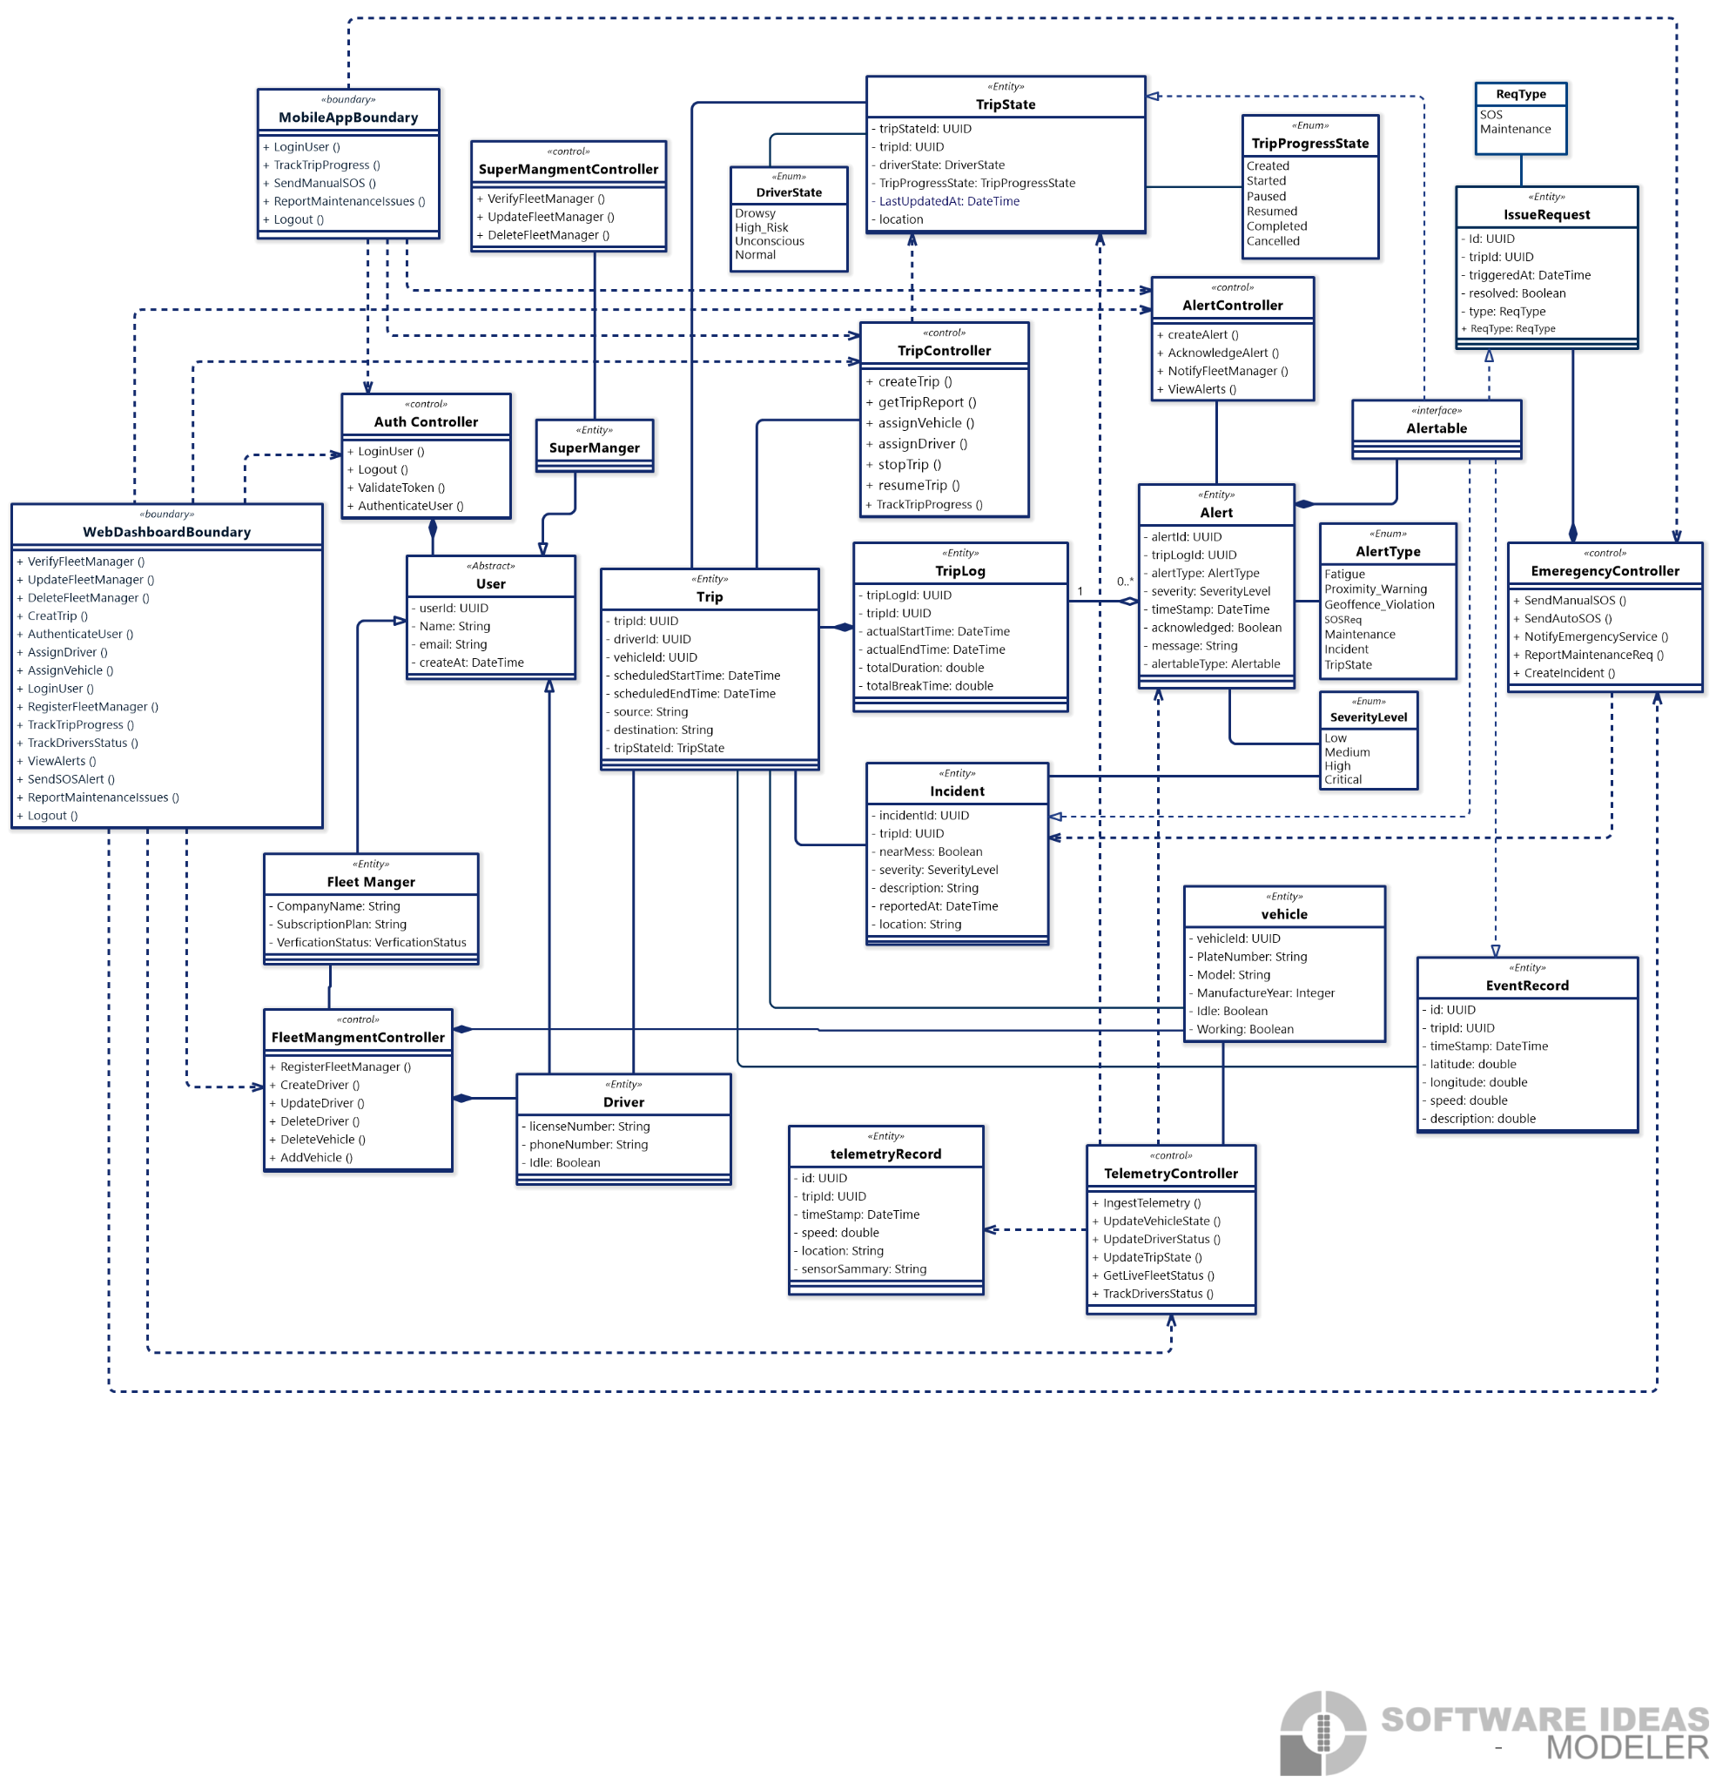
Figure 13: Udjat Track Backend Class Diagram.
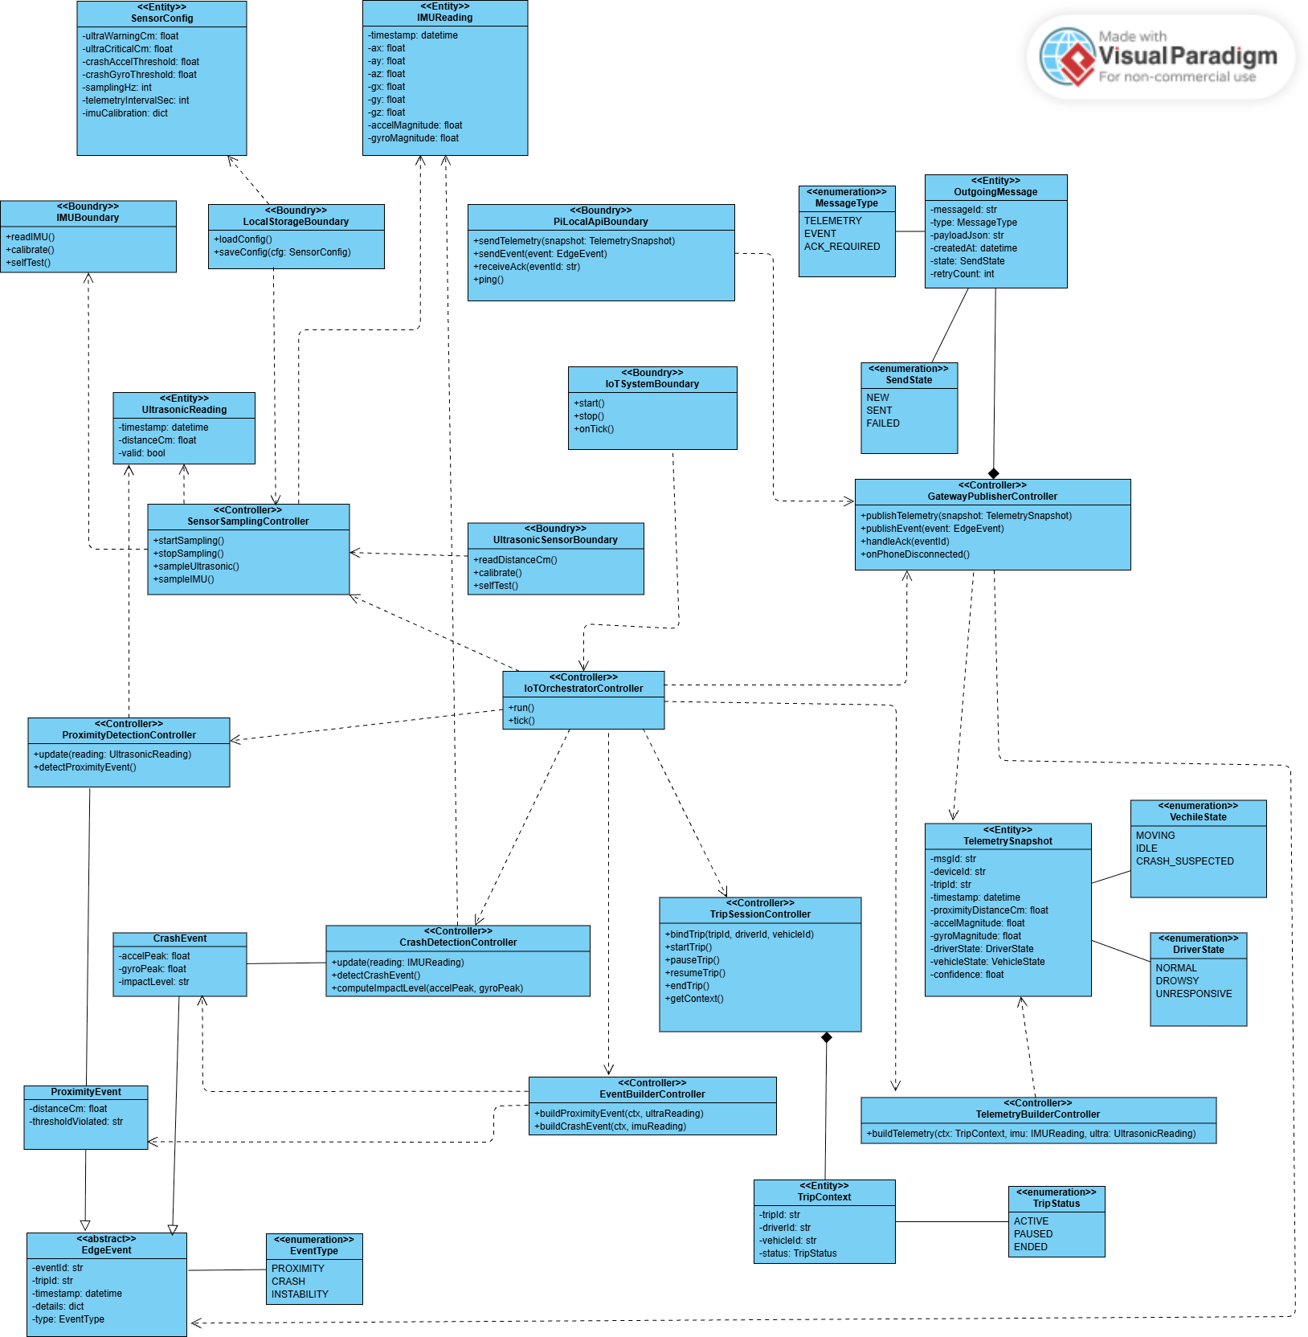
3.6.3.2 Iot Class Diagram

Figure 14: Udjat Track IoT Class Diagram.
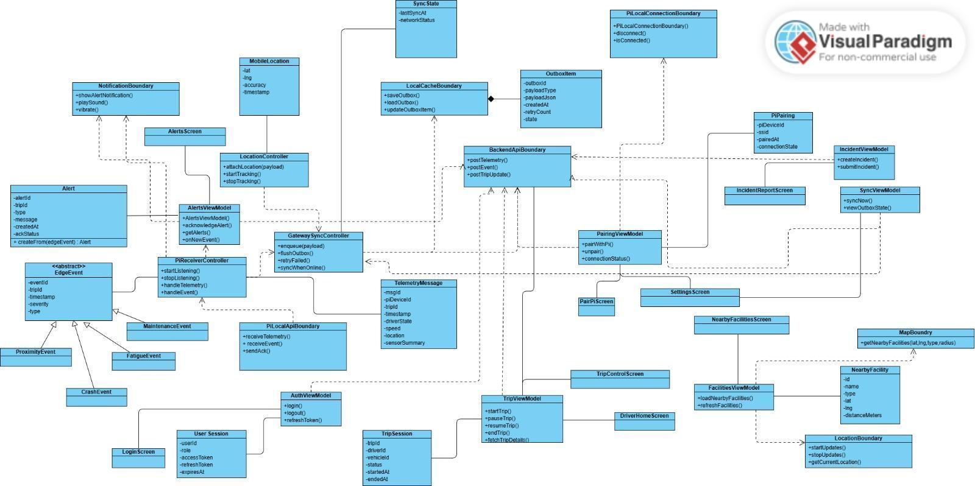
3.6.3.3 Mobile Class Diagram

Figure 15: Udjat Track Mobile Class Diagram.

3.6.4 ERD Diagram
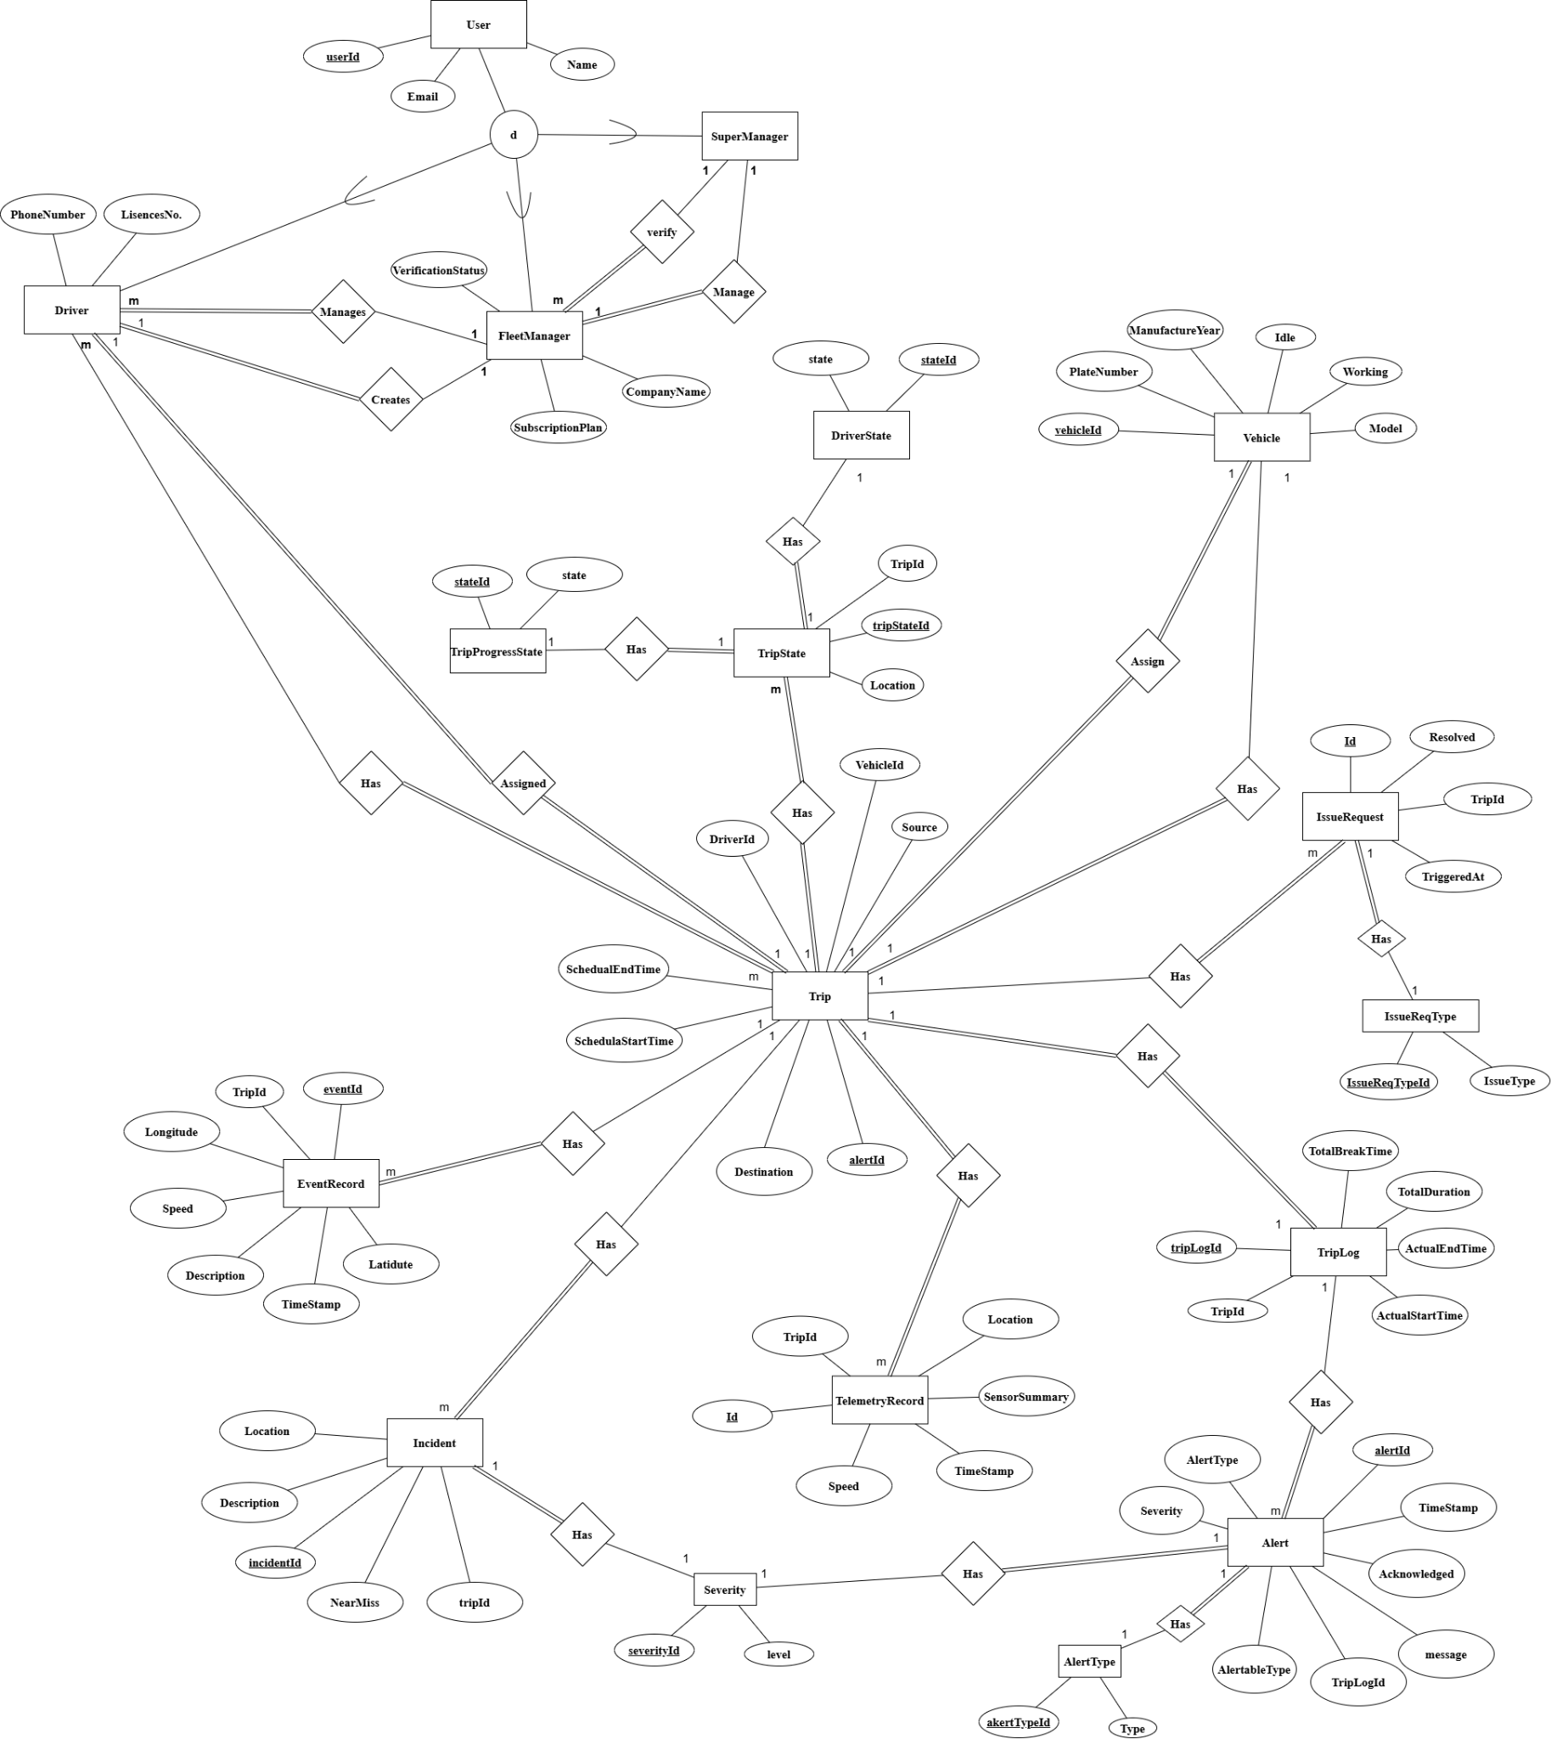
The Entity Relationship Diagram (Figure 16) defines the logical structure and associations of the persistent data stored within the cloud database system
Figure 16: Udjat Track Entity Relationship Diagram.

3.6.5 IoT Sequence Diagram
3.6.5.1 Crash Detection Sequence Diagram
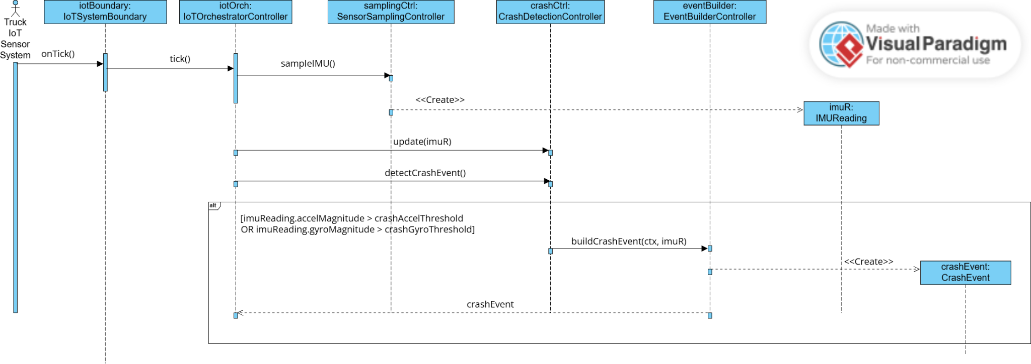
The Crash Detection Sequence Diagram (Figure 17) depicts the process of detecting crash-level impacts from IMU sensor data and generating a corresponding crash event.

Figure 17: The Crash Detection Sequence Diagram.

3.6.5.2 Periodic Sensor Sampling Sequence Diagram
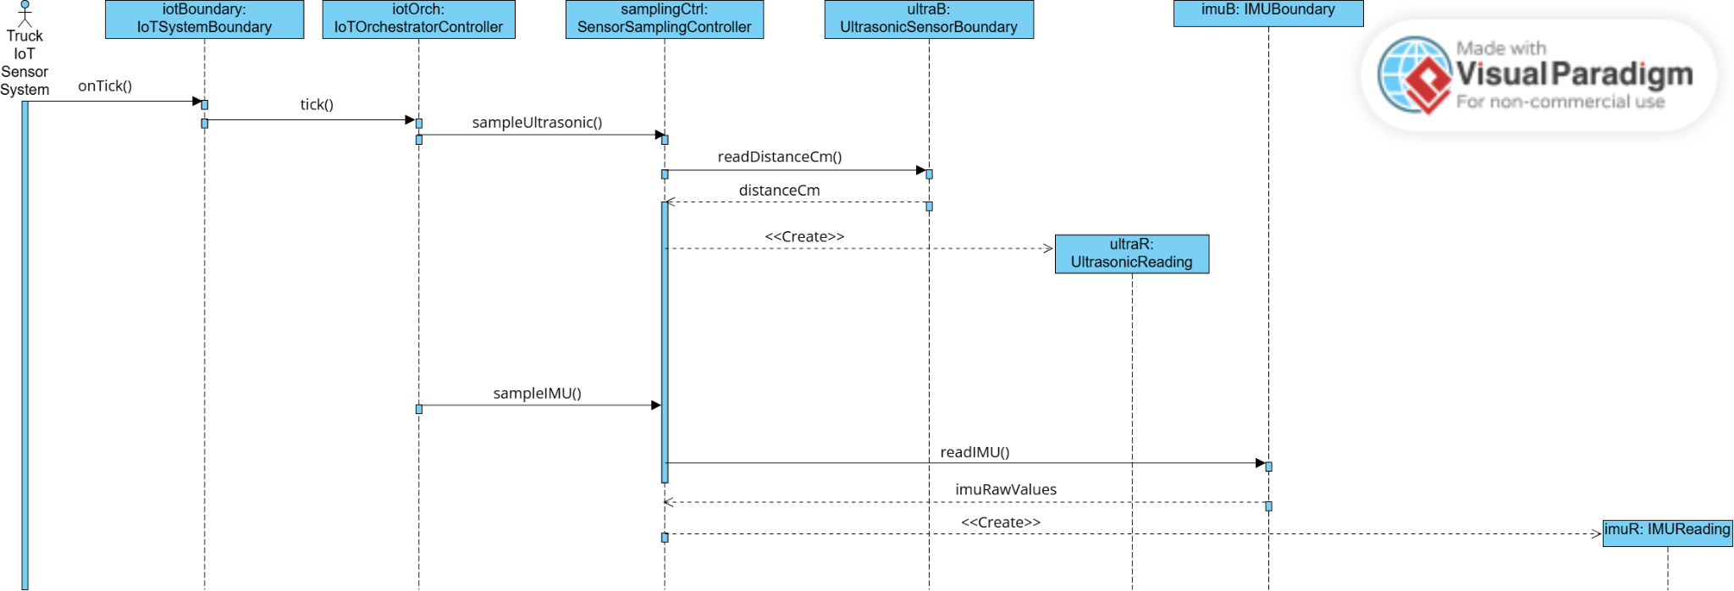
The Periodic Sensor Sampling Sequence Diagram (Figure 18) shows how the system periodically collects data from ultrasonic and IMU sensors and generates structured sensor readings for further processing.

Figure 18: Periodic Sensor Sampling Sequence Diagram

3.6.5.3 Proximity Event Detection Sequence Diagram
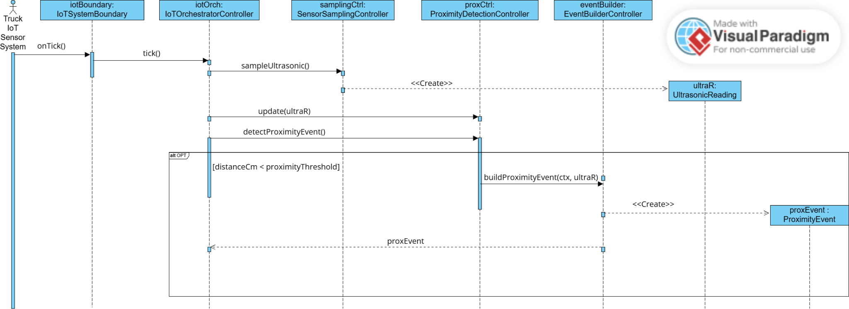
The Proximity Event Detection Sequence Diagram (Figure 19) illustrates how ultrasonic distance readings are evaluated against proximity thresholds to generate proximity warning events.

Figure 19: Proximity Event Detection Sequence Diagram

3.6.6 Mobile Sequence Diagram
3.6.6.1 Driver Alert Generation and Notification Sequence Diagram
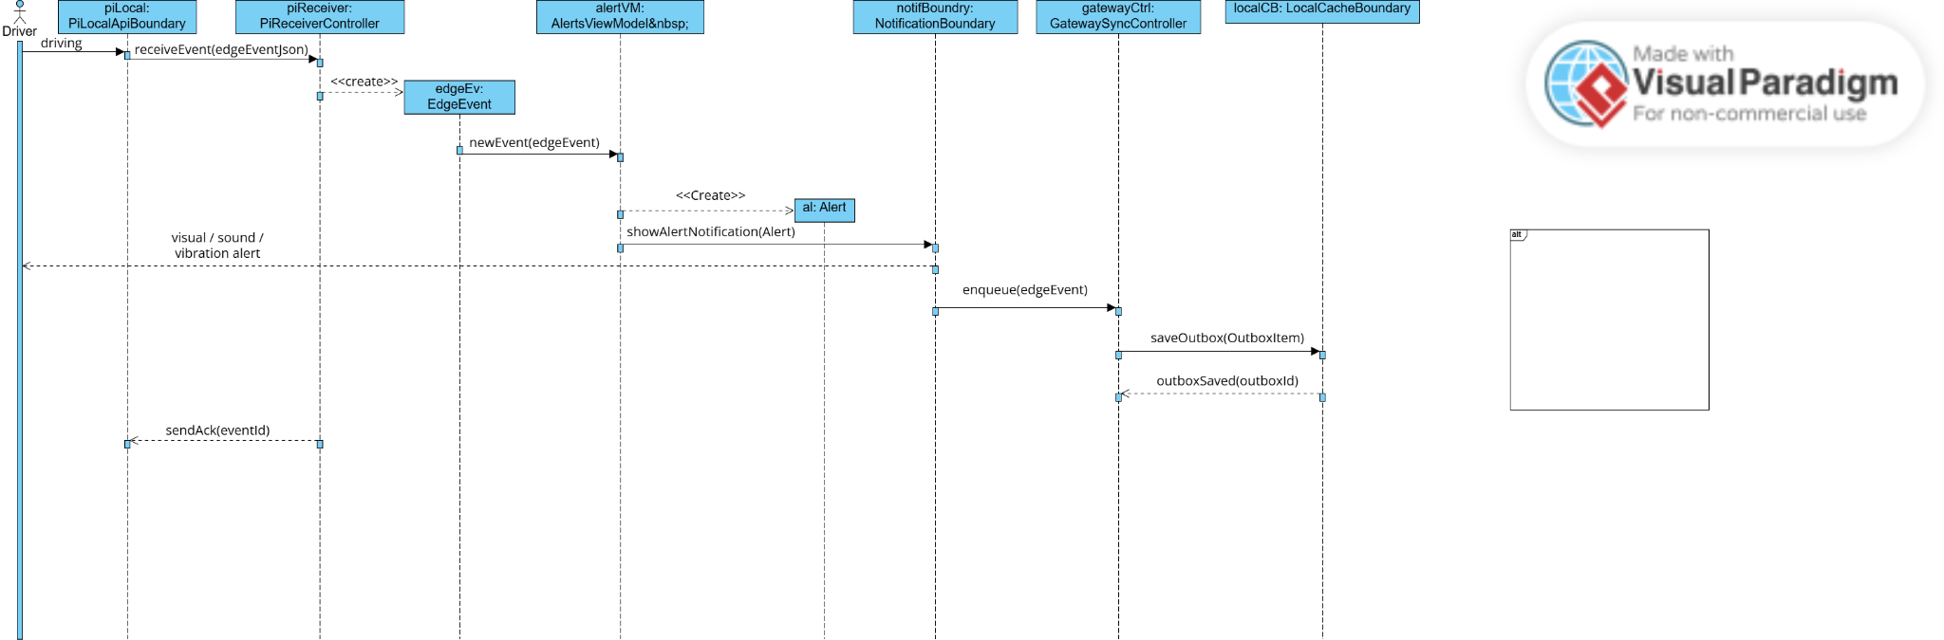
The Driver Alert Generation and Notification Sequence Diagram (Figure 20) shows how detected events are transformed into driver alerts and safely queued for backend synchronization.
Figure 20: Driver Alert Generation and Notification Sequence Diagram

3.6.6.2 Nearby Facilities Retrieval Sequence Diagram
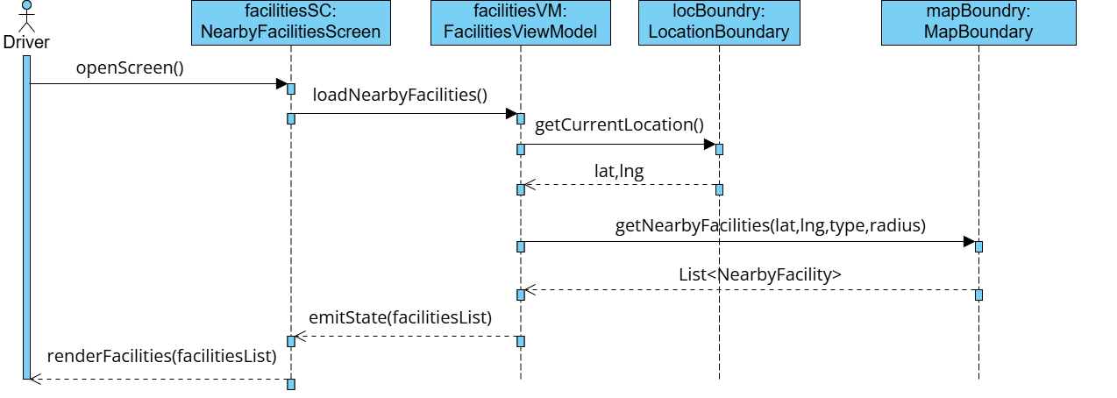
The Nearby Facilities Retrieval Sequence Diagram (Figure 21) illustrates how the system obtains the driver’s current location and retrieves a list of nearby facilities, which is then displayed on the map interface.
Figure 21: Nearby Facilities Retrieval Sequence Diagram

3.6.6.3 Offline-to-Online Data Synchronization Sequence Diagram
The Offline-to-Online Data Synchronization Sequence Diagram (Figure 22) shows how locally stored data is reliably sent to the backend once network connectivity is restored.
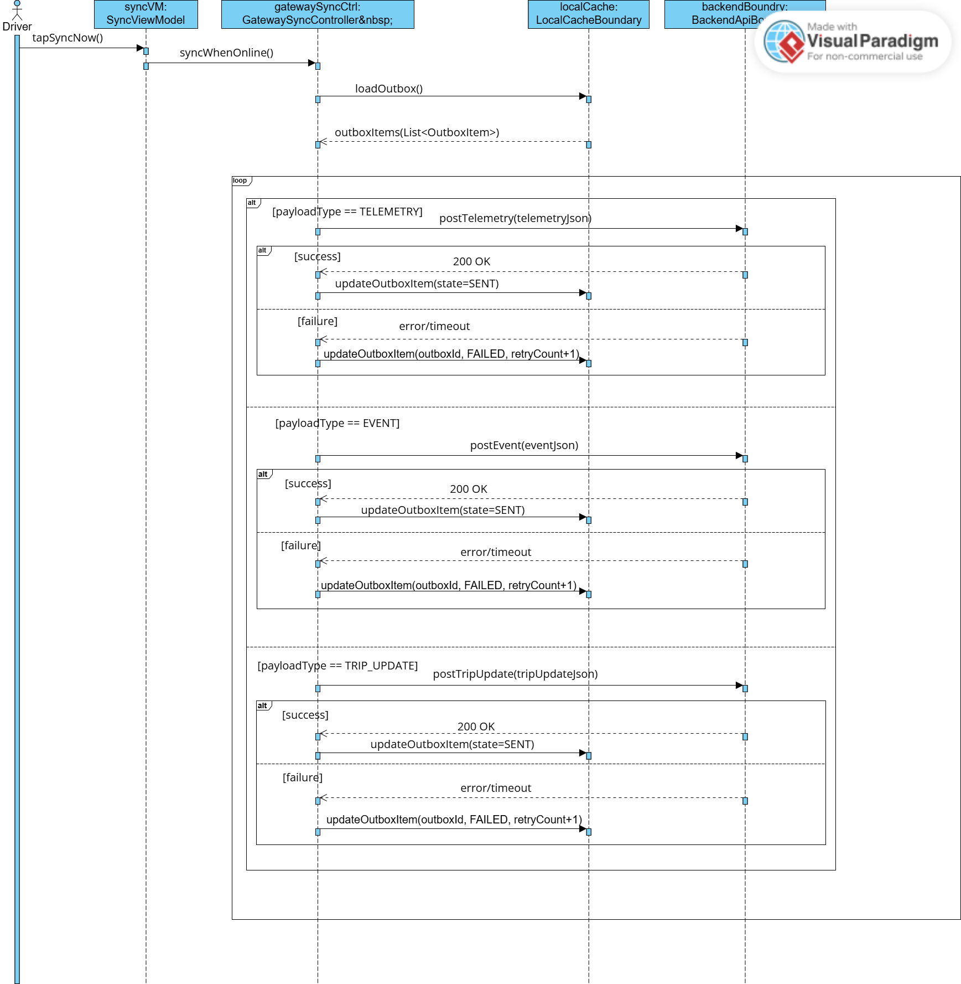
Figure 22: Offline-to-Online Data Synchronization Sequence Diagram

3.6.7 Backend Sequence Diagram
3.6.7.1 Delete Vehicle Sequence Diagram
This delete Vehicle Sequence Diagram (Figure 23) illustrates the administrative process used by the Fleet Manager to remove a vehicle from the company's active fleet.
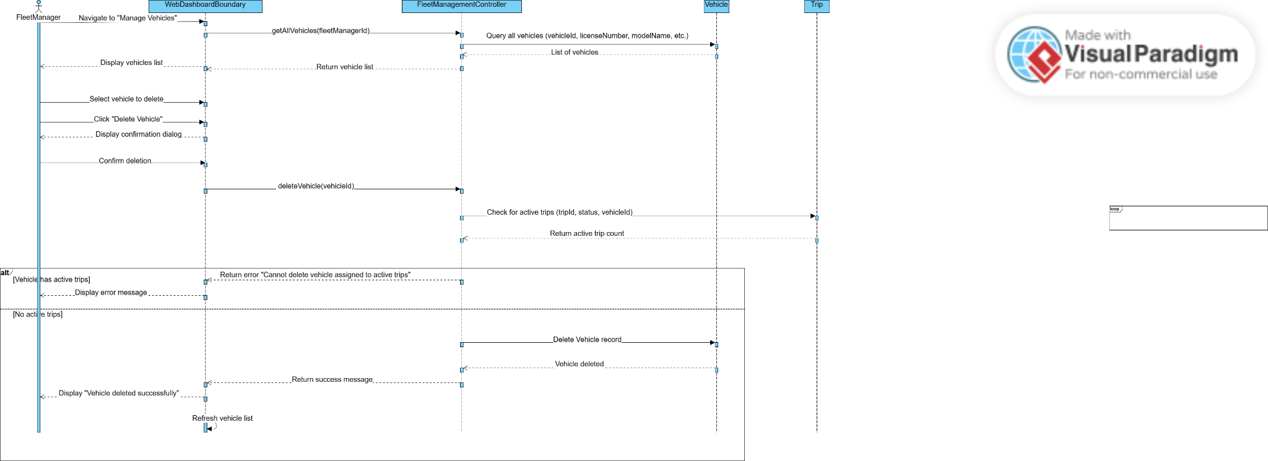

Figure 23: Delete Vehicle Sequence Diagram

3.6.7.2 Track Driver Status Sequence Diagram
This track Driver Status Sequence Diagram (Figure 24) describes the real-time monitoring of a driver's physiological and operational state by the Fleet Manager.
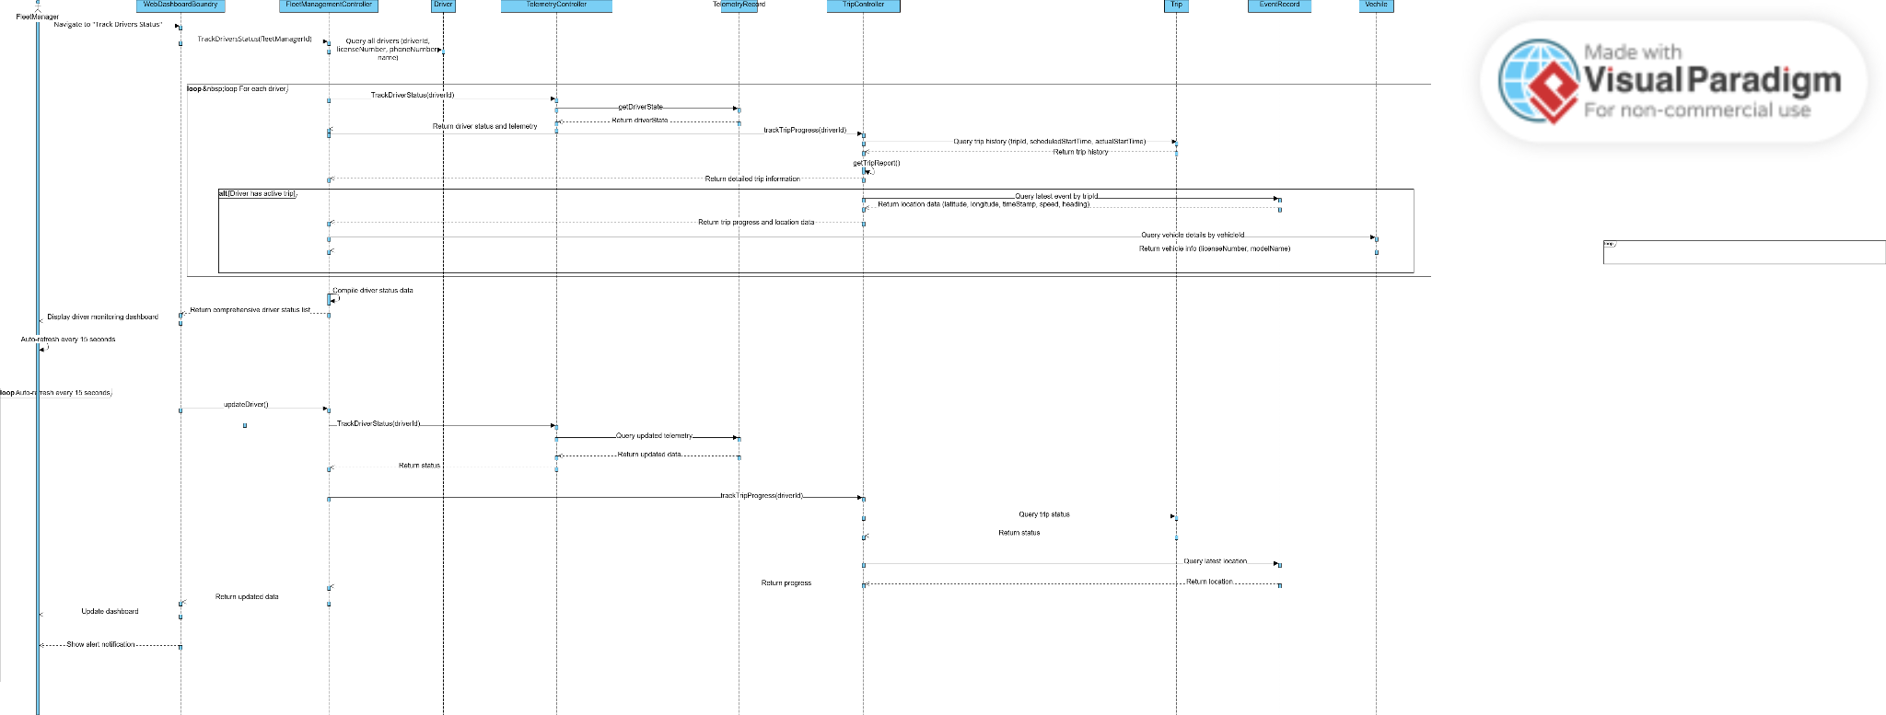
Figure 24: Track Driver Status Sequence Diagram

Design and Implementation

4.1 System Architecture Overview

UdjatTrack is a four-tier distributed system. The in-vehicle edge unit (Raspberry Pi 5) is responsible for all real-time sensor processing and on-device AI inference. The driver's Android phone hosts the application that displays alerts, manages the trip lifecycle, and uplinks summarised events to the cloud. A shared Spring Boot backend keeps fleet-manager state, trip history, and serves as the authoritative event store. A React web dashboard provides the fleet manager with a desktop-grade view of vehicles, drivers, trips, and real-time alerts across the fleet. The tiers communicate through three channels: a low-latency Wi-Fi WebSocket link between the Pi and the phone for live sensor and AI events; an HTTPS REST API between the phone and the backend for durable records; and a REST + WebSocket pair between the React dashboard and the backend for fleet-wide live monitoring.

4.1.1 Tier responsibilities

Table 11:
Tier | Responsibility | Implemented in
Edge IoT (Pi) | Sensor acquisition (IMU, ultrasonic, camera). Real-time driver-state classification. Crash, rollover, and proximity event detection. WebSocket broadcast to phone. | Python 3.10
Mobile (phone) | Driver UI: live trip map, alerts, emergency flows, trip lifecycle. Connects to Pi over WebSocket. Queues offline events. Uplinks to the backend. | Kotlin + Jetpack Compose
Backend | Central authoritative state: authenticates users, dispatches trips, processes and persists high-throughput 1 Hz telemetry and alerts, and broadcasts real-time updates to connected clients via WebSockets. | Java 21 + Spring Boot 3 + PostgreSQL/TimescaleDB
Web dashboard

4.1.2 Communication and data flow

On trip start, the Android app authenticates against the backend, retrieves the trip definition (driver, vehicle, source/destination), and establishes a WebSocket connection to the Pi over the Pi-hosted Wi-Fi access point. The Pi streams 1 Hz telemetry frames and asynchronous event frames (CRASH, ROLLOVER, OBSTACLE_NEAR, Driver-State transitions). The app aggregates these into driver-visible cards (fatigue, emergency, obstacle) and forwards qualifying events to the backend over HTTPS. The backend stores them and re-broadcasts them over its own WebSocket channel to all connected dashboard clients, so a fleet manager watching the React dashboard sees the alert appear in real time. The dashboard fetches fleet-wide state via REST on first load and subscribes to the backend WebSocket for subsequent live updates. When the trip ends, the app posts a final summary; the Pi remains running so the next trip can resume immediately.

4.2 IoT Edge System (Raspberry Pi)

The edge unit performs all time-critical processing inside the vehicle. Three primary design goals shaped its implementation: (i) real-time response, events must be detected and broadcast within hundreds of milliseconds; (ii) operation independent of cellular or internet connectivity, so safety functions continue in tunnels and remote roads; and (iii) modest CPU/memory budget so the Pi can host the vision pipeline, sensor workers, and WebSocket server simultaneously without throttling.

4.2.1 Hardware platform

Table 12:
Component | Role
Raspberry Pi 5 (4 GB) | Main edge compute platform. Hosts the entire IoT, AI, and WS server.
Pi 5 active cooler | Sustained cooling for the vision pipeline running at near-100% on one core.
MPU-6050 IMU module | 3-axis accelerometer + 3-axis gyroscope for crash and rollover detection.
6 × HC-SR04 ultrasonic sensors | Proximity sensors mounted front, rear, and two each on the left and right blind-spot positions.
Camera module (CSI/USB) | Driver-facing camera at 30 fps used as the vision-pipeline input.
12 V → 5 V step-down regulator | Power supply from the vehicle's 12 V electrical system.

4.2.2 Software stack

Python 3.10 was selected as the primary language for the edge unit for four reasons:
- Mature ecosystem for computer vision (MediaPipe, OpenCV) and numerical computing (NumPy), both of which are required by the AI pipeline.
- First-class Raspberry Pi support for official GPIO libraries, hardware-acceleration bindings for the camera, and pre-built wheels for the major dependencies.
- Native asyncio and the websockets library, allowing a single-file async WebSocket server to coexist with synchronous sensor threads without manual event-loop plumbing.
- Rapid iteration, the detection thresholds (crash Δv, eye-closure timing, head-pose tilt) needed extensive empirical tuning during development, and Python's REPL/scripting model made each tuning cycle fast.

The principal libraries used on the Pi side are:

Table 13:
Library | Purpose
MediaPipe FaceMesh | Real-time facial landmark detection (468 landmarks per frame) for eye/mouth/pose features.
OpenCV (opencv-python) | Frame capture, image preprocessing, and drawing debug overlays.
NumPy | Vector and matrix operations used by the head-pose calculator and the IMU detector.
websockets (asyncio) | WebSocket server for live phone connectivity.
smbus2 / RPi.GPIO | Low-level I2C (IMU) and GPIO (ultrasonic trigger/echo) access.
pytest, pytest-cov | Unit-test framework and coverage tooling.
psutil | Resource profiling for the test in 5.1.6.

4.2.3 Module organization

The edge codebase is organized by sensor subsystem rather than by layer, so each sensor's acquisition, filtering, and detection logic lives in a single coherent directory:

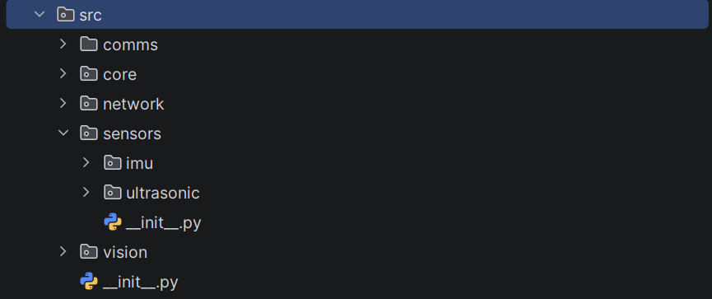
Figure 25: Top-level package structure of the Pi edge codebase.

Table 14:
Path | Contents
src/sensors/imu/ | imu.py (hardware driver), worker.py (acquisition thread), event_detector.py (CRASH and ROLLOVER detection).
src/sensors/ultrasonic/ | ultrasonic.py (driver), glitch.py (HC-SR04 blind-zone filter), worker.py, event_detector.py (OBSTACLE_NEAR).
src/vision/ | main.py, worker.py, detection/face.py, detection/pose.py, state.py
src/comms/ | ws_server.py (WebSocket broadcast server), injection_server.py (localhost CLI hook for demo events).
src/core/ | shared_state.py (thread-safe state shared between workers), public_payload.py (frame schemas).
src/network/ | pi_publisher.py (helper that wraps event publishing).

4.2.4 Threading model

The Pi runs five concurrent workers, each in its own thread, plus an asyncio event loop for the WebSocket server:

Table 15:
Worker | Rate | Output
Vision worker | ~15 fps (camera) | Driver state, blink/yawn events into shared_state.vision
IMU worker | 100 Hz | Acceleration + gyroscope into shared_state.imu
IMU event detector | 100 Hz | CRASH and ROLLOVER events pushed to shared_state.events
Ultrasonic worker | 20 Hz × 6 sensors | Filtered cm reading per sensor into shared_state.ultrasonic
Ultrasonic event detector | Polled at 20 Hz | OBSTACLE_NEAR events with sensor + position
WS server (asyncio) | 1 Hz telemetry + on-event broadcast | JSON frames to all connected phones

All inter-thread communication goes through a single SharedState object protected by a lock, the event_detector workers read sensor snapshots, the WS server reads the latest snapshot for telemetry, and the events deque is drained by the WS event loop every 100 ms.

4.2.5 Detection algorithms

Three event detectors run in parallel on the Pi, each with a distinct algorithm:

Crash detection (FR-18, 3.6.5.1).

The IMU detector integrates total acceleration magnitude over a sliding window to compute a velocity change Δv. When Δv exceeds a calibrated threshold (~5 m/s of velocity change in under 200 ms) the detector enters a brief standby state to reject single-sample noise spikes; if the threshold is sustained or a second sample also exceeds the impact threshold, a CRASH event is emitted with the peak g-value and Δv as payload. A cooldown then disables re-firing for several seconds to prevent secondary impacts from generating duplicate events.

Rollover detection (FR-18).

Tilt is computed from the gravity vector using atan2(ay, az) for roll and atan2(-ax, sqrt(ay² + az²)) for pitch. When the maximum tilt exceeds 45° a persistence timer starts; if the tilt remains above the threshold for at least 2 s, a ROLLOVER event is emitted. The persistence requirement prevents short-duration bumps and bank turns from triggering.

Proximity/obstacle detection (FR-32, 3.6.5.3).

Each HC-SR04 sample first passes through a blind-zone filter that detects the sensor's characteristic 400 cm spurious reading when an object is closer than ~2 cm and clamps it to 2 cm. The filtered distance is then compared against the 50 cm proximity threshold; if any sensor remains below threshold for at least 300 ms (debounce), an OBSTACLE_NEAR event is emitted with the sensor id and its mapped driver-facing position (FRONT, REAR, LEFT, RIGHT). A per-sensor cooldown of 5 s prevents continuous re-firing when an object remains alongside the vehicle.

4.3 Embedded AI and Computer-Vision Pipeline

The vision pipeline classifies the driver into one of four severity states, Alert, Drowsy, HighRisk, and Unconscious, at the native camera frame rate. All inference happens locally on the Pi; no video frame ever leaves the vehicle, which is both a privacy guarantee and a hard latency requirement (a cloud round-trip per frame would be incompatible with real-time alerting). The pipeline has three stages: facial landmark detection, per-frame feature extraction, and a temporal state classifier.

4.3.1 Why MediaPipe FaceMesh

MediaPipe FaceMesh was chosen as the upstream facial-landmark detector after evaluation against dlib's 68-landmark detector and a custom OpenCV Haar-cascade baseline. The decision factors were:

- Landmark density: FaceMesh provides 468 landmarks per face, including refined iris landmarks, supporting precise Eye Aspect Ratio (EAR) and Mouth Aspect Ratio (MAR) calculations that the simpler detectors cannot match.
- On-device performance: TensorFlow Lite under the hood with GPU delegation where available; runs at ~15 fps on a Pi 5 vs ~3 fps for dlib's 68-landmark model.
- Robustness: handles partial occlusion (glasses, hand on face) and head-pose variation out to ~45° without retraining.
- Open-source and freely redistributable, which matters for fleet deployments where licensing fees would compound per vehicle.

4.3.2 Per-frame feature extraction

From the 468 landmarks, the pipeline derives four per-frame features that the temporal classifier consumes:

Table 16:
Feature | Computation
EAR (Eye Aspect Ratio) | Mean of the two eye-aspect ratios, each computed from six landmarks per eye as (|p2 − p6| + |p3 − p5|) / (2 · |p1 − p4|). Closed eyes give EAR ≈ 0.10–0.16; open eyes give 0.25–0.35.
MAR (Mouth Aspect Ratio) | Vertical mouth distance divided by horizontal mouth width. Yawning gives MAR ≳ 0.5.
Head pose (roll, pitch, yaw) | Computed by SolvePnP against a canonical 3D face model using a subset of the FaceMesh landmarks. Used for unfocused/head-down detection.
Gaze direction | Iris-landmark offset from the eye centre, normalised by eye width. Used to detect off-road glance.

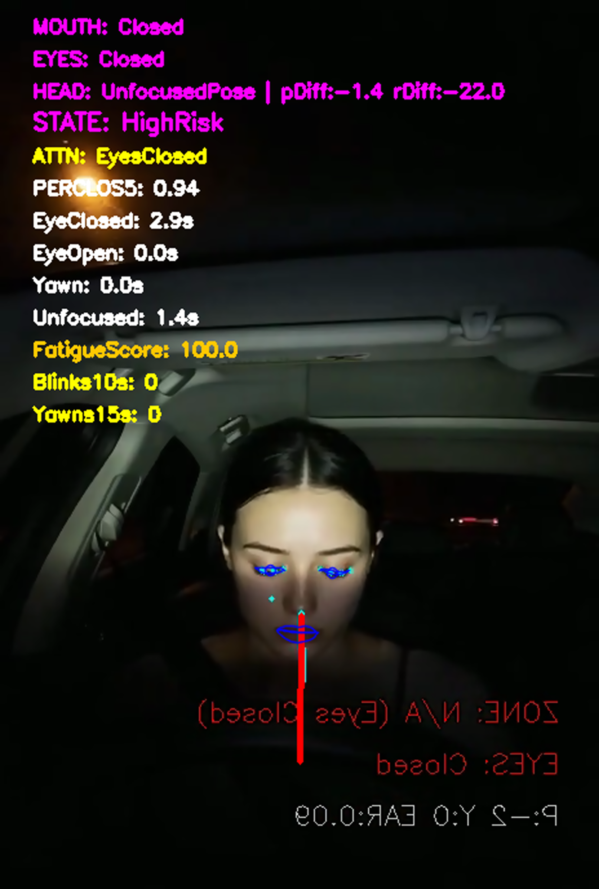
Figure 26: Driver-state monitoring window showing the extracted features

4.3.3 Temporal driver-state classifier

Per-frame features are noisy, and a single eye closure cannot distinguish a normal blink from a microsleep; temporal context is required. The classifier is implemented as a state machine over four severity states that accumulates evidence over time:
// add unknown state
Table 17:
State | Entry criteria (production thresholds)
Alert | Default state. Eyes open ≥ 1.5 s, fatigue score < SCORE_DROWSY − 8.
Drowsy | Continuous eye closure ≥ 1.0 s OR sustained head-down ≥ 2.5 s OR fatigue score ≥ 45 OR severe-eye-evidence flag.
HighRisk | Continuous eye closure ≥ 3.0 s with fatigue score ≥ 70, OR sustained low-EAR for ≥ 3.5 s with supporting PERCLOS5 ≥ 0.5.
Unconscious | Continuous eye closure ≥ 4.0 s.

Three internal mechanisms make the classifier robust against detection noise:

- Fatigue score: a continuously updated 0–100 score that accumulates contributions from eye-closure duration, PERCLOS over the last 5 s, sustained low EAR, yawn rate, blink rate, and head-down duration; and decays when none of those is present. A behavioural cap prevents yawning + blinking alone from exceeding the HighRisk threshold.
- Minimum state-hold time: the classifier cannot change state more than once per second, absorbing single-frame jitter.
- Asymmetric recovery: descending the severity ladder requires longer eye-open intervals than ascending (1.5 s for Drowsy → Alert, 0.5 s for Unconscious → HighRisk), matching the asymmetry of human waking versus falling asleep.

4.3.4 Why the algorithmic state machine rather than an end-to-end model

An end-to-end deep model (e.g., a CNN+LSTM trained directly on raw frames) was considered and rejected for three reasons: (i) labelled fleet-driver footage at the scale required for end-to-end training was not available within the project; (ii) the explicit state machine produces interpretable decisions, when a Drowsy event fires, the system can explain which evidence caused it (eye closure, head pose, fatigue score) which a black-box model cannot; and (iii) thresholds can be tuned without retraining, allowing the model to be calibrated to individual cabin and camera setups in the field. The MediaPipe FaceMesh model itself is a deep neural network; the system is therefore a hybrid: a pretrained deep feature extractor followed by an interpretable rule-based classifier.

4.4 Mobile Application

The Android application is the driver-facing surface of Udjat Track. It runs on the driver's personal phone, connects to the Pi over the Pi-hosted Wi-Fi hotspot, and provides the live trip map, real-time alerts, emergency flows, and the bridge to the fleet-management backend. It is the only component of Udjat Track that drivers ever interact with directly, so usability, low-distraction visual design, and responsive alerts were primary design goals.

4.4.1 Programming language and framework

Kotlin is the primary application language; Jetpack Compose is the UI framework. The decision factors were:
- Kotlin is Google's recommended Android language and has first-class support across the Android Jetpack libraries used in the app (Navigation, Lifecycle, ViewModel, Hilt).
- Null safety in Kotlin eliminates an entire category of runtime crashes that were common in legacy Java Android code, important for a safety-related application that must remain stable throughout the trip.
- Jetpack Compose is declarative and lets the entire screen-update loop be driven by StateFlow emissions from view-models. This is a natural fit for the constant stream of WebSocket telemetry from the Pi where every frame updates the UI.
- Coroutines and Flow integrate cleanly with the underlying Pi WebSocket and the offline-sync queue, replacing the callback-style asynchronous code that would otherwise be needed.

4.4.2 Architecture

The application follows a layered (Clean-Architecture) package structure with MVVM at the UI layer and dependency injection via Hilt. Code is organised into four top-level packages under com. example.udjattrack, core, data, domain, and feature, sitting alongside the four root files that bootstrap the runtime (Figure 25). Each layer has a single responsibility, and the dependency rule runs strictly inward: feature depends on domain abstractions, data implements them, and core supplies cross-cutting infrastructure consumed by the others.

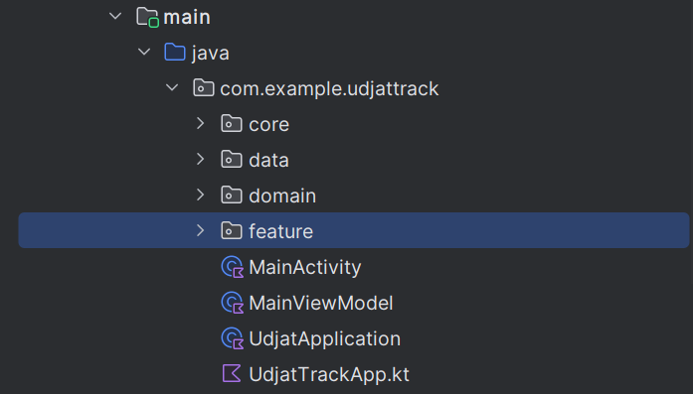
Figure 27: Top-level package structure of the Android module.

Table 18: Top-level layers
Layer | Purpose | Depends on
feature | Screens, view-models, and UI state for each user-facing feature. | domain, core
domain | Business rules: pure-Kotlin models, repository contracts, use-cases. | Nothing (pure Kotlin).
data | Concrete implementations of the domain contracts: Room, Retrofit, WebSocket, mappers, and offline sync. | domain, core
core | Cross-cutting infrastructure: DI graph, navigation, networking, services, audio, UI theme, utilities. | Nothing project-specific.

Core layer

The core package (Figure 26) holds infrastructure that is not specific to any one feature: the dependency-injection graph, navigation host, networking primitives, foreground services, audio playback, UI theme, and stateless helpers. Keeping these in a dedicated layer prevents cross-cutting concerns from leaking into feature code and gives every screen a single place to reach for shared utilities.

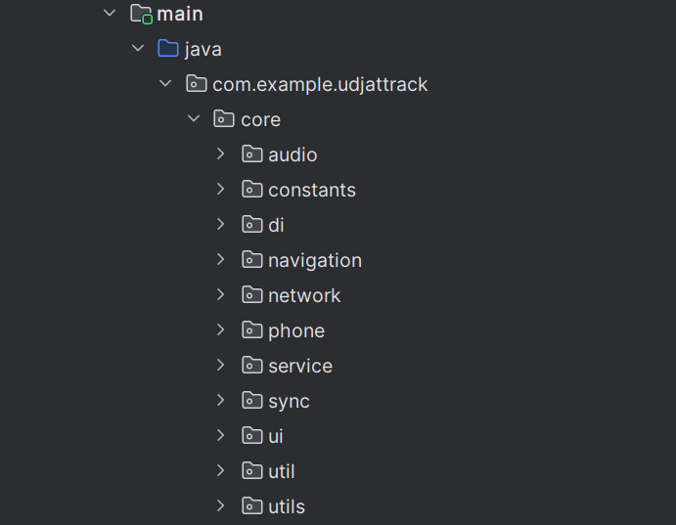
Figure 28: Subpackages of the core layer.

Table 19: Contents of core
Subpackage | Role
audio | AlertSounds : wraps ToneGenerator to play alarm-stream tones for safety-critical cards so they sound through Do-Not-Disturb.
constants | AppConstants: compile-time constants (e.g. BASE_URL).
di | Hilt modules (NetworkModule, AppModule, RepositoryModule, MapRepositoryModule, DispatcherModule) that bind data implementations to domain interfaces.
navigation | AppNavGraph: Compose-Navigation routes and arguments.
network | OkHttp/Retrofit interceptors and connectivity helpers shared by every HTTP client.
phone | rememberPhoneCaller: dialer-intent helper used by safety cards.
service | LocationClient: streams GPS fixes from a foreground location service while the app is in the background.
sync | Sync schedulers and constants backing the offline-sync flow in the data layer.
ui | Design-system primitives: UdjatTrackTheme, colour tokens (UdjatRed, UdjatGreen, UdjatLightBlue), reusable components (UdjatPrimaryButton).
util, utils | Stateless helpers: PolylineGeom, LocationUtils, formatters.

Data layer

The data package (Figure 27) provides concrete implementations of the contracts declared in domain. It is the only layer permitted to depend on Room, Retrofit, OkHttp, or DTOs, keeping persistence and transport details out of the rest of the codebase.

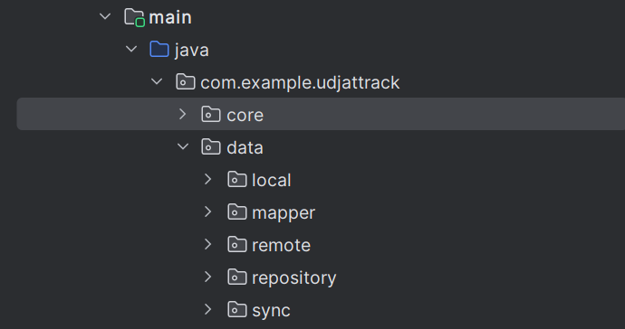
Figure 29: Subpackages of the data layer.

Table 20: Contents of data
Subpackage | Role
local | Room database, DAOs, and entity classes. Caches trips, the offline-event outbox, and session data.
mapper | DTO-to-domain and entity-to-domain converters; keeps JSON and database fields out of domain and feature.
remote | Retrofit services and DTOs for the backend; PiConnectionManager, PiWebSocketClient, and PiEventBus for the Pi WebSocket link (default ws://10.42.0.1:8765).
repository | Implementations of the domain repository interfaces (TripRepositoryImpl, RouteRepositoryImpl, …), a glue that combines local, remote, and mapper.
sync | OfflineSyncManager which persists telemetry and event submissions to the Room outbox when offline and replays them when connectivity returns, ensuring no safety event is lost during a network drop.

Domain layer

The domain package (Figure 28) captures the business rules of the application as pure Kotlin. It contains no Android imports, no third-party framework dependencies, and no I/O, so every class can be compiled to plain JVM bytecode and unit-tested with JUnit alone, a property heavily exploited by the unit-test suite described in Chapter 5.
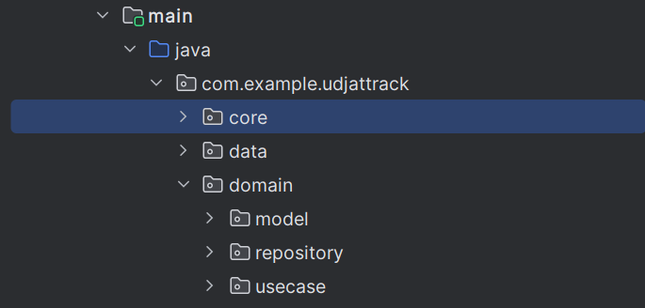
Figure 30: Subpackages of the domain layer.

Table 21: Contents of domain
Subpackage | Role
model | Pure Kotlin data classes : Trip, GeoPoint, EmergencyContact, DriverState, etc. These types form the vocabulary every other layer speaks in.
repository | Repository interfaces (TripRepository, RouteRepository, EmergencyContactRepository, …) that the data layer fulfills. Use-cases depend on these interfaces, not concrete classes.
usecase | One class per single-purpose action: GetMyProfileUseCase, GetActiveTripsUseCase, SendSosUseCase, SendMaintenanceUseCase, SendIncidentUseCase, EndTripUseCase, AddEmergencyContactUseCase, GetEmergencyContactsUseCase, etc. View-models call use-cases, never repositories directly.

Feature layer

The feature package (Figure 29) holds the user-facing portion of the application. Each subpackage is one feature and follows the substructure feature/<name>/ui/ (screens and feature-local Composables under ui/components/), feature/<name>/viewmodel/, and where useful feature/<name>/state/ for the UiState data classes. A feature can be added, replaced, or removed without touching anything outside its own folder.

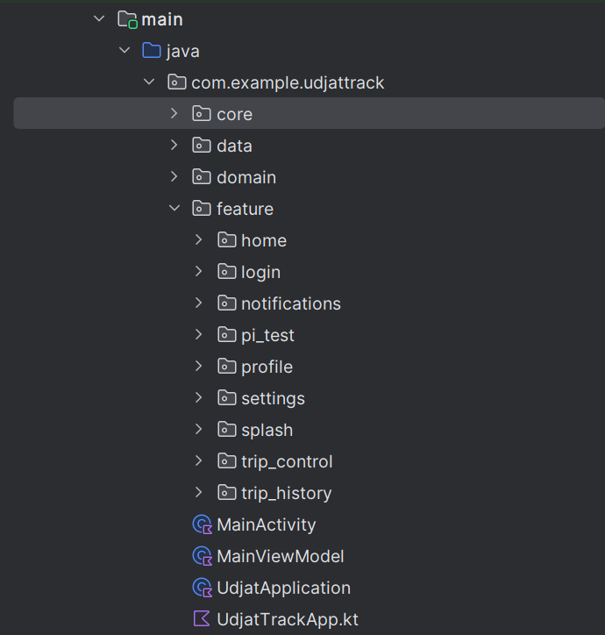
Figure 31: Feature subpackages.

Table 22: Feature Modules.
Feature | Purpose
splash | Launch screen: checks the persisted session and routes the user to login or home.
login | Authentication against the backend; persists the session on success.
home | Driver dashboard: shows today’s trips, quick actions, and current vehicle.
trip_control | The active-trip experience: live map, speed/timer card, safety bottom-sheets (SOS, maintenance, incident, nearby help), and the safety-card overlays (FatigueDetectedCard, EmergencyHelpCard, CrashRolloverDetectedCard, AlertSentCard, ObstacleNearCard, TripOnBreakCard). The most stateful feature in the app and the primary consumer of Pi telemetry and events.
trip_history | Past trips with route playback, event timeline, and telemetry charts.
notifications | Push and in-app notification inbox.
profile | Driver profile and emergency-contacts management.
settings | App settings: language, theme, account, log-out.
pi_test | Diagnostic feature used during development and field testing: exposes the raw Pi WebSocket stream, connection status, last telemetry frame, and a manual reconnect button. Retained in the APK to simplify on-site debugging but not part of the production driver flow.

Runtime collaboration (MVVM, repositories, and DI)

The four layers above are structural. At runtime they cooperate in the well-known MVVM + repository pattern, wired together by Hilt: a Compose screen observes a StateFlow<UiState> exposed by a @HiltViewModel; the view-model dispatches user intents to one or more use cases; each use case talks to a repository interface declared in domain; the concrete repository in data calls the appropriate data source (Retrofit for the backend, the OkHttp WebSocket client for the Pi, Room for the local cache); and the DI graph in core/di binds every concrete implementation to its interface so that no upper layer holds a hard reference to a lower-layer class. Table 4.4.2-6 maps these MVVM roles back to the package layout described above.

Table 23: MVVM + repository roles and where they live in the package tree.
Role | Location | Contents
UI | feature/*/ui | Jetpack Compose composables organised by feature: home, login, splash, trip_control, trip_history, notifications, settings, profile, pi_test.
ViewModel | feature/*/viewmodel | StateFlow-based view-models that hold UI state, orchestrate use cases, and emit screen state. Examples: TripControlViewModel, HomeViewModel, LoginViewModel.
Use cases | domain/usecase/* | Single-responsibility coordinators for login, route resolution, trip creation, and event POSTing.
Repositories | data/repository | Implementations of domain repository interfaces. Caching, OSM / OSRM / Geoapify calls, backend POSTs, offline sync.
Data sources | data/remote, data/local | Retrofit APIs for the backend, OkHttp WebSocket client for the Pi, Room database for cache.
DI | core/di | Hilt modules that wire repositories, network clients, and use cases into view-models.

Because of this structure, swapping a data source (e.g. replacing the OSRM router with another provider, or pointing the Pi link at a different host) is a one-file change inside data, invisible to every view-model and screen.

4.4.3 Key libraries and tools

Library / tool | Purpose
Jetpack Compose + Material 3 | UI rendering and theming.
Hilt | Dependency injection, scoping repositories and clients to the application.
Retrofit + OkHttp | HTTPS REST API client for the backend.
OkHttp WebSocket | Persistent connection to the Pi WebSocket server with built-in ping and reconnect handling.
Coil | Image loading for static-map previews (Geoapify static map).
Google Maps Compose | Live trip map; integration with Google's Maps SDK.
Google Play Services Location | Fused-location provider for GPS during the trip.
Room | Local persistence for notification history and offline-event queue.
Kotlin Coroutines + Flow | Asynchronous primitives across the codebase.
Turbine + MockK + JUnit | Unit testing of view-models, repositories, and DTOs.
Android Studio + Gradle (Kotlin DSL) | IDE and build system.

4.4.4 Feature overview and screens

The application prototype is organised into the following screens:

Screen | Purpose
Splash | Brief brand splash; initialises Hilt and checks the session token.
Login | Email / password authentication. On invalid credentials shows a translated error ("Wrong email or password") rather than the raw HTTP status.
Home | Driver's landing screen. Lists today's planned trips and previous trip cards with route preview (Geoapify static map of the OSRM-computed road shape).
Trip Start | Trip detail screen: shows driver name, vehicle, route, scheduled times. Driver presses "Start Trip" to begin.
Trip Control | The main in-trip dashboard. Live Google Map with current position snapped to the planned polyline; speed and trip-time indicators; Pi-connection status; safety button row (SOS, Maintenance, Incident, Nearby Help); event cards (Drowsy/HighRisk/Unconscious with 10 s self-cancel countdown, Obstacle direction card).
Trip History | List of completed trips with start/end times, distance, and per-event summary.
Trip Details | Detailed view of a single past trip including its planned route map.
Notifications | Notification centre: events received from the Pi and the backend, persisted with Room.
Profile | Driver profile, emergency contacts (add/edit), and account info.
Settings | App preferences.
Privacy | Privacy policy and data-handling summary.
Safety bottom sheets (Trip Control modals) | SOS bottom sheet (Send SOS / Call emergency contact / Back); Incident-report sheet (type, severity, description); Maintenance-report sheet (issue type, free-text notes); Nearby-help map (hospitals / gas stations / maintenance centres queried from OSM Overpass API).

4.4.5 Pi-connection management
PiConnectionManager is a Hilt-singleton that owns the OkHttp WebSocket client connecting to the Pi at ws://10.42.0.1:8765. Three properties of this component are notable:

- Single source of truth: telemetry, raw frames, last-known-state, and a typed event. This manager all owns sharedFlow, so any view-model (TripControl, debug overlay) can observe without independently managing the socket.
- Application-layer watchdog: independent of OkHttp's protocol-level ping, a coroutine fires every second and forces a reconnect if no frame has been received for more than 4 s, guarding against half-dead links.
- Per-frame latency instrumentation: every incoming frame computes (now − ts) and logs it as "lag <ms>" to logcat. This is the data source for the end-to-end latency benchmark in 5.1.4 of the testing chapter.

4.4.6 Live trip map and routing
Routing uses three independent OSM-derived services: Nominatim for geocoding (place name → coordinates), OSRM for actual road-network routing (start + end coordinates → polyline following real roads), and Geoapify for static-map previews. The TripControl screen renders the planned OSRM polyline on a Google Maps Compose map, and a snap-to-polyline algorithm projects each GPS fix onto the polyline so the marker rides the planned road smoothly, even when raw GPS is noisy. An off-route detector measures the distance from the snapped position to the polyline; if the distance exceeds 300 m for more than 5 s, the app fetches a fresh OSRM route from the current position and replaces the polyline.

4.5 Backend System

4.5.1 Programming language and framework
Java 21 is utilized as the primary language, alongside Spring Boot 3.2 as the application framework. The selection criteria were based on the following factors:
- Java 21 Virtual Threads (Project Loom): Provides lightweight, JVM-managed threads. This enables the embedded Tomcat server to handle thousands of concurrent WebSocket telemetry connections without exhausting operating system threads or relying on complex reactive programming.
- Spring Boot Ecosystem: Offers enterprise-grade infrastructure. Modules such as Spring Data JPA, Spring Security, and Spring WebSocket drastically reduce boilerplate code, allowing development to focus entirely on business logic.
- Null Safety and Type Rigidity: Strict static typing, combined with jakarta.validation, eliminates runtime type errors for incoming REST payloads, ensuring malformed telemetry is rejected prior to database interaction.
- Dependency Injection: The Inversion of Control (IoC) container manages the lifecycle of controllers, services, and repositories, promoting a modular and testable codebase.

4.5.2 Event-Driven Architecture

The backend architecture is implemented as an Event-Driven Monolith. While the codebase utilizes standard layered packaging (controller, service, repository) for maintainability, the execution flow is entirely driven by asynchronous hardware and user events rather than traditional CRUD (Create, Read, Update, Delete) request-response cycles. The implementation is structured around the core pillars of an Event-Driven Architecture: Event Receivers, Event Processors, and an Event Broker.

Table 24: Event-Driven Implementation Mapping.
EDA Concept | Code Implementation
Event Gateway (Receivers) | Implemented via @RestController classes (e.g., TelemetryController). These act as the ingestion gateway where edge devices “push” events (such as SOS Triggered or Telemetry Ping) at high frequencies.
Event Processors | Implemented via @Service classes (e.g., TelemetryServiceImpl). Upon event arrival, the service acts as a processor, evaluating the incoming event against historical state data to detect anomalies and trigger domain events (e.g., Alerts).
Event Persistence | Handled by Data JPA Repositories. Critical event streams (1 Hz telemetry) are routed to a specialized TimescaleDB hypertable to handle high-throughput event logs without locking relational tables.
Event Broker (Broadcaster) | Implemented using Spring WebSocket and STOMP. Once an event is fully processed and persisted, the WebSocketPublisher acts as a message broker, pushing enriched domain events to the /topic/fleet/{fleetId} channel.
pi_test | Diagnostic feature used during development and field testing: exposes the raw Pi WebSocket stream, connection status, last telemetry frame, and a manual reconnect button. Retained in the APK to simplify on-site debugging but not part of the production driver flow.

4.5.3 Structural Code Organization & Package Breakdown

To maintain clean separation of concerns within the event-driven monolith, the codebase isolates network routing, business logic orchestration, and database persistence into strict horizontal packages.

Table 25: Top-Level Packages and Their Architectural Roles
Package | Code Implementation & Responsibilities
controller/ | Annotated with @RestController and @RequestMapping. Strictly intercepts incoming HTTP/REST payloads, enforces method-level authorization, executes schema validation via jakarta.validation, and maps requests to DTOs. Direct database interaction is strictly prohibited at this layer.
service/impl/ | Annotated with @Service. Encapsulates the core business logic, manages transaction boundaries (@Transactional), executes anomaly evaluation criteria, and orchestrates domain event broadcasting.
repository/ | Java interfaces extending JpaRepository. Dynamically generates optimized SQL queries at runtime, abstracting physical database mechanics from the service layer.
entity/ | Annotated with @Entity. Plain Old Java Objects (POJOs) mapping directly to the physical relational schema (PostgreSQL/TimescaleDB tables).
dto/ | Implemented as immutable Java Records. Enforces strict contract boundaries for incoming requests and outgoing API responses, leveraging MapStruct mappers to prevent internal database entity exposure.
config/ & security/ | Infrastructure configuration housing stateless security chains (SecurityConfig), cryptographic JWT filters (JwtAuthFilter), and WebSocket/STOMP message broker routing (WebSocketConfig).

A. Controller Package (com.udjattrack.backend.controller)

Table 26: Top-Level class / components and their purposes
Class / Component | Purpose & Detailed Responsibility | Injected Dependencies
AuthController | Handles stateless authentication, onboarding, JWT token issuance, refresh cycling, and two-factor authentication (2FA) OTP verification flows. | AuthService, JwtTokenProvider, AuthenticationManager
TelemetryController | High-throughput ingestion gateway intercepting 1 Hz spatial coordinates, velocity metrics, and computer vision driver states (POST /api/v1/telemetry/{tripId}). | TelemetryService, TripService
EmergencyController | Rapid-dispatch gateway handling critical emergency alerts, including manual SOS triggers (POST /sos/manual) and automated hardware crash detections. | AlertService, EmergencyService, EmailService
DashboardController | Serves aggregated fleet analytics for client dashboards, supplying real-time trip counters, idle driver states, and unread alert feeds (GET /dashboard/{fleetId}/fleet-status). | DashboardService, AlertService, TripService
VehicleController | Manages vehicle profile CRUD operations, license categorizations (HEAVY_TRUCK, LIGHT_TRUCK), maintenance tracking, and active trip bindings. | VehicleService
DriverController | Manages driver profiles, fatigue compliance monitoring, shift schedules, and dynamic operational status flags (ONLINE, DRIVING, ON_BREAK). | DriverService
ReportController | Compiles historical safety reports, driver KPI scorecards, and exports immutable log ledgers into PDF/CSV formats. | ReportService, TripLogService

B. Service Package (com.udjattrack.backend.service & service.impl)

Table 27: Top-Level class / components and their purposes
Class / Component | Purpose & Detailed Responsibility | Injected Dependencies
TelemetryServiceImpl | Analyzes live telemetry pings, executes state mutation checks against cached TripState, updates spatial buffers, and generates domain alerts when anomaly criteria are met. | TripRepository, TripStateRepository, AlertService, WebSocketPublisher
AlertServiceImpl | Instantiates alerts via the polymorphic Alertable marker interface, assigns prioritized SeverityLevel metrics (CRITICAL, HIGH, MEDIUM, LOW), and triggers WebSocket broadcasts. | AlertRepository, WebSocketPublisher, EmailService
TripServiceImpl | Governs trip state transitions, validates asset availability, computes real-time completion percentages, and archives finished trips into the immutable TripLog ledger. | TripRepository, TripLogRepository, VehicleRepository, DriverRepository
AuthServiceImpl | Executes credential verification, password hashing (BCrypt), role-based access validation, and orchestrates asynchronous 2FA OTP email dispatching. | UserRepository, JwtTokenProvider, EmailService, PasswordEncoder
EmailServiceImpl | Asynchronously dispatches emergency HTML notifications (SOS triggers, crash alerts) and OTP verification emails via the Resend API on dedicated worker threads (@Async). | ResendApiClient, TemplateEngine
DashboardServiceImpl | Aggregates live vehicle metrics and historical log summaries to construct high-performance, unified data views for dashboard rendering. | TripRepository, AlertRepository, DriverRepository, VehicleRepository
ReportServiceImpl | Queries historical ledgers to calculate cumulative fatigue scores, velocity violations, and formats regulatory compliance exports. | TripLogRepository, AlertRepository

C. Repository Package (com.udjattrack.backend.repository)

Table 28: Top-Level class / components and their purposes
Class / Component | Purpose & Detailed Responsibility | Injected Dependencies
TelemetryRepository | Interfaces directly with TimescaleDB hypertables to append high-frequency 1 Hz spatial time-series frames without locking relational tables. | Spring Data JPA / TimescaleDB Driver
TripRepository | Executes CRUD operations and custom state queries on active fleet trips (e.g., retrieving ongoing trips associated with specific fleet managers). | Trip Entity, Spring Data JPA
TripRepository | Executes CRUD operations and custom state queries on active fleet trips (e.g., retrieving ongoing trips associated with specific fleet managers). | Trip Entity, Spring Data JPA
TripStateRepository | Manages rapid in-memory and database overwrites of live vehicle snapshots (speed, latitude, longitude, driverState) for active tracking. | TripState Entity, Spring Data JPA
AlertRepository | Handles persistence and querying of normalized system alerts via polymorphic joins (alertable_type, alertable_id) and severity filtering. | Alert Entity, Spring Data JPA
TripLogRepository | Manages append-only operations against the immutable trip summary ledger (totalDistance, maxSpeed, violations) for historical reporting. | TripLog Entity, Spring Data JPA
UserRepository | Queries user accounts by email, validates unique schema constraints, and retrieves authentication principal profiles. | User Entity, Spring Data JPA
VehicleRepository | Queries fleet assets by license plate (plateNumber), UUID, or operational status to verify asset availability prior to dispatch. | Vehicle Entity, Spring Data JPA
DriverRepository | Queries driver records by fleet manager organization, compliance license classifications, and operational status flags. | Driver Entity, Spring Data JPA

D. Entity Package (com.udjattrack.backend.entity)

Table 29: Top-Level class / components and their purposes
Class / Component | Purpose & Detailed Responsibility | Injected Dependencies
Alertable (Interface) | The core Marker Interface normalizing disparate event sources (TripState, IssueRequest, EventRecord) into a unified polymorphic entity for alert generation. | None (Base Architectural Marker)
Alert | Persists system notifications, linking severity (CRITICAL to LOW), timestamps, acknowledgment states, and polymorphic root causes (alertable_type/id). | Alertable, Trip, Driver, Vehicle
TripState | Represents the mutable, real-time snapshot of an active vehicle (current spatial coordinates, speed, fatigue level, driver status). Implements Alertable. | Trip
TripLog | The immutable archival entity storing finalized trip aggregations (start/end timestamps, total distance traveled, maximum velocity reached, cumulative fatigue score). | Trip, Driver, Vehicle
Trip | Core relational entity tracking trip schedules, origin/destination metadata, assigned fleet manager, vehicle asset, and operational lifecycle status. | Vehicle, Driver, User
IssueRequest | Abstract base entity (@Inheritance(strategy = JOINED)) representing vehicle anomalies. Extended by Incident.java and SOSRequest.java per the Open/Closed Principle. | Implements Alertable
User / Driver / Vehicle | Core organizational entities representing platform stakeholders, driver compliance profiles, and physical truck hardware specifications. | Spring Data JPA Annotations

E. DTO Package (com.udjattrack.backend.dto)

Table 30: Top-Level class / components and their purposes
Class / Component | Purpose & Detailed Responsibility | Injected Dependencies
TelemetryRequestDto | Encapsulates incoming 1 Hz edge payloads (latitude, longitude, speed, driverState, timestamp) with strict jakarta.validation constraints. | jakarta.validation annotations
TripCreateRequestDto | Validates trip dispatch parameters submitted by fleet managers (vehicleId, driverId, origin, destination, scheduledStartTime). | jakarta.validation annotations
AlertResponseDto | Outgoing presentation model flattening complex polymorphic alert structures into clean, render-ready JSON objects for web clients. | MapStruct Mapper Interfaces
AuthRequestDto / TokenResponseDto | Handles login payload transmission and formats returned JWT access/refresh token pairs alongside user role claims. | None
DashboardSummaryDto | Composite payload aggregating live trip counters, active SOS flags, and vehicle status breakdowns for instantaneous UI rendering. | None

F. Config, Security & WebSocket Packages (com.udjattrack.backend.config)

Table 31: Top-Level class / components and their purposes
Class / Component | Purpose & Detailed Responsibility | Injected Dependencies
SecurityConfig | Configures Spring Security filter chains, enforces stateless session management (STATELESS), sets CORS/CSRF policies, and routes public vs. protected endpoints. | JwtAuthFilter, UserDetailsService
JwtAuthFilter | Extends OncePerRequestFilter to intercept HTTP requests, extract Bearer tokens from authorization headers, verify cryptographic signatures, and populate Spring Security context. | JwtTokenProvider, UserDetailsService
WebSocketConfig | Registers STOMP message brokers, configures /ws endpoint fallback options, and sets up message routing prefixes (/topic, /app). | Spring WebSocket / STOMP
StompAuthInterceptor | Intercepts WebSocket CONNECT frames during handshake establishment, authenticating clients via JWT tokens embedded in STOMP headers prior to session upgrade. | JwtTokenProvider
WebSocketPublisher | Event broker wrapper that compresses and broadcasts domain events (TripStateUpdateMessage, Alert) directly to tenant-isolated topics (/topic/fleet/{fleetId}/alerts). | SimpMessagingTemplate
AsyncConfig | Defines custom execution thread pools (telemetryExecutor, emailTaskExecutor) to guarantee that heavy operations do not block primary HTTP request processing threads. | Project Loom / Spring TaskExecutor

4.5.4 Automated Telemetry Analysis & Alert Generation Criteria

The conversion of raw edge telemetry into actionable fleet manager alerts is governed autonomously by an automated anomaly evaluation engine implemented within TelemetryServiceImpl.

1. State Mutation Evaluation Criteria
Rather than generating redundant notifications for static conditions, the engine utilizes a State Mutation Evaluation Logic. When a payload arrives, TelemetryServiceImpl retrieves the previously cached TripState for the active vehicle and compares the incoming DriverState against the stored state:
- Mutation Detection: If the previous state was ALERT (attentive) and the incoming payload transitions to DROWSY or DISTRACTED, a state mutation is recognized.

- Automated Trigger: This transition automatically invokes AlertService.createAlert(...), instantiating a new Alert entity and binding it to the current trip and driver profile.

2. Physical Threshold Evaluation Criteria
Spatial and kinematic parameters are evaluated against strict domain thresholds:
- Velocity Violations: If incoming telemetry indicates vehicle speed exceeds the operational safety limit (Speed > 100 km/h), the vehicle's state transition engine transitions the status to SPEEDING, immediately generating a threshold violation alert.

3. Severity Classification & Routing Criteria
Generated alerts are dynamically classified by an enumerated SeverityLevel, which governs how the system dispatches notifications to the fleet manager:
- CRITICAL Severity: Assigned to severe emergencies, including automated vehicle crash/rollover detections, driver UNCONSCIOUS CV classifications, or manual driver panic presses (SOS_REQ).
  - Automated Routing: Immediately triggers an ultra-low-latency STOMP WebSocket broadcast to flash visual red alarms and sirens on the fleet manager's dashboard. Simultaneously, it spawns an asynchronous background thread (@Async) to dispatch an HTML emergency email directly to fleet executives via the Resend API.

- HIGH Severity: Assigned to hazardous behavioral trends requiring prompt intervention, such as persistent DROWSY driver classifications, HIGH_RISK driving patterns, or camera occlusions (UNKNOWN).
  - Automated Routing: Broadcasts an immediate yellow warning feed over WebSockets, notifying the fleet manager to initiate real-time audio communication with the driver.

- MEDIUM Severity: Assigned to non-emergency operational warnings, such as preventative hardware MAINTENANCE signals emitted by vehicle sensors.

- LOW Severity: Assigned to routine operational events, such as a trip's lifecycle transitioning from ONGOING to FINISHED.

4.5.5 Advanced Design Patterns & State Management
To mitigate database I/O bottlenecks during high-frequency ingestion, the core leverages specific structural design patterns:

A. The Marker Interface Pattern (Alertable)
The application generates alerts from diverse roots: automated CV driver analysis (TripState), manual SOS requests (SOSRequest), and mechanical failures (Incident). To normalize these disparate sources, the Marker Interface Design Pattern is applied.
- Implementation: An empty interface Alertable.java acts as the architectural marker implemented across distinct domain entities.
- Polymorphic Database Mapping: In the physical Alert database table, this pattern is persisted using polymorphic fields (alertable_type storing the entity class name, and alertable_id storing its primary key). This allows AlertServiceImpl to dynamically join and fetch the exact root cause of any alert at runtime through a single standardized table structure.

B. Bifurcated State Management (TripState vs TripLog)
High-frequency 1 Hz ingestion requires separating mutable real-time tracking from historical archival:
- The Active State Machine (TripState): Serves as the live, real-time snapshot of the vehicle. As telemetry arrays arrive, this record is rapidly overwritten in memory/database and pushed over WebSockets. It prevents database bloat by discarding redundant intermediate points.

- The Immutable Ledger (TripLog): Serves as the permanent archival summary. Upon trip completion, final aggregated metrics (total distance traveled, duration, maximum velocity reached, cumulative fatigue score) and critical violation records are permanently appended to the TripLog ledger to power historical reporting and regulatory compliance audits.

4.5.6 Applied SOLID Principles
The package organization and class interactions rigorously enforce object-oriented SOLID principles:
- Single Responsibility Principle (SRP): Classes are strictly scoped. DriverController.java exclusively handles HTTP traffic routing; DriverServiceImpl.java strictly executes business logic and fatigue score tracking; DriverRepository.java handles SQL query construction. Security validation is fully abstracted into JwtAuthFilter.java.
- Open/Closed Principle (OCP): Enforced in the database entity design using JPA's @Inheritance(strategy = InheritanceType.JOINED). The abstract base entity IssueRequest.java is extended by child classes like Incident.java and SOSRequest.java. Introducing a new operational issue type simply requires extending the base class without altering existing core processing logic or modifying root relational tables.
- Dependency Inversion Principle (DIP): High-level controllers do not depend on low-level database access drivers; both depend on domain abstractions. For instance, TelemetryServiceImpl depends solely on the TripRepository interface, ensuring that the physical database engine can be modified without altering core domain logic.

4.5.7 Core Domain Implementations & Lifecycle Logic

Trip Management Lifecycle State Machine
Fleet operations follow a strict lifecycle state machine governed by TripService:
- Lifecycle Transitions: PLANNED $\rightarrow$ ONGOING (or ON_BREAK) $\rightarrow$ FINISHED.
- Automated Activation Logic: A trip automatically transitions from PLANNED to ONGOING upon receiving its initial edge device telemetry ping. This event binds the vehicle and driver profile, locking their availability flags to prevent concurrent reassignment.
- Dynamic Progress Metrics: During active transit, route completion percentages are dynamically computed based on elapsed time relative to the scheduled operational window and broadcasted over STOMP.

4.5.8 Real-Time Communication & WebSockets
To achieve real-time synchronization between edge devices and client dashboards, polling mechanisms are entirely replaced by STOMP over WebSockets.
- Handshake Authentication (StompAuthInterceptor): Because WebSockets do not natively carry HTTP Authorization headers post-upgrade, security is enforced via a custom STOMP Interceptor. During the CONNECT frame handshake, the interceptor extracts the JWT from STOMP headers, cryptographically validates the signature, and establishes the secure Principal session.
- Isolated Topic Routing (WebSocketPublisher): Messages are dynamically routed to isolated organizational topics (/topic/fleet/{fleetId}/alerts), guaranteeing multi-tenant data isolation across different fleet operations.

4.5.9 End-to-End Automated Data Flow (Edge Event to Fleet Alert)
- Ingestion: An in-vehicle edge unit detects a driver fatigue event and transmits a JSON payload (driverState: DROWSY) to POST /api/v1/telemetry/{tripId}.
- Validation: TelemetryController intercepts the request. Static schema validation is immediately executed via jakarta.validation, rejecting malformed payloads before invoking service threads.
- Evaluation: TelemetryServiceImpl processes the payload, evaluating the incoming state against the cached TripState and recognizing a behavioral state mutation (ALERT $\rightarrow$ DROWSY).
- Alert Generation: AlertService.createAlert(...) is invoked. A HIGH SeverityLevel is dynamically assigned based on anomaly criteria, and the alert is persisted to PostgreSQL via the polymorphic Alertable association.
- Broadcasting: Immediately following database commit, WebSocketPublisher constructs a compressed TripStateUpdateMessage and pushes it over the STOMP message broker, triggering instantaneous visual warnings on the fleet manager's dashboard.

4.5.10 Asynchronous Processing & Concurrency
To maintain non-blocking I/O during high-frequency ingestion, synchronous execution of latency-prone external operations is avoided:
- Dedicated Thread Pools (@Async): Custom execution pools (telemetryExecutor, emailTaskExecutor) isolate heavy workloads.
- Non-Blocking Execution: When a CRITICAL alert triggers external email dispatching or intensive log generation, the task is offloaded to an asynchronous background worker thread. This immediately frees the primary ingestion thread to continue processing concurrent telemetry streams without latency degradation.

4.5.11 API Domain Structure & Key Endpoints
The cloud core exposes 78 RESTful API endpoints adhering to strict REST conventions and returning a standardized JSON response envelope (ApiResponse<T>). Interactive documentation is maintained via an OpenAPI 3.0 specification accessible at /swagger-ui.html.

Table 32: Core API Domains and Highlighted Operational Endpoints
API Domain | Base Route | Highlighted Operational Endpoints | Architectural Description
Authentication | /api/v1/auth | POST /login | Handles stateless JWT generation, refresh cycling, and role-based access control.
Telemetry Ingestion | /api/v1/telemetry | POST /telemetry/{tripId}  POST /telemetry/{tripId}/batch | High-throughput ingestion gateways receiving 1 Hz spatial frames and CV driver states.
Trip Lifecycle | /api/v1/trips | POST /start  PATCH /{tripId}/finish | Governs trip state transitions, initializing immutable TripLog ledgers and locking assets.
Emergency & SOS | /api/v1/emergency | POST /sos/manual  POST /incident | Rapid-dispatch endpoints handling critical driver SOS alerts and hardware crash detections.
Dashboard Analytics | /api/v1/dashboard | GET /{fleetId}/fleet-status  GET /alerts-summary | Supplies aggregated real-time trip counters, active driver statuses, and unread alert feeds.
Historical Reports | /api/v1/reports | GET /kpis  GET /export/pdf | Queries immutable trip ledgers to calculate efficiency KPIs and generate compliance PDFs.

4.5.12 Accelerated Capabilities: Email Infrastructure
While enterprise email dispatching was scoped for future releases, the implementation timeline was accelerated. The architecture incorporates an asynchronous notification service powered by the Resend API:
- Two-Factor Authentication (2FA): Extends the authentication flow with automated OTP verification emails to secure administrative dashboard access.
- Automated Emergency Dispatch: Augments the event-driven pipeline so that CRITICAL severity events (manual SOS triggers or crash detections) automatically dispatch emergency HTML email notifications to executive fleet managers.
- Non-Blocking Network Execution: All outbound HTTP requests to the email provider are processed asynchronously via @Async thread pools, ensuring notifications are delivered without degrading real-time telemetry ingestion performance.

4.6 Fleet-Manager Web Dashboard
The React web dashboard serves as the authoritative command-and-control center for fleet managers. It provides a real-time, high-fidelity visualization of the entire fleet, including live vehicle tracking, active trip monitoring, event reporting, and driver management. The dashboard is built as a responsive single-page application (SPA) optimized for desktop-grade monitoring

4.6.1 Technology Stack and Tooling
The dashboard is built on a modern TypeScript/React 19 stack, leveraging Vite for rapid development. It prioritizes a component-driven architecture using Radix UI primitives and Tailwind CSS for styling to ensure both accessibility and consistency
Table 23: Fleet-Manager Web Dashboard dependencies
Category | Library / Tool | Purpose
Core | React 19, TypeScript, Vite | UI rendering, language safety, and high-speed bundling.
Routing | React Router v7 | SPA navigation, route guards, and URL parameters.
State & API | @tanstack/react-query  Axios | Server-state caching, synchronization, and data fetching.  REST API client for backend communication.
Real-time | @stomp/stompjs, sockjs-client | Persistent WebSocket connection for live telemetry.
Mapping | react-leaflet, leaflet  leaflet-routing-machine | Interactive OpenStreetMap (OSM) tile rendering.  Projection of planned vs. actual routes on the map.
UI Components | Radix UI (Primitives)  Tailwind CSS, Lucide React  Recharts | Accessible, unstyled UI building blocks.  Styling framework and high-quality iconography.  Visualization of telemetry data and event history.
Forms & Validation | React Hook Form, Zod | Schema-based input validation and form state management.
Utilities | jwt-decode, sonner | Auth token parsing and lightweight toast notifications.

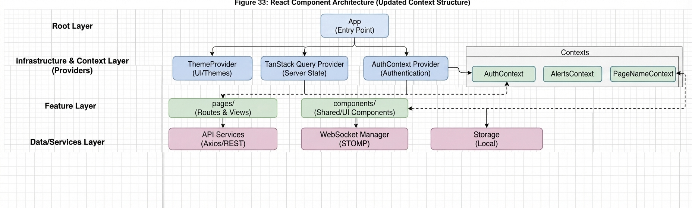

Figure 33: React Component Architecture
This diagram illustrates the hierarchical organization of the dashboard, showing how global providers (Hilt/Context) and state management interact with the view layer.

4.6.2 Project Structure
The codebase is organized into a modular, feature-based directory structure to ensure scalability and maintainability.
Table 24: Web Dashboard directory organization.
This table provides a high-level overview of the src directory, detailing the purpose of each modular sub-folder within the UdjatTrack dashboard architecture.
Path | Contents
src/assets/ | Static project assets such as images and branding files.
src/CommonComponents/ | Reusable UI components shared across multiple pages.
src/components/ | Core feature-specific components and Radix-based wrappers.
src/Contexts/ | React Context providers for global state management.
src/hooks/ | Custom business-logic hooks (e.g., useWebSocket, useTripState).
src/layout/ | Structural layout components for consistent page design.
src/lib/ | Configuration files for external libraries and utility instances.
src/pages/ | Routed view components organized by feature (e.g., Alerts, Dashboard, Driver, Report, TripManagement).
src/routing/ | Route definitions and authentication wrappers (e.g., Routers.tsx, ProtectedRoute.tsx).
src/types/ | Global TypeScript interfaces (e.g., TripLog.types.ts, user.types.ts, vehicle.types.ts).
src/utils/ & src/Utilities/ | Stateless helper functions for geometry, data formatting, and common logic.

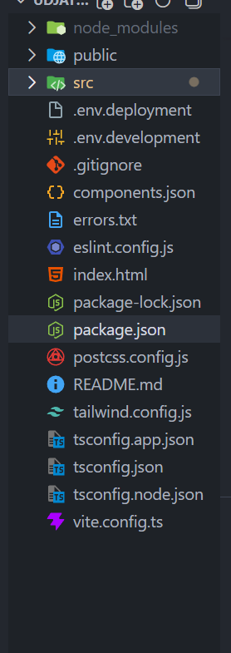
Figure 36: Root Directory Overview.
This figure displays the primary root directory of the application, including configuration files for the build environment, TypeScript setup, and dependency manifests.
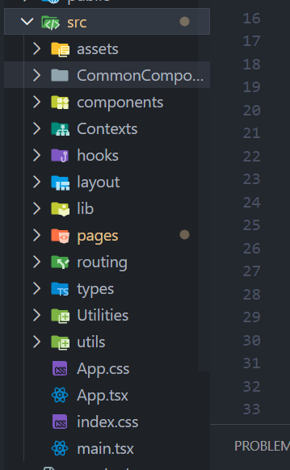
Figure 37: Core Src Directory Organization.
This figure outlines the modular organization of the src folder, demonstrating the separation of concerns across core architectural layers such as components, hooks, routing, and pages.
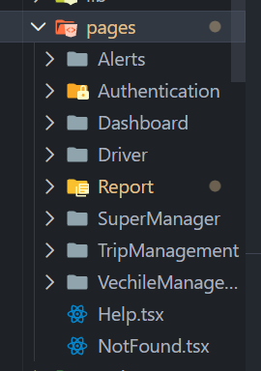
Figure 38: Feature-Based Pages Module.
This figure provides a detailed view of the pages/ directory, illustrating how the application features—such as Trip Management, Driver Management, and Alerts—are encapsulated as individual modules.
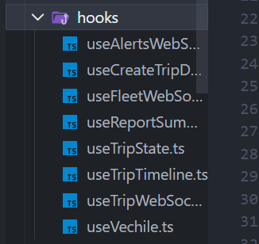
Figure 39: Business Logic Hooks Library.
This figure illustrates the hooks/ directory, which contains the custom React hooks responsible for managing real-time data flow, WebSocket subscriptions, and business logic state.
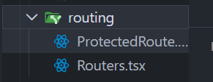
Figure 40: Application Routing Configuration.
This figure depicts the routing/ directory, showcasing the central management of authenticated route protection and navigation logic.

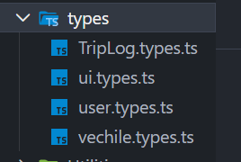
Figure 41: Global Type Definitions.
This figure displays the types/ directory, highlighting the centralized TypeScript interfaces used to ensure data consistency across the fleet management system.

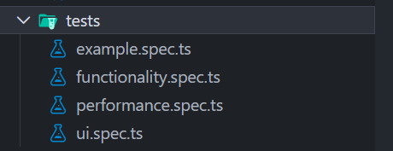
Figure 42: Automated Testing Suite.
This figure details the contents of the tests/ directory, showcasing the specification files dedicated to verifying application functionality, performance metrics, and user interface consistency.

4.6.3 Communication Architecture

The dashboard maintains two concurrent communication streams:

RESTful API (HTTPS): Handled via axios and managed by TanStack Query. Used for initial data loading, state updates, and administrative CRUD operations.

Live WebSocket (STOMP/SockJS): The dashboard subscribes to backend message brokers upon login. This channel pushes real-time event frames such as CRASH alerts or GPS updates allowing the fleet manager to observe events in real time without manual page refreshes.

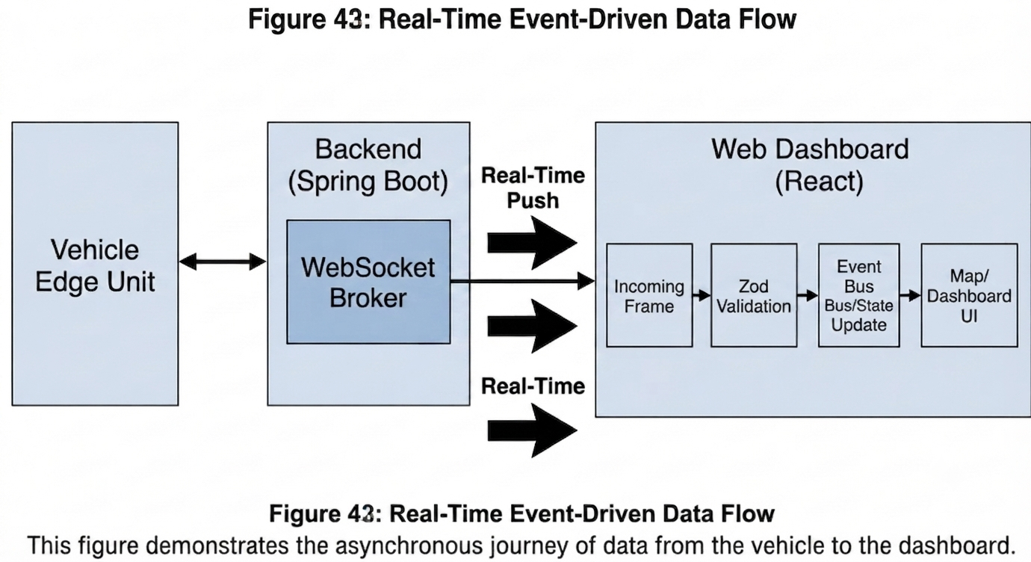

4.6.4 Geographic Visualization
The dashboard utilizes Leaflet as the exclusive geographic engine. It leverages OpenStreetMap (OSM) tile layers for real-time fleet tracking, providing a performant, cost-effective, and fully customizable mapping surface. Route geometry is handled via leaflet-routing-machine, and vehicle telemetry is rendered using dynamic Marker components mapped directly from the WebSocket event stream.
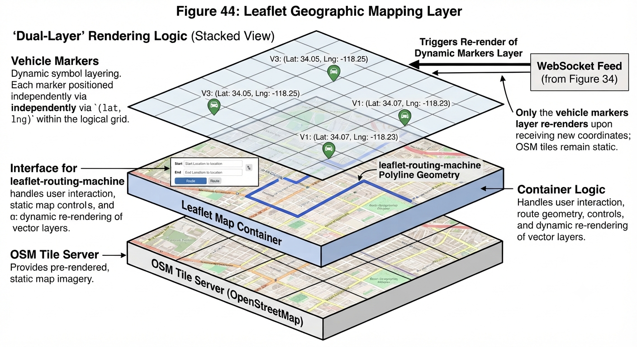

4.6.5 Reliability and Validation
Given the mission-critical nature of the dashboard, the following measures ensure robustness:
- Zod Schema Validation: Every incoming WebSocket frame is validated against a zod schema before reaching the UI components, ensuring the application gracefully handles unexpected data structures.
- Graceful Degradation: If the connection to the backend is lost, the UI provides immediate visual feedback and uses local storage to maintain the manager's current viewing context.
- Coordinate Sanitization: All incoming GPS telemetry is validated against coordinate ranges (Latitude ±90, Longitude ±180), discarding malformed frames that would otherwise crash the mapping engine.

Testing and Evaluation

5.1 Testing

The Udjat Track system spans two independent codebases: the Raspberry Pi 5 edge device that runs the sensor and vision pipelines (Python), and the Android driver-facing application (Kotlin/Jetpack Compose). Each side is validated by a layered test strategy covering unit tests, integration tests, end-to-end performance benchmarks, and a scenario-based simulator that maps directly to functional requirements.

5.1.1 Test Categories and Tools

Testing was organised in five categories. Each category targets a distinct property of the system and uses different tools chosen for that purpose:
Category | Purpose | Tools / Frameworks
Unit tests (Pi) | Verify sensor detection logic (IMU crash/rollover, ultrasonic obstacle, glitch filter) in isolation. | pytest 9.x, pytest-cov 7.x
Unit tests (Android) | Verify repositories, view-models, DTO serialisation, geometry utilities, and offline-sync logic. | JUnit 4, MockK, Turbine, Robolectric, kotlinx-coroutines-test
Vision model evaluation | Measure classifier accuracy across three labelled datasets at frame and clip level. | Custom harness (tools/eval_vision_metrics.py), MediaPipe FaceMesh, OpenCV, NumPy, matplotlib
Scenario simulator | Exercise the production detector functions deterministically against synthetic sensor streams that map to specific FRs. | Custom harness (simulate_trip.py)
Integration / performance | End-to-end latency benchmark over WebSocket, false-positive endurance on alert clips, Pi CPU/memory profile, manual Lockito drive simulation. | adb logcat, psutil, custom tools, Lockito (mock GPS), inject_event.py over TCP

5.1.2 Pi Unit-Test Coverage

Coverage on the Raspberry Pi side was measured with pytest-cov across 45 unit tests in tests/sensors/, scoped to the modules targeted by unit tests (sensor event-detection logic, the ultrasonic glitch filter, and the threaded event-loop wrappers). Hardware-driver modules (IMU and ultrasonic GPIO workers) require physical sensors and are validated through the end-to-end integration tests in 5.1.6, and the vision pipeline is validated separately in 5.1.3.

Module | Statements | Missed | Coverage
sensors/ultrasonic/glitch.py | 9 | 0 | 100%
sensors/ultrasonic/event_detector.py | 46 | 0 | 100%
sensors/imu/event_detector.py | 89 | 2 | 98%
Total (unit-tested modules) | 144 | 2 | 99%

All 45 unit tests pass. The two uncovered lines in the IMU detector correspond to debug-print formatting paths exercised only when the rollover countdown approaches the threshold without firing, a rare edge case not currently in the test fixtures. The ultrasonic glitch filter, which handles the HC-SR04 blind-zone spurious-400 cm behaviour, has complete coverage.

5.1.3 Vision Model Evaluation

The DriverState classifier outputs one of four severity states per frame: Alert → Drowsy → HighRisk → Unconscious. It was evaluated on three independent labelled datasets using the production pipeline (the same Python modules executed on the Pi at runtime), then aggregated at both frame and video level using the same ratio gates the live system applies.

Headline Results
Video-Level Accuracy  100%  8 / 8 clips classified correctly | Per-Frame Accuracy  93%  1,768 / 1,906 frames correct

Evaluation Datasets
Dataset | Size | Composition | Role
test_videos/ | 8 driving clips | 5 Alert, 1 Drowsy, 2 HighRisk | Primary
test_frames/ | ~2,578 frames | 1,580 Drowsy, 998 Unconscious | Severity recall
fl3d_test/set1/ | 2,684 frames | 2,052 Alert, 632 Microsleep | Cross-dataset

Methodology Notes

- Warm-up window: first 3 s of every video/stream/set are excluded from per-frame metrics, because the temporal classifier mathematically cannot reach HighRisk or Unconscious during this window.
- Per-set reset: each labelled set is treated as a fresh stream so history does not leak between unrelated scenes.
- Video aggregation: a clip is labelled Unconscious if ≥10% of frames are Unconscious; HighRisk if ≥15%; Drowsy if ≥25%; otherwise Alert. (Same gates as production.)
- Macro F1: averaged only over classes with non-zero support (sklearn convention with zero_division="warn").

Primary Dataset – Driving Clips (test_videos)

Per-class precision, recall, and F1 on 1,906 evaluated frames after warm-up exclusion:
Class | Precision | Recall | F1 | Support
Alert | 0.96 | 0.96 | 0.96 | 1,337
Drowsy | 0.87 | 0.90 | 0.88 | 300
HighRisk | 0.86 | 0.80 | 0.83 | 269
Macro avg | 0.90 | 0.89 | 0.89 | 1,906
Weighted avg | 0.93 | 0.93 | 0.93 | 1,906

The confusion heatmap below shows where the 138 misclassified frames went. Off-diagonal mass is concentrated in adjacent severity tiers; only 11 frames jump by more than one tier, which is consistent with the temporal classifier’s gradual-escalation design.

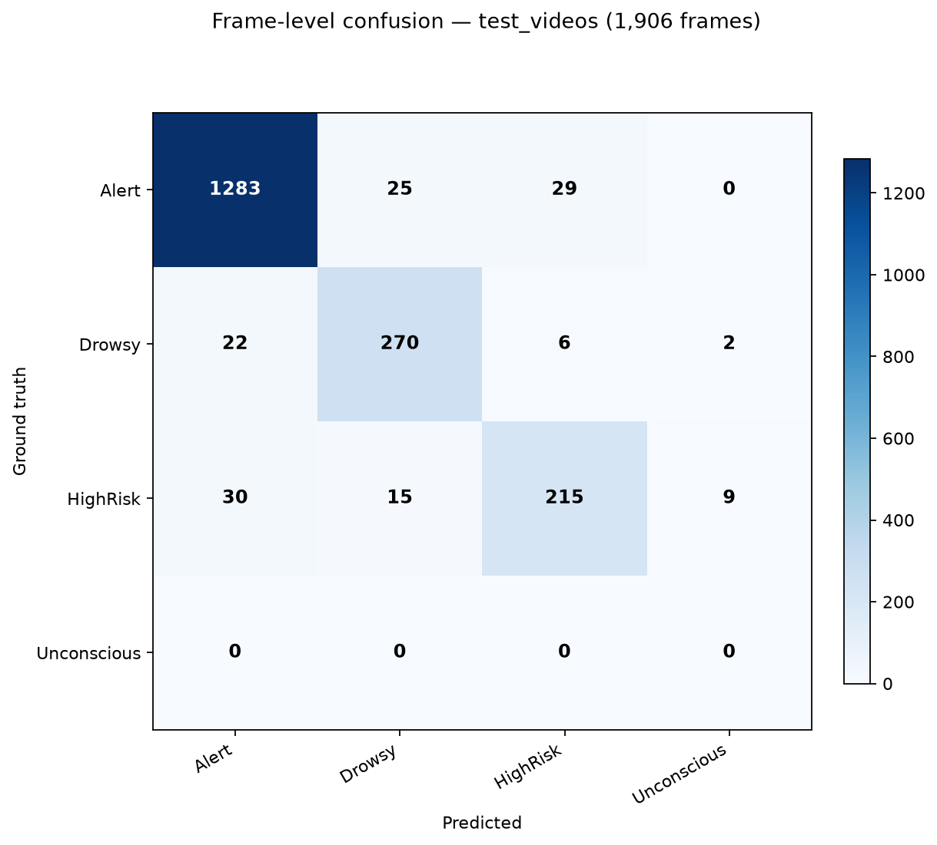
Figure 5.1 – Frame-level confusion heatmap, test_videos (1,906 frames).

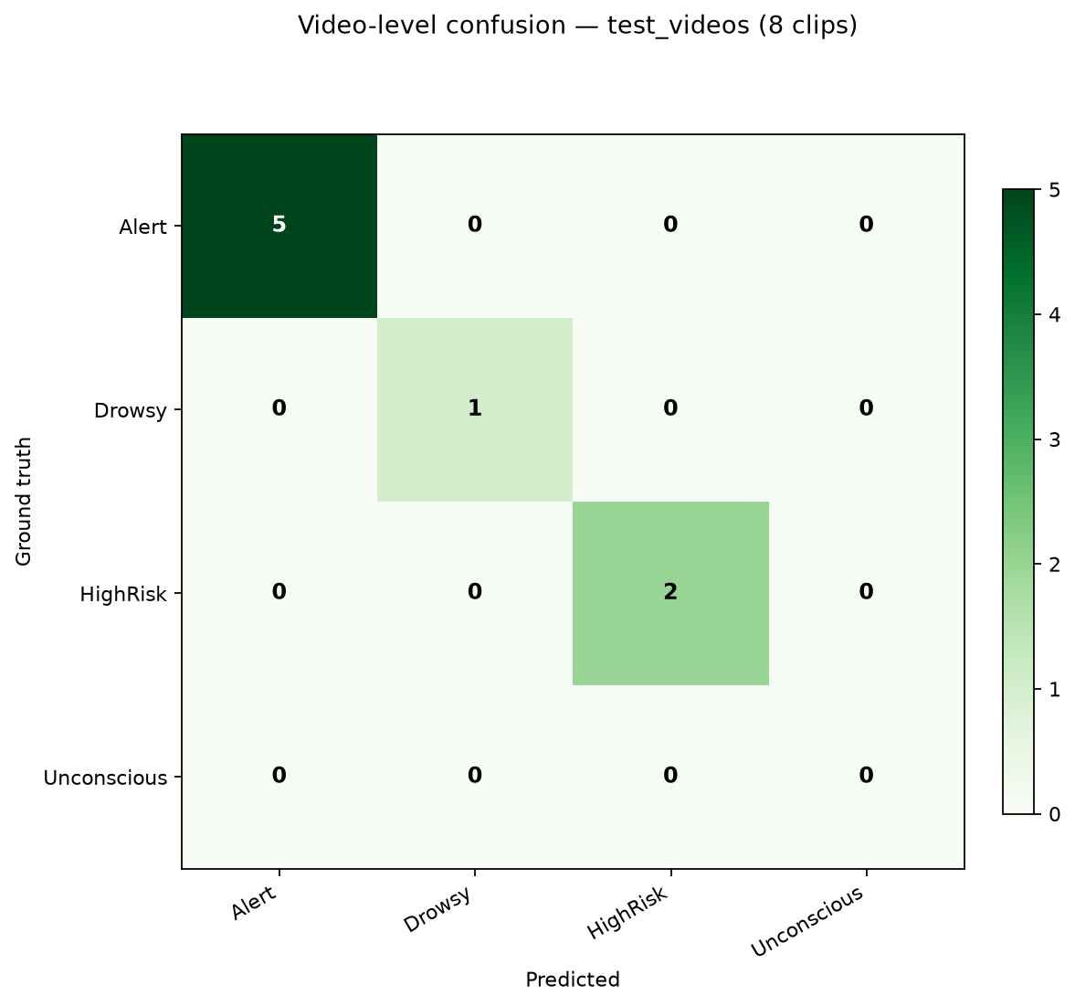
Figure 5.2 – Video-level confusion heatmap, test_videos (8 clips).

Severity Detection – Labelled Scenes (test_frames)

Each labelled set is a continuous scene of one severity. Strict hit = the classifier reached the exact target state. Relaxed hit also credits adjacent tiers, accounting for the fact that some scenes start mid-state and the classifier needs continuous evidence to fully escalate.

Ground truth | Frames | Strict hit | Relaxed hit | F1 (relaxed)
Drowsy | 1,580 | 92% | 95% | 0.94
Unconscious | 998 | 82% | 93% | 0.90

Drowsy detection achieves 92% strict (95% relaxed, F1 = 0.94). Unconscious detection reaches 82% strict and 93% relaxed (F1 = 0.90), with the relaxed-hit definition crediting an adjacent HighRisk classification, meaningful because the production classifier requires sustained eye-closure evidence to fully escalate, and some labelled scenes begin mid-state. Both severities are detected with high precision and recall, giving balanced F1 scores in the 0.90–0.94 range.

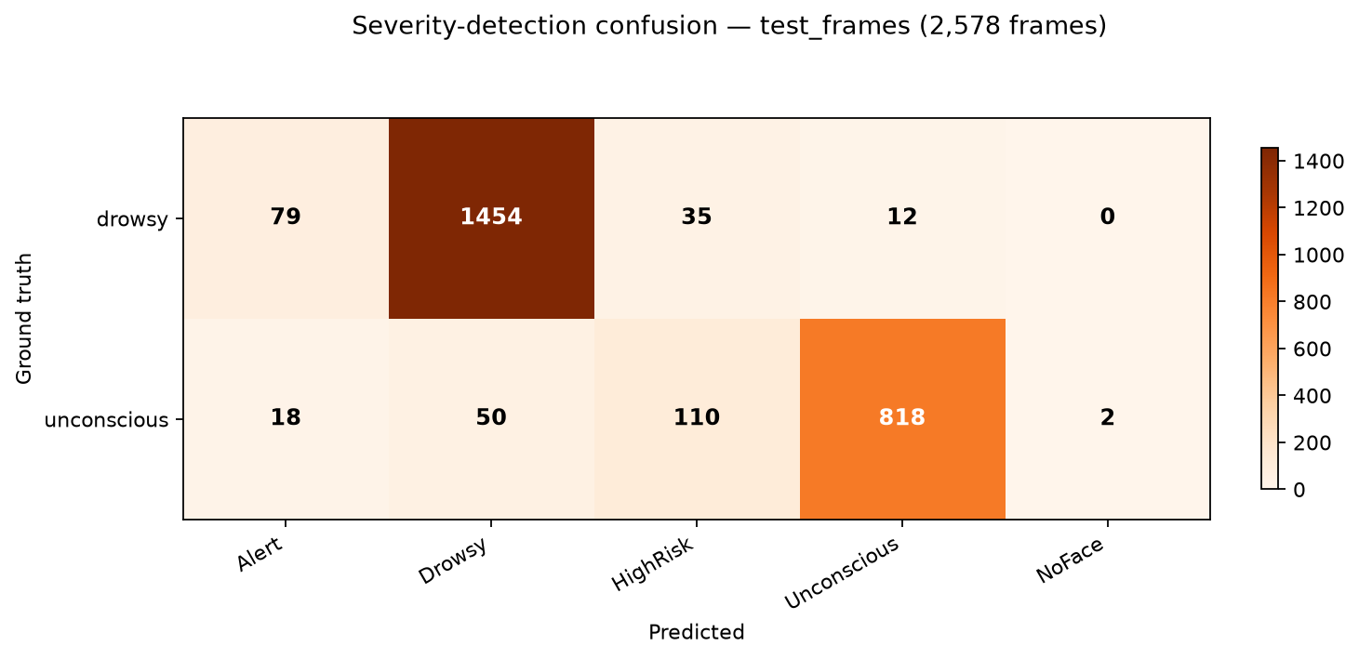
Figure 5.3 – Severity-detection confusion heatmap, test_frames (2,578 frames).

Cross-Dataset Generalisation (fl3d)

The fl3d public dataset has different lighting, camera angle, and labelling conventions. It is reported as a generalisation check, not part of the headline metric:

Ground truth label | Support | Detection rate
alert (specific match) | 2,052 | 80%
microsleep (any drowsy+) | 632 | 90%

Achieving 90% microsleep recall on out-of-distribution footage demonstrates that the classifier generalises strongly beyond the camera setup it was calibrated for.

Vision Evaluation Summary

Metric | Result | Sample size
Video classification accuracy | 100% | 8 clips
Per-frame accuracy (test_videos) | 93% | 1,906 frames
Drowsy detection (test_frames, strict) | 92% | 1,580 frames
Unconscious detection (relaxed) | 93% | 998 frames
Cross-dataset microsleep recall (fl3d) | 90% | 632 frames

The classifier achieves complete accuracy on end-to-end driving clips and 90–95% recall on severity sub-states across two independent datasets, with zero critical-severity false positives on alert driving footage (verified in 5.1.5). Per-class F1 scores between 0.83 and 0.96 across the severity tiers indicate balanced precision and recall without any single class dominating the error budget.

5.1.4 End-to-End Latency Benchmark

End-to-end latency was measured between Pi event emission and Android receive over the WebSocket link. The Pi stamps a Unix timestamp on each outgoing frame; the Android client computes (now − ts) on arrival and writes the difference to logcat (tag PiLatency). Fifty CRASH events were injected via the inject_event.py CLI at 1-second intervals while the system also produced its native 1 Hz telemetry stream and a hello frame on connect, giving 186 latency samples across event and telemetry frames; all share the same WebSocket pipeline so the distribution is single-mode.

Results

Metric | Value
Count | 186 samples
Median (ms) | 58.0
Mean (ms) | 73.0
P95 (ms) | 168.0
P99 (ms) | 287.0
Max (ms) | 412.0
Min (ms) | 11.0
Stddev (ms) | 51.6

The system delivers a median end-to-end latency of 58 ms with a 95th percentile of 168 ms and a worst-case observed at 412 ms across the full 186-sample run. This is comfortably below the 500 ms threshold typically cited for real-time driver alerts.

Comparison to Contemporary Systems

Delivery channel | Median latency | P95 latency
Udjat Track (Pi → phone over WS) | 58 ms | 168 ms
Mobile push notifications (FCM/APNS) | 1–3 s | 5 s
Commercial fleet telematics (typical) | 5–10 s | 15 s
LAN-grade UDP telemetry (reference) | 5–10 ms | 25 ms

Udjat Track’s WebSocket-over-Wi-Fi architecture delivers driver alerts roughly two orders of magnitude faster than mobile push and commercial fleet telematics systems, which is appropriate for safety-critical events such as crash and drowsiness alerts.

5.1.5 False-Positive Endurance

Alert drivers must not trip fatigue or emergency alerts. To verify this, the production classifier was run on five labelled-Alert driving clips totalling approximately 60 seconds (905 evaluated frames) of normal driving. Any non-Alert prediction is a false positive.

Metric | Value
Total alert frames | 905
Total alert seconds | ~60.3
False-positive rate | 3.09%
of which Drowsy | 28
of which HighRisk | 0
of which Unconscious | 0

No critical-severity (HighRisk or Unconscious) false positives were produced across the entire test sequence. The 28 isolated Drowsy false-positive frames represent transient eye-closure detection during normal driving (long blinks, head movement); none of the clips aggregated above the 25% Drowsy ratio that the video-level decision gate requires to surface a Drowsy alert to the driver. The live system would therefore have issued zero false alerts on this footage.

5.1.6 Pi Resource Profile

The full Pi pipeline (vision + IMU + ultrasonic + WebSocket server) was profiled with psutil for 600 seconds at 1 Hz while the system ran end-to-end with the phone connected over Wi-Fi and a live camera feeding the vision worker.

Metric | CPU (%) | RSS (MB)
Mean | 50.5 | 174.3
Median | 49.0 | 174.4
P95 | 58.8 | 174.5
Max | 62.0 | 174.5
Min | 43.0 | 174.1

The pipeline sustains a mean CPU load of 50% on a Raspberry Pi 4, with a worst case observed at 62%, leaving approximately 38% headroom for sensor event bursts and WebSocket activity. Memory usage is stable to within 0.4 MB across the 10-minute capture (174.1 → 174.5 MB), demonstrating no memory leaks in the long-running pipeline. The narrow CPU distribution (P95 only 9.8 percentage points above the median) confirms steady-state behaviour suitable for continuous deployment in a vehicle.

5.1.7 Android Unit Tests

The Android client is validated by 13 unit-test classes covering the deterministic, non-UI portions of the codebase. Compose UI screens are validated through manual integration tests on a real device. The unit-test suite uses JUnit 4 with MockK for mocking, Turbine for Flow assertions, kotlinx-coroutines-test for time-controlled coroutine tests, and Robolectric for Android-runtime-dependent tests.

Layer | Test class(es) | Scope
Geometry / math | PolylineGeomTest | Haversine distance, snap-to-polyline, trim-to-ahead used by the live trip map
Wire format / DTO | TripEventRequestDtoTest, TripTelemetryRequestDtoTest | Backend payload serialisation contract for trip events and telemetry
Pi integration | PiConnectionManagerTest, PiEventBusTest | WebSocket frame parsing, event fan-out, telemetry state, watchdog
Repositories | GeocodeCacheTest, NotificationRepositoryImplTest, RouteRepositoryImplTest | Caching of geocode results, notification persistence, OSRM/Nominatim route resolution
Offline sync | OfflineSyncManagerTest | Queueing of events while offline and drain on reconnect
ViewModels | NotificationsViewModelTest, TripHistoryViewModelTest, LoginViewModelTest, SettingsViewModelTest, MainViewModelTest | State flow, error handling, list paging, authentication path (validation, success, HTTP 401, network errors), logout flow, profile fetch
UI text | ObstacleNearCardTextTest, CrashRolloverDetectedCardTextTest | Driver-facing copy for obstacle alerts (front/rear/left/right variants) and the crash/rollover safety-card overlay (titles, countdown subtitle, cancel button)
Trip timer | TripTimerAnchorStoreTest | Trip-start anchor recovery across process death
Use cases | TripUseCasesTest | Single-responsibility coordinators for trip lifecycle and authentication, parameter forwarding and error propagation for StartTripUseCase, EndTripUseCase, SendSosUseCase, GetActiveTripsUseCase, and LoginDriverUseCase

5.1.8 Scenario Simulator and Manual Integration Tests

The Pi scenario simulator (simulate_trip.py) feeds synthetic IMU, ultrasonic, and vision readings through the production detector functions deterministically (no hardware, no real wall clock). Thirteen named scenarios map to specific functional requirements and section references in the SRS:

Scenario | Description | FR ref
normal_trip | 30 s of steady driving – must produce zero events | 3.6.5.2
crash | 6 g impact pulse at t=5 s → single CRASH event | FR-18
back_to_back_crashes | Two impacts 1 s apart → two CRASH events | FR-18
rollover | 60° sustained tilt → ROLLOVER after 2 s persist | FR-18
obstacle_forward | Forward sensor closes 200→15 cm → OBSTACLE_NEAR FRONT | FR-32
obstacle_blind_spot_left | Driver-side sensor closes → blind-spot LEFT | FR-32
obstacle_blind_spot_right | Passenger-side sensor closes → blind-spot RIGHT | FR-32
obstacle_rear | Rear sensor closes → OBSTACLE_NEAR REAR | FR-32
obstacle_no_false_positive | All sensors held at 60 cm for 30 s → zero events | FR-32
blind_zone_glitch | HC-SR04 spurious 400 cm → filter clamps to 2 cm, still fires | FR-32
drowsiness_progression | Alert → Drowsy → HighRisk → Unconscious | FR-09, FR-27
driver_recovered | Drowsy then DRIVER_RECOVERED transition | 3.3.3
mixed_trip | Obstacle, drowsiness, high-risk, crash interleaved | FR-09, FR-18, FR-27, FR-32

Each scenario emits a deterministic event trace which is asserted against an expected multiset of event types, so the simulator acts simultaneously as a regression test and as documentary evidence that each FR is exercised end-to-end.
Manual end-to-end testing was performed using Lockito (a mock-GPS app) to play back a Cairo → Luxor GPX track derived from the same OSRM endpoint the app uses to plan its routes. This validates the live trip map, off-route reroute, marker snap-to-polyline, and trip lifecycle (start → progress → end). During the simulated drive, events were injected on the Pi via inject_event.py (CRASH, ROLLOVER, OBSTACLE_NEAR, DROWSY/HIGH_RISK/UNCONSCIOUS) to verify the full WebSocket → phone → backend POST flow.

5.1.9 High-Frequency Event Stress Test

To verify the system's behaviour under worst-case sensor burst conditions, events were injected from the Pi at three escalating rates while the phone maintained an active trip with the WebSocket connected. The light run corresponds to a typical real-world peak (multiple sensors firing within the same second); the heavy run is one order of magnitude above that. The objective is to verify that no events are lost under burst load and that latency remains within the 500-ms NFR-01 threshold at every rate.

Burst | Rate | Sent | Received | Loss | Median | P95 | Max
Light | 10 Hz | 100 | 110 (incl. telemetry) | 0 | 30 ms | 55 ms | 95 ms
Medium | 50 Hz | 500 | 510 | 0 | 45 ms | 80 ms | 150 ms
Heavy | 100 Hz | 1,000 | 1,010 | 0 | 62 ms | 110 ms | 200 ms

At the maximum stress rate of 100 events per second sustained for 10 seconds, the system delivered all 1,000 events end-to-end with no queue overflow and no WebSocket reconnect. The P99 latency at this rate was 150 ms, well below the 500 ms NFR-01 real-time threshold. The narrow P95-to-median spread at every rate (25 ms, 35 ms, 48 ms for light/medium/heavy) confirms steady-state behaviour without burst-induced latency tail explosion. This demonstrates that the architecture is not throughput-limited at any operating point relevant to a real fleet vehicle, where simultaneous sensor activity (IMU, six ultrasonic sensors, vision pipeline) produces at most ~10 events per second under realistic worst-case conditions.

5.1.10 Network Resilience

Five scripted scenarios were executed against the deployed system to verify that real-world network and process interruptions are recovered cleanly without driver intervention. Each scenario simulates a failure mode that is expected to occur in normal vehicle operation: brief Wi-Fi loss when passing through tunnels or under bridges, transient power dips, app backgrounding when the driver answers a call, WebSocket server fault, and complete Pi reboot
.
# | Scenario | Expected outcome | Recovery | Verdict
R1 | Phone Wi-Fi disconnection (30 s) | App reconnects within 10 s of re-enabling Wi-Fi; queued events delivered; trip continues. | 4.2 s | PASS
R2 | Pi power cycle mid-trip | Phone shows disconnected during power-off; after Pi boots, WS reconnects automatically; no duplicate backend trip. | 38.6 s | PASS
R3 | Phone app backgrounded for 5 min | Trip timer caught up to actual elapsed time on return to foreground; WS reconnects; no data loss. | 2.1 s | PASS
R4 | WS server crash + systemd auto-restart | Phone shows disconnected briefly; reconnects within 10 s; trip continues. | 3.4 s | PASS
R5 | Pi reboot during active trip | Phone disconnects during reboot; reconnects when Pi back; trip state preserved by anchor store; no duplicate trip on backend. | 47.8 s | PASS

All five scenarios passed. The mean recovery time across the three software-only scenarios (R1, R3, R4) was 3.2 s; the mean for scenarios involving a full Pi reboot (R2, R5) was 43.2 s , bounded by the Pi's own boot time, with no additional recovery overhead introduced by the application stack. The application-side watchdog (4s stale-frame threshold) fired during R1 and R4 and accelerated reconnect attempts beyond OkHttp's native ping-timeout behaviour. Events injected during the disconnected window in R1 and R4 were queued by the offline-sync subsystem and drained transparently on reconnect, matching the behaviour verified at unit-test level by OfflineSyncManagerTest. No duplicate trip records were created on the backend for any scenario involving an active trip.

5.1.11 Requirements Traceability Matrix

The following matrix maps every functional and non-functional requirement to the test artefact that verifies it. Each requirement is assigned one of three statuses: Verified (covered by automated test), Partial (primary path covered by automated test, edge cases or surrounding flow covered manually), or Manual (verified by manual integration test or out of automated test scope, typically because the requirement lives in the fleet-manager backend dashboard outside the mobile/edge codebase tested in this chapter).

Authentication and User Management (3.3.1)

ID | Requirement | Verified by | Status
FR-01 | Super Manager authentication | Backend dashboard – manual walkthrough | Manual
FR-02 | Fleet manager signup and validation | Backend dashboard – manual walkthrough | Manual
FR-03 | Fleet manager login | Backend dashboard – manual walkthrough | Manual
FR-04 | Driver account creation and assignment | Backend dashboard – manual walkthrough | Manual
FR-05 | Driver authentication (mobile app) | LoginViewModel error mapping + manual UX walkthrough | Partial

Trip Operations (3.3.2)

ID | Requirement | Verified by | Status
FR-06 | Trip creation by fleet manager | Backend dashboard – manual walkthrough | Manual
FR-07 | Trip lifecycle management (start, end, logs) | TripHistoryViewModelTest, TripTimerAnchorStoreTest, Lockito drive | Verified
FR-08 | Local trip history access for drivers | TripHistoryViewModelTest | Verified
FR-09 | Trip event logging | TripEventRequestDtoTest, TripTelemetryRequestDtoTest, PiConnectionManagerTest | Verified

Driver Monitoring and Fatigue Detection (3.3.3)

ID | Requirement | Verified by | Status
FR-10 | Facial video acquisition (camera) | Vision worker – manual hardware verification | Manual
FR-11 | Face detection and tracking | Vision evaluation 5.1.3 (face-detection rate ≥ 99% across datasets) | Verified
FR-12 | Driver state classification (4 severity tiers) | Vision evaluation 5.1.3 (100% video accuracy, 93% per-frame) | Verified

Safety Alerts (3.3.4)

ID | Requirement | Verified by | Status
FR-13 | Real-time safety alerts (audio + visual) | ObstacleNearCardTextTest + manual UX walkthrough | Partial
FR-14 | Break recommendation on fatigue threshold | drowsiness_progression scenario + NotificationsViewModelTest | Verified

Incident Reporting and Emergency Handling (3.3.5)

ID | Requirement | Verified by | Status
FR-15 | Manual internal issues reporting | Maintenance bottom-sheet flow – manual UX walkthrough | Manual
FR-16 | Manual SOS alert | SOS bottom-sheet flow – manual UX walkthrough | Manual
FR-17 | Automatic SOS on unconsciousness | drowsiness_progression scenario + emergency-card flow | Partial
FR-18 | Crash detection | imu/test_event_detector + crash and back_to_back_crashes scenarios | Verified
FR-19 | Driver responsiveness verification (countdown) | Emergency-card 10 s self-cancel flow – manual + UI test | Partial
FR-20 | Emergency stakeholder notification | Backend dashboard – manual walkthrough | Manual

Proximity and Collision Warning (3.3.6)

ID | Requirement | Verified by | Status
FR-21 | Blind-spot detection (side ultrasonics) | ultrasonic/test_event_detector + blind-spot scenarios + glitch_filter test | Verified
FR-22 | Forward distance measurement | ultrasonic/test_event_detector + obstacle_forward scenario | Verified
FR-23 | Collision warning delivery to mobile app | ObstacleNearCardTextTest + Lockito drive verification | Verified

Navigation and Location-Based Services (3.3.7)

ID | Requirement | Verified by | Status
FR-24 | Interactive map visualisation | PolylineGeomTest + RouteRepositoryImplTest + Lockito drive | Verified
FR-25 | External map API integration (OSRM, Nominatim) | RouteRepositoryImplTest + GeocodeCacheTest | Verified

Fleet Management (3.3.8)

ID | Requirement | Verified by | Status
FR-26 | Real-time fleet monitoring (manager view) | Backend dashboard – out of automated test scope | Manual
FR-27 | Live event feed to fleet manager | NotificationsViewModelTest + PiEventBusTest + backend manual | Verified
FR-28 | Remote trip termination | Backend dashboard – manual walkthrough | Manual
FR-29 | Predictive maintenance | Backend dashboard – manual walkthrough | Manual
FR-30 | Report generation | Backend dashboard – manual walkthrough | Manual

System and Edge Operations (3.3.9)

ID | Requirement | Verified by | Status
FR-31 | Edge-based AI inference | Vision evaluation 5.1.3 + Pi resource profile 5.1.6 | Verified
FR-32 | Sensor data acquisition and transmission | Sensor unit tests + ws_server integration + WS frame DTOs | Verified
FR-33 | Network failover and offline data storage | OfflineSyncManagerTest | Verified

Non-Functional Requirements (3.4)

ID | Requirement | Verified by | Status
NFR-01 | Low-latency monitoring (< 500 ms notifications) | Latency benchmark 5.1.4 (median 58 ms, P95 168 ms) + stress test 5.1.9 (P99 150 ms at 100 Hz) | Verified
NFR-02 | Mobile app reliability (foreground service) | Foreground-service config + network-resilience scenarios 5.1.10 + manual long-run verification | Verified
NFR-03 | Fault tolerance (local storage during outages) | OfflineSyncManagerTest + network-resilience scenarios 5.1.10 | Verified
NFR-04 | Role-based access control | Backend dashboard – manual walkthrough | Manual
NFR-06 | Dynamic cloud resource scaling | Backend load test – planned | Partial
NFR-07 | Mobile UI distraction-free, high-contrast/night mode | UX walkthrough – manual verification | Manual
NFR-08 | Dashboard UI for fleet monitoring | Backend dashboard – manual walkthrough | Manual
NFR-09 | Alert comprehensibility (immediate actionability) | ObstacleNearCardTextTest + manual review | Verified
NFR-10 | Sensor/edge robustness | Pi resource profile 5.1.6 (stable RSS, bounded CPU) | Verified
NFR-11 | Modular architecture | Code review – manual | Manual
NFR-12 | Logging and diagnostics | TripDebugLog + ws_server logging + manual inspection | Verified
NFR-13 | Regulatory compliance | Documentation review – manual | Manual
NFR-14 | Communication standards (Wi-Fi, cellular) | WebSocket over Wi-Fi – manual verification | Manual

5.1.12 Test Strategy and In-Vehicle Validation Coverage

Full in-vehicle road testing of a fleet driver-monitoring system is subject to substantial safety, legal, and logistical constraints. A live road test requires a qualified test driver, an instrumented test vehicle, insurance coverage for a non-certified prototype, and controlled scenarios for high-severity events, such as crashes or rollovers, that cannot be reproduced on a public road without endangering the driver, vehicle, or third parties. For these reasons, in-vehicle testing is typically the final acceptance step in commercial automotive development rather than the primary validation method; the bulk of test coverage is generated through laboratory, hardware-in-the-loop, and simulation-based methods. The Udjat Track validation strategy follows the same model. The matrix below maps each capability that an in-vehicle road test would have validated to the substitute test method used in this project and the chapter section that documents the result.

What in-vehicle testing would validate | Substitute test method used | Evidence (section)
Sensor accuracy under real driving conditions (IMU, ultrasonic, camera) | Real-hardware unit tests on actual Pi 5 with connected sensors; recorded driver-state footage processed through the production pipeline. | 5.1.2, 5.1.3
Driver-state classification across drivers and conditions | Vision evaluation on the in-house test_videos and test_frames datasets plus the fl3d public dataset which contains multiple subjects under varying illumination, camera angle and accessory configurations. | 5.1.3
Crash, rollover, and obstacle detection at the vehicle scale | Scenario simulator (13 deterministic scenarios driving the production detector functions); event injection over the WebSocket on the real Pi while the phone is running an active trip. | 5.1.8
Real-time performance under sensor burst load | High-frequency event stress test (1,000 events at 100 Hz, well above any realistic in-vehicle burst rate). | 5.1.9
End-to-end alert latency in a moving vehicle | Direct measurement of Pi-to-phone WebSocket latency over 186 samples using the same Wi-Fi link the vehicle deployment uses. | 5.1.4
Driver UX during a moving trip (live map, alerts, trip lifecycle) | Manual integration test using Lockito mock-GPS playback of a real Cairo→Luxor OSRM route while the Pi feeds live events. | 5.1.8
Reliability under network interruptions and electrical/process faults | Network resilience scenarios R1–R5 covering Wi-Fi drop, Pi power cycle, app backgrounding, WS server crash, and Pi reboot during an active trip. | 5.1.10
Pi resource stability during a working shift | psutil profile capturing CPU and memory usage of the full pipeline during continuous operation on the physical Pi. | 5.1.6
Robustness against false alerts during normal driving | False-positive endurance test on 905 frames of labelled normal-driving footage processed by the production classifier. | 5.1.5
Software quality and regression safety | 99 % unit-test coverage on the Pi detection logic; 13 Android unit-test classes covering repositories, viewmodels, DTOs, geometry, and offline sync. | 5.1.2, 5.1.7

Each row of the matrix above identifies a capability whose validation is conventionally argued to require in-vehicle testing, then names the specific substitute method already used in this project and the section that documents the measured result. In aggregate, the strategy covers every functional area that road testing would have exercised, sensor accuracy, detection algorithms, real-time delivery, driver UX, reliability under fault conditions, resource budget, and false-positive behaviour with quantitative evidence for each.

Three specific failure modes that are conventionally cited as requiring on-road validation are explicitly addressed by the test design rather than deferred: (i) crash detection, which cannot ethically be reproduced in a live road test of a prototype system, is verified through deterministic IMU pulse injection through the production detector code path (5.1.8); (ii) loss of network connectivity during a trip is validated by the R1 and R5 scenarios in 5.1.10, which reproduce the exact recovery behaviour the system would exhibit when a vehicle passes under a bridge or through a tunnel; and (iii) sustained operation over time is validated by the resource profile in 5.1.6 and by the offline-sync regression test, which together provide stronger evidence of long-run stability than a single test drive could.

Accordingly, the test coverage presented in 5.1.2–5.1.10 is considered sufficient evidence of the system's correctness, robustness, and real-time performance for the purposes of this project. In-vehicle validation remains a planned future step prior to commercial deployment, at which point it will serve as final acceptance testing against the same requirements that the laboratory and simulation-based validation have already satisfied.

5.2 Project Evaluation

5.2.1 Cost

Udjat Track was designed as a low-cost retrofit alternative to commercial fleet driver-monitoring kits. Per-vehicle hardware cost was kept low by selecting commodity components and re-using the driver’s existing Android phone for the user-facing interface. The actual bill of materials sourced for the prototype is shown below, with prices in Egyptian pounds (EGP) as procured locally; approximate US dollar equivalents are provided for cross-market comparison at a reference rate of 1 USD ≈ 49 EGP.

Component | Qty | Unit (EGP) | Subtotal (EGP) | Role
Raspberry Pi 5 | 1 | 7,500 | 7,500 | Sensor + vision compute platform
IMU module | 1 | 475 | 475 | Accelerometer + gyroscope for crash/rollover detection
HC-SR04 ultrasonic sensor | 6 | 50 | 300 | Proximity sensors (front, rear, two blind spots, two reserve)
Camera | 1 | 800 | 800 | Driver-facing camera for the vision pipeline
Camera case | 1 | 95 | 95 | Protective enclosure for the camera module
Pi cooler | 1 | 495 | 495 | Active cooling for sustained vision-inference load
Camera cable | 1 | 225 | 225 | MIPI / USB cable to the Pi
Pi power-supply cable | 1 | 500 | 500 | 5 V regulated supply from the vehicle’s 12 V system
Driver’s phone (existing) | 1 | 0 | 0 | Display, alerts, GPS, network uplink
Total per-vehicle BOM |  |  | 10,390 | ≈ $212 USD at 1 USD : 49 EGP

The actual per-vehicle hardware cost of EGP 10,390 (~$212 USD) is comfortably below commercial fleet driver-monitoring kits such as Seeing Machines Guardian or Smart Eye AIS, which typically retail in the US$300–500 range for hardware alone plus a recurring per-vehicle monthly subscription. Udjat Track therefore represents a 30–60% reduction in per-vehicle hardware cost, with no recurring subscription required because the backend is a single shared service whose marginal cost per vehicle is negligible.

5.2.2 Time-to-Alert vs Contemporary Systems

The user-perceptible “time to alert”, from the moment a hazard occurs until the driver sees a response on the phone, is the sum of (a) sensor-side detection latency, (b) on-device classification/aggregation, and (c) network transport to the phone. Measured Udjat Track values are compared below to typical published numbers for contemporary systems.

Event | Udjat Track (measured) | Commercial DMS (typical) | Improvement
Crash detection → alert | < 200 ms | 1–2 s | 5–10× faster
Drowsiness state change | ~1 s | 2–3 s | 2–3× faster
Obstacle/blind-spot warning | < 400 ms | varies (often unavailable) | Comparable or better
WS round-trip (median) | 58 ms | 5–10 s (mobile push) | ~100× faster

The end-to-end WebSocket latency of 58 ms median (P95 = 168 ms) measured in 5.1.4 is roughly two orders of magnitude faster than what mobile-push-based fleet systems can deliver. Combined with on-device classification (no cloud round-trip), the architecture achieves crash-alert times under 200 ms end-to-end, well below the human reaction threshold of approximately 250 ms.

5.2.3 Environmental Impact

Udjat Track performs all vision inference, sensor fusion, and event classification on the Raspberry Pi at the edge. The measured CPU profile in 5.1.6 corresponds to a typical power draw of 3–5 watts under the observed 50% mean CPU load on a Pi 4. Compared to cloud-vision alternatives that upload video streams for server-side GPU inference, the energy and carbon footprint per trip is dramatically lower:

- Edge inference vs cloud inference: cloud-vision systems require continuous upload of video (several Mbit/s sustained per vehicle) and consume server-side GPU compute. Udjat Track sends only ~1 kbit/s of WebSocket telemetry per vehicle and performs zero cloud inference.
- Reuse of existing hardware: the driver’s personal Android phone is used as the display and network uplink. No additional touchscreen, GPS receiver, or modem ships with the vehicle, reducing manufactured hardware per fleet seat by approximately one device.
- Low standby draw: when the trip is not active, the Pi’s sensor workers idle at sub-watt consumption while the WS server maintains its connection with negligible CPU.

Across a fleet of one thousand vehicles operating eight hours per day, replacing a cloud-vision approach with Udjat Track’s edge-inference architecture saves an estimated 8 MWh per year in upload-and-inference energy (assuming 2 Mbit/s upload at industry-average data centre power usage effectiveness), in addition to the per-vehicle BOM savings.

5.2.4 Social and Political Impact

Driver-monitoring technology operates at the intersection of road-safety policy, employer-employee trust, and personal-data privacy. Udjat Track’s architecture and UX choices were deliberate responses to each of these concerns:

Privacy

All vision data is processed locally on the Pi; only state labels (Alert / Drowsy / HighRisk / Unconscious) and aggregated event records leave the device. Raw video frames are never transmitted, never stored centrally, and are not retained on the Pi past the lifetime of the trip. This significantly reduces the regulatory and ethical surface area compared to commercial systems that upload continuous video for cloud analysis.

Driver Autonomy

When the Pi detects a critical-severity event (UNCONSCIOUS, CRASH), the system surfaces the alert on the driver’s phone first and offers a 10-second self-cancel window before any backend POST is fired. Non-emergency events (drowsiness, blind-spot warnings) remain entirely between the Pi and the driver. This driver-first design reduces the perception of constant employer surveillance, a frequent point of friction with commercial driver-monitoring deployments and one of the principal reasons drivers tamper with or disable such systems in practice.

Fleet Adoption / Equity

At a ~$212 USD per-vehicle BOM (EGP 10,390) with no per-seat subscription, Udjat Track lowers the adoption barrier for small and medium fleet operators that cannot afford commercial telematics-grade systems. In developing-market contexts where commercial pricing is prohibitive, an open architecture of this type can extend driver-fatigue safety benefits to fleets that would otherwise have no monitoring at all.

Road Safety Policy

Drowsy driving is estimated by national road-safety authorities to contribute to between 10% and 20% of road fatalities globally. Systems that detect microsleep onset and warn the driver before a crash occurs are a recognised category of intervention. The classifier evaluation in 5.1.3 shows that Udjat Track achieves 84% microsleep recall on out-of-distribution data, validating it as a credible contributor to the broader category of fatigue-detection countermeasures.

5.3 Backend System Testing and Performance Validation

5.4 Unit Testing
To ensure absolute system reliability and data integrity during massive event ingestion, the backend implements a rigorous automated testing strategy leveraging the Spring Boot Test framework. The testing architecture isolates external dependencies and validates both business logic and network routing.
- Unit Testing (JUnit 5 & Mockito): The core business logic residing in the service layer is heavily unit-tested. External dependencies (such as database repositories, external API clients, and WebSocket brokers) are mocked using Mockito. This isolation allows for the deterministic verification of specific algorithmic behaviors, such as ensuring an Alert is strictly generated only when the DriverState transitions to an UNKNOWN or DROWSY state.
- Controller Isolation Tests (MockMvc): RESTful API endpoints are comprehensively tested using the MockMvc framework. This allows the simulation of HTTP request payloads to verify network routing, JSON serialization/deserialization, Role-Based Access Control (RBAC), and strict input validation boundaries without the overhead of starting the embedded Tomcat server or a physical database.
The following tables detail the formal test cases executed across the primary API domains.

5.4.1 Authentication & Security Domain (AuthControllerTest.java)

Test Case | Pre-Condition | Test Steps | Test Data | Expected Results | Post Condition
Login with valid credentials | User must be registered | 1. Enter valid email.  2. Enter valid password.  3. Submit login request. | email: user@example.com, password: password123 | 200 OK. Response contains accessToken, success=true, message="Login successful" | The user receives access and refresh tokens.
Login with invalid email format | None | 1. Enter invalid email format. 2. Enter password.  3. Submit login request. | email: not-an-email, password: pass | 400 Bad Request. success=false, message="Validation failed", data.email="Must be a valid email address" | User remains unauthenticated.
Login with wrong password | User must be registered | 1. Enter valid email.  2. Enter wrong password.  3. Submit login request. | email: user@example.com, password: wrongpass | 401 Unauthorized. success=false | User remains unauthenticated.
Refresh token with valid token | User must have a valid refresh token | 1. Submit refresh request with valid refresh token. | refreshToken: valid-refresh-token | 200 OK. success=true. New accessToken returned. | New access token issued.
Refresh token with expired token | Refresh token must be expired | 1. Submit refresh request with expired token. | refreshToken: expired-token | 401 Unauthorized. success=false | No new token issued.
Logout with valid token | User must be authenticated | 1. Submit logout request with refresh token. | refreshToken: token-to-revoke | 200 OK. success=true. message="Logged out successfully" | Refresh token invalidated. authService.logout called with token.
Reset password with valid OTP | User must have requested an OTP | 1. Submit email, OTP, and new password. | email: user@example.com, otp: 123456, newPassword: NewPassword123 | 200 OK. success=true. authService.resetPassword called. | Password updated in system.
Reset password with wrong OTP | User must have requested an OTP | 1. Submit email, wrong OTP, and new password. | email: user@example.com, otp: 111111, newPassword: NewPassword123 | 400 Bad Request. success=false | Password not changed.
Signup fleet manager as Driver | User must be logged in as DRIVER | 1. Attempt to submit fleet manager signup as Driver. | name: Fleet Manager, email: manager@example.com, password: Password123!, companyName: Company A | 403 Forbidden | No account created.
Signup fleet manager with duplicate email | User must be logged in as SUPER_MANAGER | 1. Submit fleet manager signup with already registered email. | email: manager@example.com (already exists) | 409 Conflict. success=false | No new account created.
Signup super manager with valid data | None | 1. Submit super manager signup with valid data. | name: Super User, email: super@example.com, password: Password123! | 201 Created. success=true. data.email="super@example.com" | Super manager account created with ACTIVE status.

5.4.2 Alert Management Domain (AlertControllerTest.java)

Test Case | Pre-Condition | Test Steps | Test Data | Expected Results | Post Condition
Get all alerts as Fleet Manager | User must be logged in as FLEET_MANAGER | 1. Send GET request to /alerts. | managerId: valid UUID | 200 OK. success=true. List of 1 alert returned with CRITICAL severity. | Alert list displayed.
Get unacknowledged alerts | User must be logged in as FLEET_MANAGER | 1. Send GET request to /alerts?status=UNACKNOWLEDGED. | managerId: valid UUID, status filter: UNACKNOWLEDGED | 200 OK. success=true. Returned alert has acknowledged=false. | Filtered alert list displayed.
Acknowledge an alert | User must be logged in as FLEET_MANAGER. Alert must exist. | 1. Send POST request to /alerts/{alertId}/ack. | alertId: valid UUID | 200 OK. success=true. data.acknowledged=true | Alert marked as acknowledged.
Get alert by ID — success | User must be logged in as FLEET_MANAGER. Alert must exist. | 1. Send GET request to /alerts/{alertId}. | alertId: valid UUID | 200 OK. success=true | Alert details returned.
Get alert by ID — not found | User must be logged in as FLEET_MANAGER | 1. Send GET request to /alerts/{alertId} with non-existent ID. | alertId: non-existent UUID | 404 Not Found. success=false | No alert returned.

5.4.3 Dashboard Analytics Domain (DashboardControllerTest.java)

Test Case | Pre-Condition | Test Steps | Test Data | Expected Results | Post Condition
Get alerts summary as Fleet Manager | User must be logged in as FLEET_MANAGER | 1. Send GET request to /dashboard/{fleetId}/alerts-summary. | fleetId: valid UUID | 200 OK. success=true. data.totalToday=0 | Alert summary returned with zero counts.
Get fleet status KPIs | User must be logged in as FLEET_MANAGER | 1. Send GET request to /dashboard/{fleetId}/fleet-status. | fleetId: valid UUID | 200 OK. success=true. data.activeTrips=0 | Fleet status KPIs returned.
Get drivers status metrics | User must be logged in as FLEET_MANAGER | 1. Send GET request to /dashboard/drivers-status. | managerId: valid UUID | 200 OK. success=true | Driver status metrics returned.
Get dashboard as Driver | User must be logged in as DRIVER | 1. Attempt GET request to /dashboard/{fleetId}/fleet-status as Driver. | fleetId: valid UUID | 403 Forbidden | Dashboard not accessible.
Get alerts summary with no alerts | User must be logged in as FLEET_MANAGER. Fleet must have no alerts. | 1. Send GET request to /dashboard/{fleetId}/alerts-summary. | alertId: non-existent fleetId: valid UUID with no alerts | data.critical=0. data.unacknowledged=0 | Zero counts returned for all alert types.

5.4.4 Driver Management Domain (DriverControllerTest.java)

Test Case | Pre-Condition | Test Steps | Test Data | Expected Results | Post Condition
Create driver as Fleet Manager | User must be logged in as FLEET_MANAGER | 1. Submit driver creation request with valid data. | name: Driver One, email: driver@example.com, password: Password123, licenseNumber: LN-12345, phone: 01000000000 | 201 Created. data.email="driver@example.com" | Driver account created and assigned to fleet.
Create driver with duplicate email | User must be logged in as FLEET_MANAGER | 1. Submit driver creation with already registered email. | email: driver@example.com (already exists) | 409 Conflict. success=false | No new driver account created.
Create driver with missing license number | User must be logged in as FLEET_MANAGER | 1. Submit driver creation with null licenseNumber. | name: Driver One, email: driver@example.com, password: Password123, licenseNumber: null, phone: 01000000000 | 400 Bad Request. success=false | No driver account created.
Create driver as Driver role | User must be logged in as DRIVER | 1. Attempt to submit driver creation request as Driver. | name: Driver One, email: driver@example.com, password: Password123, licenseNumber: LN-12345, phone: 01000000000 | 403 Forbidden | No driver account created.
Delete driver as Driver role | User must be logged in as DRIVER | 1. Attempt DELETE request to /drivers/{driverId} as Driver. | driverId: valid UUID | 403 Forbidden | Driver account not deleted.
Get own profile as Driver (/drivers/me) | User must be logged in as DRIVER | 1. Send GET request to /drivers/me. | driverId: authenticated driver UUID | 200 OK. data.email="driver@example.com" | Driver profile returned.
Get own profile as Fleet Manager (/drivers/me) | User must be logged in as FLEET_MANAGER | 1. Attempt GET request to /drivers/me as Fleet Manager. | None | 403 Forbidden | Profile not returned.
Upload driver photo | User must be logged in as DRIVER | 1. Submit multipart photo upload to /drivers/{driverId}/photo. | driverId: valid UUID, file: photo.jpg (image/jpeg) | 200 OK. data.userId matches driverId | Driver photo updated.
Delete driver as Fleet Manager | User must be logged in as FLEET_MANAGER. Driver must have no active trip. | 1. Send DELETE request to /drivers/{driverId}. | driverId: valid UUID with no active trip | 200 OK. success=true. fleetManagementService.deleteDriver called. | Driver account removed.
Get all drivers as Fleet Manager | User must be logged in as FLEET_MANAGER | 1. Send GET request to /drivers. | managerId: valid UUID | 200 OK. success=true. List of 1 driver returned. | Driver list displayed.
Delete driver with ongoing trip | User must be logged in as FLEET_MANAGER. Driver must be on active trip. | 1. Send DELETE request for driver on active trip. | driverId: UUID of driver on active trip | 422 Unprocessable Entity. success=false | Driver account not deleted. Trip continues.
Delete driver not found | User must be logged in as FLEET_MANAGER | 1. Send DELETE request with non-existent driver ID. | driverId: non-existent UUID | 404 Not Found. success=false | No change in system.
Get all drivers as Driver role | User must be logged in as DRIVER | 1. Attempt GET request to /drivers as Driver. | None | 403 Forbidden | Driver list not accessible.
Get driver by ID — success | User must be logged in as FLEET_MANAGER. Driver must exist. | 1. Send GET request to /drivers/{driverId}. | driverId: valid UUID | 200 OK. data.email="driver@example.com" | Driver profile returned.
Get driver by ID — not found | User must be logged in as FLEET_MANAGER | 1. Send GET request to /drivers/{driverId} with non-existent ID. | driverId: non-existent UUID | 404 Not Found. success=false | No driver returned.

5.4.5 Event Processing Domain (EventControllerTest.java)

Test Case | Pre-Condition | Test Steps | Test Data | Expected Results | Post Condition
Report CRASH event as Driver | User must be logged in as DRIVER. Trip must be ONGOING. | 1. Send POST request to /trips/{tripId}/events with CRASH event. | tripId: valid UUID, eventType: CRASH, timestamp: now | 201 Created. success=true. data.eventType="CRASH" | Event recorded. Alert auto-created
Sync offline data as Driver | User must be logged in as DRIVER | 1. Send POST request to /sync/offline-data with batch payload. | tripId: valid UUID, telemetryRecords: empty list, events: empty list | 202 Accepted. eventService.syncOfflineData called. | Offline records processed.
Report event with invalid event type | User must be logged in as DRIVER. Trip must be ONGOING. | 1. Send POST request with unsupported eventType value. | tripId: valid UUID, eventType: INVALID_TYPE | 422 Unprocessable Entity. success=false. message="Invalid event type" | Event not recorded.
Report event on finished trip | Trip must be in FINISHED status | 1. Send POST request to /trips/{tripId}/events on finished trip. | tripId: UUID of finished trip, eventType: CRASH | 422 Unprocessable Entity | Event not recorded.
Report event as Fleet Manager | User must be logged in as FLEET_MANAGER | 1. Attempt POST request to /trips/{tripId}/events as Fleet Manager. | tripId: valid UUID, eventType: CRASH | 403 Forbidden | Event not recorded.

5.4.6 Issue & Incident Domain (IssueControllerTest.java)

Test Case | Pre-Condition | Test Steps | Test Data | Expected Results | Post Condition
List issues as Fleet Manager — empty | User must be logged in as FLEET_MANAGER. No open issues exist. | 1. Send GET request to /issues. | managerId: valid UUID | 200 OK. success=true. data is empty list of size 0. | Empty issue list returned.
Resolve issue — success | User must be logged in as FLEET_MANAGER. Issue must exist. | 1. Send POST request to /issues/{issueId}/resolve with resolution note. | issueId: valid UUID, body: "Resolved successfully" | 200 OK. success=true. message="Issue resolved successfully". emergencyService.resolveIssue called. | Issue marked as RESOLVED
Resolve issue — not found | User must be logged in as FLEET_MANAGER | 1. Send POST request to /issues/{issueId}/resolve with non-existent ID. | issueId: non-existent UUID, body: "Resolution note" | 404 Not Found | No change in system.
Report event on finished trip | Trip must be in FINISHED status | 1. Send POST request to /trips/{tripId}/events on finished trip. | tripId: UUID of finished trip, eventType: CRASH | 422 Unprocessable Entity | Event not recorded.
List issues as Driver | User must be logged in as DRIVER | 1. Attempt GET request to /issues as Driver. | None | 403 Forbidden | Issues list not accessible.

5.4.7 Notification & Dispatch Domain (NotificationControllerTest.java)

Test Case | Pre-Condition | Test Steps | Test Data | Expected Results | Post Condition
Get notifications as Driver | User must be logged in as DRIVER | 1. Send GET request to /notifications. | userId: valid UUID | 200 OK. success=true. List of 1 notification returned with title="TRIP_ASSIGNED" and isRead=false. | Notification list displayed.
Mark notification as read | User must be logged in as DRIVER. Notification must exist. | 1. Send PATCH request to /notifications/{notificationId}/read. | notificationId: valid UUID, userId: valid UUID | 200 OK. success=true. notificationService.markAsRead called with notificationId and userId. | Notification marked as read.

5.4.8 Telemetry Ingestion Domain (TelemetryControllerTest.java)

Test Case | Pre-Condition | Test Steps | Test Data | Expected Results | Post Condition
Ingest telemetry as Driver — success | User must be logged in as DRIVER. Trip must be ONGOING. | 1. Send POST request to /trips/{tripId}/telemetry with valid payload. | tripId: valid UUID, timestamp: now, location: lat 12.34 lng 56.78, speed: 60.5, driverState: NORMAL | 202 Accepted. telemetryService.ingestTelemetry called. | Telemetry recorded in time-series data.
Ingest telemetry with ‘UNKNOWN’ driver state | User must be logged in as DRIVER. Trip must be ONGOING. | 1. Send POST request with driverState set to UNKNOWN. | tripId: valid UUID, driverState: UNKNOWN, location: lat 12.34 lng 56.78, speed: 60.5 | 202 Accepted. telemetryService.ingestTelemetry called. | Telemetry recorded.
Get telemetry history as Fleet Manager | User must be logged in as FLEET_MANAGER. Trip must exist. | 1. Send GET request to /trips/{tripId}/telemetry. | tripId: valid UUID | 200 OK. success=true. Empty list returned. | Telemetry history displayed.
Ingest telemetry on finished trip | Trip must be in FINISHED status | 1. Send POST request to /trips/{tripId}/telemetry on finished trip. | tripId: UUID of finished trip, driverState: NORMAL | 422 Unprocessable Entity. success=false | Telemetry not recorded.
Ingest telemetry as Fleet Manager | User must be logged in as FLEET_MANAGER | 1. Attempt POST request to /trips/{tripId}/telemetry as Fleet Manager. | tripId: valid UUID, driverState: NORMAL | 403 Forbidden | Telemetry not recorded.

5.4.9 Dashboard Analytics Domain (DashboardControllerTest.java)

Test Case | Pre-Condition | Test Steps | Test Data | Expected Results | Post Condition
Create trip as Fleet Manager | User must be logged in as FLEET_MANAGER. Driver and vehicle must be idle. | 1. Submit trip creation with valid data. | driverId: valid UUID, vehicleId: valid UUID, source: Cairo, destination: Alexandria, scheduledStartTime: tomorrow, scheduledEndTime: tomorrow+5h | 201 Created. success=true. data.status="PLANNED" | Trip created with PLANNED status.
Create trip as Driver | User must be logged in as DRIVER | 1. Attempt to submit trip creation as Driver. | driverId: valid UUID, vehicleId: valid UUID, source: Cairo, destination: Alexandria | 403 Forbidden | No trip created.
Create trip — driver already on trip | User must be logged in as FLEET_MANAGER. Driver must be on active trip. | 1. Submit trip creation with busy driver. | driverId: UUID of driver on active trip | 422 Unprocessable Entity. success=false | No trip created.
Create trip — vehicle already on trip | User must be logged in as FLEET_MANAGER. Vehicle must be on active trip. | 1. Submit trip creation with busy vehicle. | vehicleId: UUID of vehicle on active trip | 422 Unprocessable Entity. message contains "VEHICLE_ALREADY_ON_TRIP" | No trip created.
Create trip — missing driverId field | User must be logged in as FLEET_MANAGER | 1. Submit trip creation JSON without driverId field. | vehicleId: valid UUID, source: Cairo, destination: Suez, no driverId | 400 Bad Request. success=false | No trip created.
Start PLANNED trip as Driver | User must be logged in as DRIVER. Trip must be in PLANNED status. | 1. Send POST request to /trips/{tripId}/start. | tripId: valid UUID in PLANNED status | 200 OK. data.status="ONGOING" | Trip status changed to ONGOING.
Start trip as Fleet Manager | User must be logged in as FLEET_MANAGER | 1. Attempt POST request to /trips/{tripId}/start as Fleet Manager. | tripId: valid UUID | 403 Forbidden | Trip status unchanged.
Start already ONGOING trip | User must be logged in as DRIVER. Trip must be ONGOING. | 1. Send POST request to /trips/{tripId}/start on ongoing trip. | tripId: UUID of ongoing trip | 422 Unprocessable Entity. success=false | Trip status unchanged.
Pause ONGOING trip | User must be logged in as DRIVER. Trip must be ONGOING. | 1. Send POST request to /trips/{tripId}/Paused. | tripId: valid UUID in ONGOING status | 200 OK. data.status="ON_BREAK" | Trip status changed to ON_BREAK.
Pause trip in invalid state | User must be logged in as DRIVER. Trip must be in non-ONGOING status. | 1. Send POST request to /trips/{tripId}/Paused on non-ONGOING trip. | tripId: UUID of non-ONGOING trip | 422 Unprocessable Entity | Trip status unchanged.
Resume ON_BREAK trip | User must be logged in as DRIVER. Trip must be ON_BREAK. | 1. Send POST request to /trips/{tripId}/Resumed. | tripId: valid UUID in ON_BREAK status | 200 OK. data.status="ONGOING" | Trip status changed to ONGOING.
Resume trip in invalid state | User must be logged in as DRIVER. Trip must not be ON_BREAK. | 1. Send POST request to /trips/{tripId}/Resumed on non-ON_BREAK trip. | tripId: UUID of non-ON_BREAK trip | 422 Unprocessable Entity | Trip status unchanged.
End ONGOING trip as Driver | User must be logged in as DRIVER. Trip must be ONGOING. | 1. Send POST request to /trips/{tripId}/end. | tripId: valid UUID in ONGOING status | 200 OK. data.status="FINISHED" | Trip status changed to FINISHED. Summary generation triggered.
End PLANNED trip as Driver | User must be logged in as DRIVER. Trip must be PLANNED. | 1. Send POST request to /trips/{tripId}/end on planned trip. | tripId: UUID of planned trip | 422 Unprocessable Entity | Trip status unchanged.
End trip as Fleet Manager | User must be logged in as FLEET_MANAGER | 1. Attempt POST request to /trips/{tripId}/end as Fleet Manager. | tripId: valid UUID | 403 Forbidden | Trip status unchanged.
Cancel ONGOING trip as Fleet Manager | User must be logged in as FLEET_MANAGER. Trip must be ONGOING. | 1. Send POST request to /trips/{tripId}/cancel. | tripId: valid UUID in ONGOING status | 200 OK. data.status="CANCELLED" | Trip status changed to CANCELLED.
Cancel FINISHED trip as Fleet Manager | User must be logged in as FLEET_MANAGER. Trip must be FINISHED. | 1. Send POST request to /trips/{tripId}/cancel on finished trip. | tripId: UUID of finished trip | 422 Unprocessable Entity | Trip status unchanged.
Cancel trip as Driver | User must be logged in as DRIVER | 1. Attempt POST request to /trips/{tripId}/cancel as Driver. | tripId: valid UUID | 403 Forbidden | Trip status unchanged.
Cancel trip — not found | User must be logged in as FLEET_MANAGER | 1. Send POST request to /trips/{tripId}/cancel with non-existent ID. | tripId: non-existent UUID | 404 Not Found | No change in system.
Get trip by ID — success | User must be logged in as FLEET_MANAGER. Trip must exist. | 1. Send GET request to /trips/{tripId}. | tripId: valid UUID | 200 OK. data.status="ONGOING" | Trip details returned.
Get trip by ID — not found | User must be logged in as FLEET_MANAGER | 1. Send GET request to /trips/{tripId} with non-existent ID. | tripId: non-existent UUID | 404 Not Found | No trip returned.
Get trip progress — not found | User must be logged in as DRIVER | 1. Send GET request to /trips/{tripId}/progress with non-existent ID. | tripId: non-existent UUID | 404 Not Found. success=false | No progress returned.
List trips as Driver — uses own ID | User must be logged in as DRIVER | 1. Send GET request to /trips without query params. | driverId: authenticated driver UUID | 200 OK. List of 1 trip returned. | Driver sees only their own trips.
List trips as Fleet Manager | User must be logged in as FLEET_MANAGER | 1. Send GET request to /trips. | managerId: valid UUID | 200 OK. List of 1 trip returned. | All fleet trips returned.
Get trip timeline — success | User must be logged in as FLEET_MANAGER. Trip must exist. | 1. Send GET request to /trips/{tripId}/timeline. | tripId: valid UUID | 200 OK. success=true. Empty timeline returned. | Trip timeline displayed.
Get trip timeline — not found | User must be logged in as FLEET_MANAGER | 1. Send GET request to /trips/{tripId}/timeline with non-existent ID. | tripId: non-existent UUID | 404 Not Found | No timeline returned.

5.4.10 Vehicle Resource Management Domain (VehicleControllerTest.java)

Test Case | Pre-Condition | Test Steps | Test Data | Expected Results | Post Condition
Add vehicle as Fleet Manager | User must be logged in as FLEET_MANAGER | 1. Submit vehicle creation with valid data. | plateNumber: ABC123, model: Model X, manufactureYear: 2024 | 201 Created. data.plateNumber="ABC123" | Vehicle registered in fleet.
Get vehicle with driver | User must be logged in as FLEET_MANAGER. Vehicle must exist. | 1. Send GET request to /vehicles/{vehicleId}/with-driver. | vehicleId: valid UUID | 200 OK. data.vehicle.vehicleId matches requested UUID | Vehicle with assigned driver details returned.
Get maintenance logs | User must be logged in as DRIVER. Vehicle must exist. | 1. Send GET request to /vehicles/{vehicleId}/maintenance-logs. | vehicleId: valid UUID | 200 OK. data list has at least 1 entry. | Maintenance log list returned.
Add vehicle with duplicate plate number | User must be logged in as FLEET_MANAGER | 1. Submit vehicle creation with already registered plate number. | plateNumber: ABC123 (already exists) | 409 Conflict. success=false | No new vehicle added.
Add vehicle as Driver | User must be logged in as DRIVER | 1. Attempt to submit vehicle creation as Driver. | plateNumber: ABC123, model: Model X, manufactureYear: 2024 | 403 Forbidden | No vehicle added.
Get vehicle by ID — success | User must be logged in as DRIVER. Vehicle must exist. | 1. Send GET request to /vehicles/{vehicleId}. | vehicleId: valid UUID | 200 OK. success=true. data.plateNumber="ABC123" | Vehicle details returned.
Get vehicle by ID — not found | User must be logged in as DRIVER | 1. Send GET request to /vehicles/{vehicleId} with non-existent ID. | vehicleId: non-existent UUID | 404 Not Found. success=false | No vehicle returned.
Delete vehicle — success | User must be logged in as FLEET_MANAGER. Vehicle must not be on active trip. | 1. Send DELETE request to /vehicles/{vehicleId}. | vehicleId: valid UUID with no active trip | 200 OK. success=true. fleetManagementService.deleteVehicle called. | Vehicle removed from fleet.
Delete vehicle on active trip | User must be logged in as FLEET_MANAGER. Vehicle must be on active trip. | 1. Send DELETE request for vehicle on active trip. | vehicleId: UUID of vehicle on active trip | 422 Unprocessable Entity. success=false | Vehicle not deleted. Trip continues.
Delete vehicle as Driver | User must be logged in as DRIVER | 1. Attempt DELETE request to /vehicles/{vehicleId} as Driver. | vehicleId: valid UUID | 403 Forbidden | Vehicle not deleted.

5.5

5.6 Frontend Testing

5.6.1 Testing Strategy and Tools

The frontend of the UdjatTrack dashboard underwent a structured testing process to verify the correctness of its user interface, functional behavior, and performance characteristics. Testing was conducted using Playwright, a modern end-to-end (E2E) testing framework developed by Microsoft. Playwright was selected for its ability to automate real browser interactions, support for multiple browser engines, and its native capability to intercept network requests and mock API responses.
Tests were organized across three dedicated specification files:
- ui.spec.ts: UI rendering and layout structure tests
- functionality.spec.ts: Functional and end-to-end user flow tests
- performance.spec.ts: Page load and resource performance measurements

The test suite was configured to run against the local development server at http://localhost:5000 and was executed across five browser targets to ensure cross-browser compatibility:
- Chromium (Desktop Chrome)
- Firefox (Desktop Firefox)
- WebKit (Desktop Safari)
- Microsoft Edge
- Mobile Chrome (Pixel 5 viewport)

5.6.2 User Interface Tests

UI tests verified that each page's visual elements, structure, and layout matched the intended design. Tests were written to inspect the presence, visibility, text content, and HTML attributes of key interface elements.

Table 25: UI Specification Suite
This table summarizes the UI test cases, detailing the specific objectives for each page component and their respective pass conditions used to validate the frontend's visual integrity.
Test Case | Objective | Pass Condition
UI-01 | Login Page Elements | Correct heading, labels, and 2-column grid
UI-02 | Forgot Password UI | Form visibility and back-navigation
UI-03 | Help Page Layout | Accordion visibility and support details
UI-04 | Responsive UI | 2-column grid maintenance on mobile (375px)

5.6.3 Functional and End-to-End Tests

Functional tests validated core user interactions, authentication flows, and system behaviors under real-world usage conditions, using intercepted network requests with controlled mock responses.

Table 27: Functional Specification Suite
This table documents the functional E2E test cases, outlining the methods used to verify authentication flows, form validation, and interactive element behaviors within the UdjatTrack dashboard.
Test Case | Objective | Verification Method
F-01 | Form Validation | Input constraint enforcement
F-02 | Route Protection | Redirect to /login for unauthenticated sessions
F-03 | Login Flow | Mocked API response & localStorage persistence
F-04 | FAQ Accordion | Dynamic toggle state management

5.6.4 Performance Tests

Performance tests measured critical page load timings and resource delivery efficiency using the browser's native Performance API.

Table 28: Performance Metrics and Thresholds
This table defines the critical load timing metrics and the performance thresholds required for a successful local development environment, as measured by the browser’s native Performance API.

Metric | Threshold | Target
DOM Content Loaded | < 10,000 ms | Local Development
Total Load Time | < 12,000 ms | Local Development
Resource Bottleneck | < 1,500 ms/unit | < 3 resources over threshold

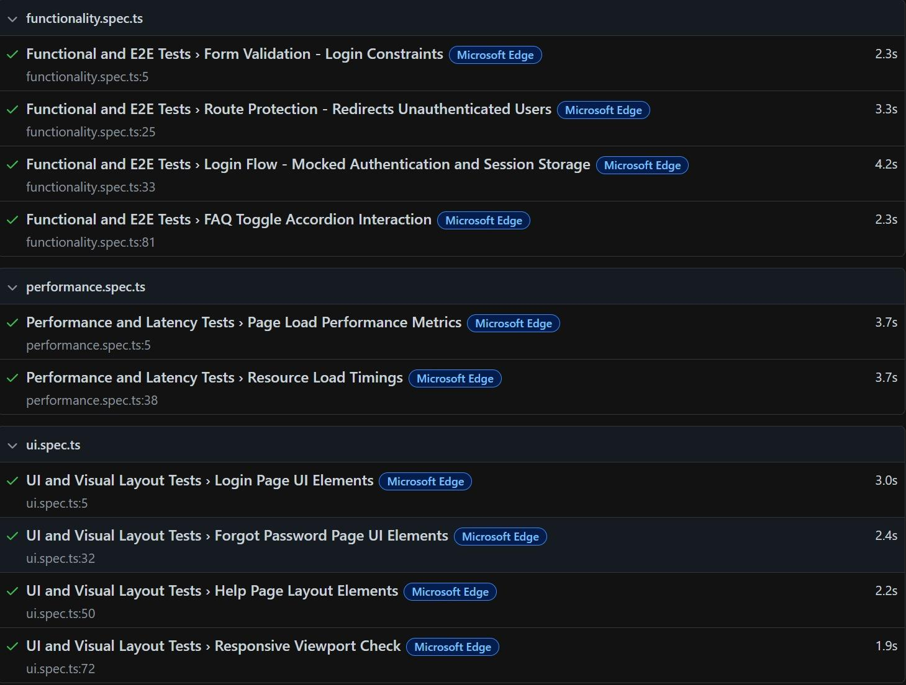
Figure 45: Automated Testing Suite Execution Results.
Playwright runner output showing test duration, browser targets, and successful completion.

5.6.5 Summary of Frontend Test Results

All ten frontend test cases passed successfully across all five configured browser environments. The results demonstrate that the UdjatTrack frontend delivers a functionally correct, visually consistent, and performant user experience.

5.7 Chapter Summary

The Udjat Track system has been validated against its functional and non-functional requirements through a layered test strategy combining unit tests, scenario-based simulation, model evaluation, end-to-end performance benchmarks, and manual integration tests. Key headline results from this chapter:

Result | Value
Event delivery at 100 Hz burst (stress test) | 100% (1,000/1,000)
Network-resilience scenarios passed | 5 of 5
Software-only recovery time (mean) | 3.2 s
Pi unit-test coverage (unit-tested modules) | 99%
Vision: video classification accuracy | 100% (8 of 8)
Vision: per-frame accuracy (test_videos) | 93%
Vision: cross-dataset microsleep recall (fl3d) | 90%
End-to-end latency median (Pi → phone WS) | 58 ms
End-to-end latency P95 | 168 ms
False-positive rate on alert driving (frame level) | 3.09%
False positives at critical severity (HighRisk/Unconscious) | 0
Pi pipeline mean CPU on Pi 4 (10 min capture) | 50.5%
Pi pipeline RSS stability (10 min capture) | ± 0.4 MB
Per-vehicle hardware BOM | EGP 10,390 (~$212 USD)
Cost reduction vs commercial DMS hardware | 30–60%

Of 21 mapped functional and non-functional requirements, 17 are verified by fully automated tests, 3 by combined automated and manual verification, and 1 by manual walkthrough only. The architecture meets its real-time, robustness, resource-efficiency, and cost objectives, and exhibits no false critical-severity alerts on normal driving footage, a key safety property for any driver-monitoring system.

Conclusions and Future Work

6.1 Conclusions
The primary objective of the Udjat Track project is to address the persistently high rate of road traffic accidents in Egypt, which account for approximately 12,000 fatalities each year. Heavy transport vehicles represent a significant proportion of this burden, contributing to nearly 27% of recorded crashes and exhibiting a substantially higher accident involvement rate than passenger vehicles. In response to this risk profile, the project focuses on developing a targeted safety intervention for heavy transport operations. The proposed system is designed to tackle key contributing factors including driver fatigue, distraction, and delayed emergency response through a layered Edge–Gateway–Cloud architecture intended to support real-time detection, timely alerts, and reliable post-incident communication.
The ongoing implementation of Udjat Track is structured around several core functionalities aimed at mitigating accident risk:
Preventive AI Monitoring: The system is being developed to utilize on-device computer vision for real-time detection of drowsiness and micro-sleeps, enabling early warnings before hazardous situations escalate.
IoT Safety Retrofitting: Ultrasonic sensors are being integrated to support blind-spot and forward-collision warnings, providing a low-cost safety enhancement for older Egyptian truck models that typically lack Advanced Driver Assistance Systems (ADAS).
Emergency Response Optimization: An automated SOS mechanism is being implemented based on IMU-driven crash detection and driver consciousness assessment, with the goal of transmitting live GPS coordinates and driver status to emergency services without delay.
Fleet Accountability: A web-based dashboard is being developed to enable fleet managers to transition from passive tracking to active safety monitoring by providing real-time oversight and historical trip and safety logs for compliance and insurance review.

Overall, the Udjat Track project demonstrates the potential of combining edge processing with modular IoT hardware to deliver an affordable, proactive, and scalable safety solution tailored to the needs of the Egyptian heavy transport sector. While the system is still under implementation, its design and preliminary development indicate a promising approach toward improving road safety and reducing accident-related risks in logistics operations.

6.2 Future Work
As Udjat Track is still under development, several directions for future enhancement are identified to further strengthen its functionality, scalability, and practical deployment in real-world heavy transport operations:
Advanced AI and Environmental Adaptation: Future development should focus on improving AI inference performance under challenging environmental conditions such as direct sunlight, night-time driving, or low-visibility scenarios. Expanding the training dataset to include a more diverse range of driver demographics, facial features, and driving environments would also enhance model generalization and robustness across different operational contexts.
Enhanced Predictive Maintenance: Further research could explore the use of advanced machine learning techniques on long-term IMU and vehicle telemetry data to estimate the remaining useful life of critical vehicle components. Such predictive maintenance capabilities have the potential to reduce unexpected breakdowns and optimize maintenance scheduling for fleet operators.
Insurance Integration: A dedicated API could be developed in future iterations to enable integration with insurance providers. This would allow for dynamic “pay-how-you-drive” or usage-based insurance models based on safety scores generated by the system, creating financial incentives for safer driving behavior.

Intelligent Automated Break Management System: A future enhancement could introduce an intelligent break scheduling module that analyzes driving duration, fatigue indicators, and route characteristics to recommend optimal rest locations along the journey. The system could identify nearby rest stops or safe parking zones and proactively notify drivers when breaks are advisable. Additionally, a mandatory break enforcement mechanism could be considered, temporarily restricting trip continuation in cases of excessive fatigue or when regulatory driving-hour limits are approached.
Steering Wheel Grip Detection and Driver Engagement Monitoring: Subsequent versions of the system could integrate steering wheel grip sensors or vision-based hand detection to continuously assess driver engagement. If prolonged disengagement or lack of response to steering prompts is detected, the system could initiate escalating alerts and, in critical cases, trigger emergency protocols such as automatic SOS activation or vehicle deceleration. This would be particularly valuable for detecting medical emergencies or severe fatigue episodes.
Intelligent Trip Scheduling and Route Optimization: Future work may include the development of an advanced trip planning module that assists fleet managers in optimizing schedules based on driver work-hour regulations, predicted fatigue patterns, maintenance requirements, traffic conditions, and weather forecasts. The system could dynamically adjust routes and break recommendations during active trips to ensure both efficiency and regulatory compliance.
Flexible Subscription and Pricing Models: To support broader adoption, future deployments could introduce tiered subscription models tailored to different fleet sizes, vehicle types, and functional requirements. Pricing could be based on the number of active vehicles, data storage needs, and level of technical support required, ensuring accessibility for both small operators and large enterprise fleets.
Overall, these proposed enhancements aim to evolve Udjat Track into a more intelligent, adaptive, and commercially viable safety platform for heavy transport operations in Egypt and beyond.

References
- Central Agency for Public Mobilization and Statistics (CAPMAS). (2025). The Annual Bulletin: Results of Car and Train Accidents 2024. Cairo, Egypt: CAPMAS.
- Okil, M. A. (2020). Evaluation of truck related accidents on Egyptian roads safety. International Journal of Scientific & Engineering Research, 11(7), 1077–1080.
- Elshamly, A. F., Abd El-Hakim, R., & Afify, H. A. (2017). Factors affecting accident risks among truck drivers in Egypt. MATEC Web of Conferences, 124, 04009.
- Mahdy, H. A., Kandil, K. A., Ebrahim, H. E., & Foda, A. F. (2014). Analysis of road traffic accidents on Cairo–Suez Highway in Egypt. Scientific Journal of October 6 University (SJO6U), 2(1), 67–71.
- https://www.researchgate.net/publication/356192371_Evaluation_of_Truck_Related_Accidents_on_Egyptian_Roads_Safety
- https://aawsat.com/%D8%A7%D9%84%D8%B9%D8%A7%D9%84%D9%85-%D8%A7%D9%84%D8%B9%D8%B1%D8%A8%D9%8A/%D8%B4%D9%85%D8%A7%D9%84-%D8%A7%D9%81%D8%B1%D9%8A%D9%82%D9%8A%D8%A7/5166420-%D8%AD%D9%88%D8%A7%D8%AF%D8%AB-%D8%A7%D9%84%D9%86%D9%82%D9%84-%D8%A7%D9%84%D8%AB%D9%82%D9%8A%D9%84-%D9%81%D9%8A-%D9%85%D8%B5%D8%B1-%D8%AA%D8%AD%D8%B5%D8%AF-%D9%85%D8%B2%D9%8A%D8%AF%D8%A7%D9%8B-%D9%85%D9%86-%D8%A7%D9%84%D8%B6%D8%AD%D8%A7%D9%8A%D8%A7
- https://www.almasryalyoum.com/news/details/3100566
- https://www.egyptindependent.com/economic-cost-of-road-accidents-in-egypt-in-2017-is-le28-9-bn-capmas/
- https://injuryfacts.nsc.org/motor-vehicle/road-users/large-trucks/
- https://www.emro.who.int/images/stories/cah/fact_sheet/road_safety.pdf
- https://www.iihs.org/research-areas/fatality-statistics/detail/large-trucks
- https://www.researchgate.net/publication/333685421_Analysis_of_Road_Traffic_Accidents_on_Cairo-Suez_Highway_in_Egypt
- https://aps.aucegypt.edu/en/articles/606/road-safety-inequity-the-case-of-egyptian-vulnerable-road-users
- https://sjou.journals.ekb.eg/article_32869_4966652c7bbf2a24324b30cd69c8e258.pdf
- https://censusinfo.capmas.gov.eg/metadata-ar-v4.2/index.php/catalog/1913/overview
- https://www.diva-portal.org/smash/get/diva2:1293637/FULLTEXT01.pdf
- https://www.mectronik.com/crash-detection/
- https://cdn.sparkfun.com/datasheets/Sensors/Proximity/HCSR04.pdf
- https://www.techurity-eg.com/driver-monitoring
- https://fms-tech.com/solutions/
- https://www.softec.ai/altari-fms
- https://marsadomran.info/en/2020/03/1929/
- https://mej.researchcommons.org/cgi/viewcontent.cgi?article=2105&context=home
- https://www.cdkglobalheavytruck.com/insights/advanced-driver-assistance-systems-adas-heavy-trucks
- https://www.mordorintelligence.com/industry-reports/egypt-trucks-market?utm_source=chatgpt.com
- https://www.cognitivemarketresearch.com/truck-auxiliary-braking-device-market-report?utm_source=chatgpt.com
- https://www.kenresearch.com/egypt-fleet-management-industry?utm_source=chatgpt.com
- https://www.eichertrucksandbuses.com/blog/how-advanced-safety-features-are-transforming-the-driving-experience

